Neural Networks



We have 3 types of layers in a neural network,

1. Input layer
2. Hidden layer
3. Output layer

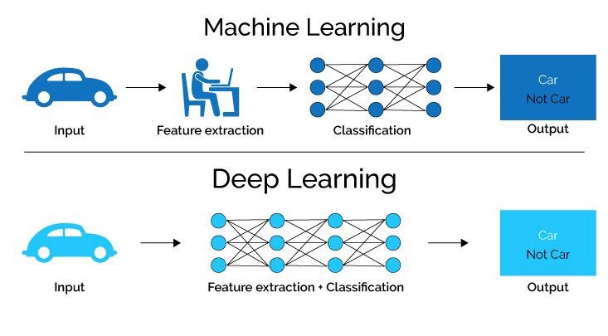

In deep learning, both Feature extraction as well as classification both is done by the machine itself whereas in machine learning, feature extraction is done by us and not by the machine.

Why do we need non-linearity (non-linear activation functions) in neural networks?  
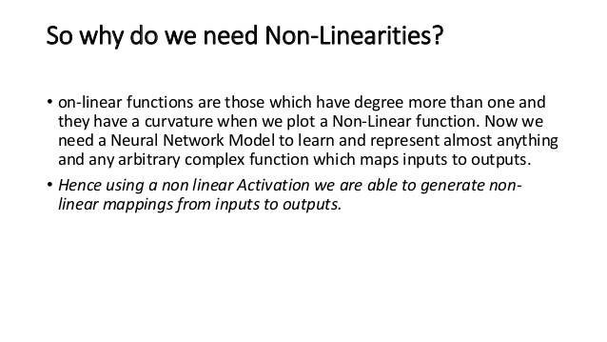

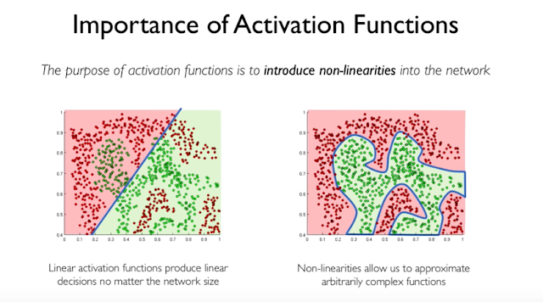

Deep learning problems are non-linear by nature and we can’t do predictions using a linear function.

There are 3 types of Neural Network

1. Artificial Neural Network (ANN).

2. Convolutional Neural Network (CNN).

3. Recurrent Neural Network (RNN).

Artificial Neural Networks (ANN)

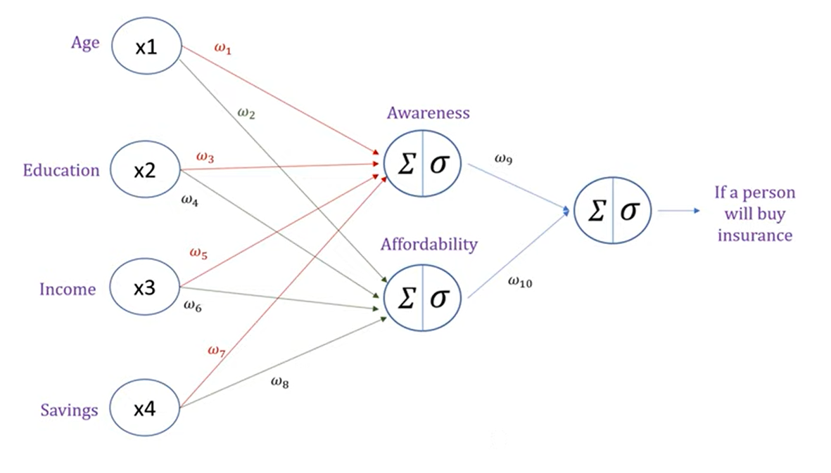

In AAN, we have 2 types of processes happening in our neural network,

1. Forward propagation
2. Backward propagation

Forward Propagation

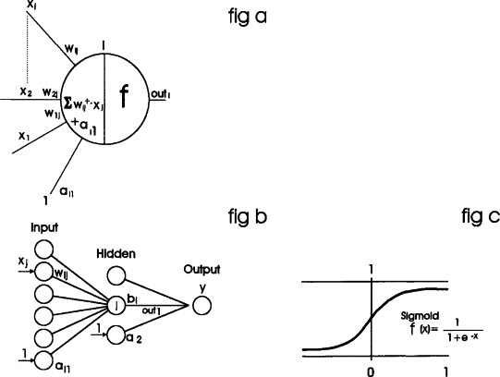

In forward propagation, every neuron does 2 steps which can be seen from fig 1 of above image,

* Calculates Z = (wi)*x + b // where wi = ith slope or weight
* Calculates sigmoid of resultant ‘Z’ sigmoid(Z) and passes the result to the next neuron of next layer with other weights and continues the same procedure till the output layer.

When the output (prediction y’) is made, an error is calculated using the cost function and now weights are adjusted(updated) and prediction value is calculated again by backpropagation to get predicted value with minimal error possible. The backpropagation will adjust(update) the weights in such a way that error is minimized.



Backpropagation





In Backpropagation process, when the output or a prediction is made using forward propagation, we go back from output layer till the first layer and update the weights. We do this backpropagation and forward propagation again and again, and stops when we get minimal error or best result. The weights(slopes) of each layer are updated using chain rule.

The Chain Rule

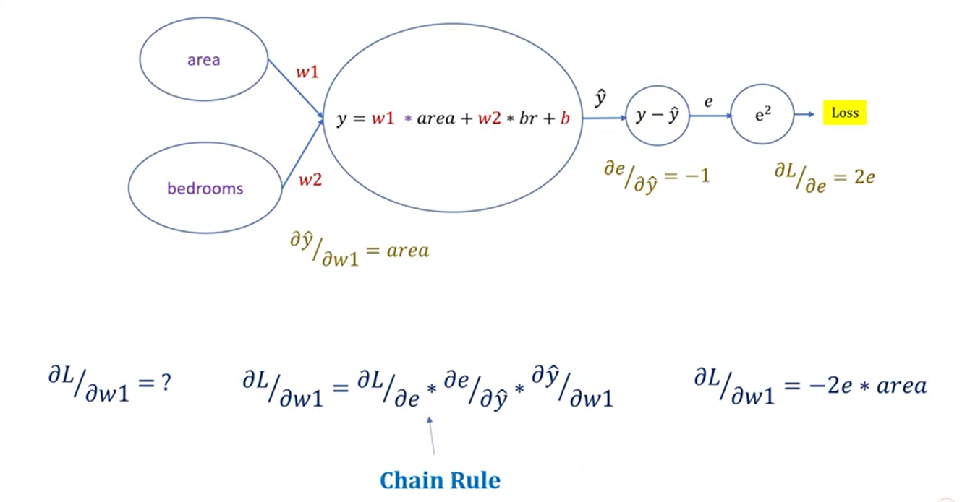

Note: The derivative here is partial derivative which means all other variables will be treated as constant except for the one with whom the derivative is being taken.

Slope 🡪 weights (we are actually updating slopes).

Here we calculated the partial derivative of Loss w.r.t partial derivative of weight#1 which will include all the slopes (partial derivatives) of the layers in between them. Similarly, if we want to find the slope or weight of any layers, then we will have to include partial derivatives (slopes) of the layers in between them.

Example#1,

Partial derivative of Loss / partial derivative of w2 = dL/de * de/dy * dy/dw2.

Weights or slopes are then updated using following equation,

W(old) = w(new) – learning rate * partial derivative which was calculated using the chain rule. (Gradient descent)

Example#2,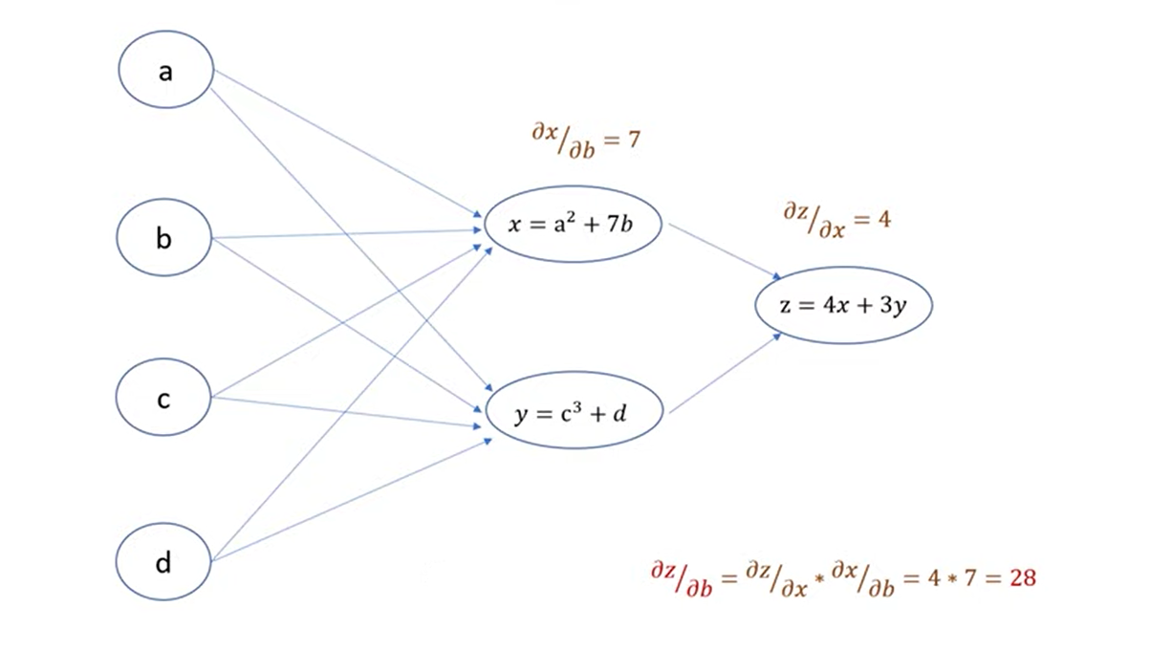The activation function of ANN can be sigmoid, softmax, relu, leaky relu, tanh etc.

Convolutional Neural Network (CNN)

**Convolutional Neural Networks**, or CNNs, were designed to map image data to an output variable. They have proven so effective that they are the go-to method for any type of prediction problem involving image data as an input.

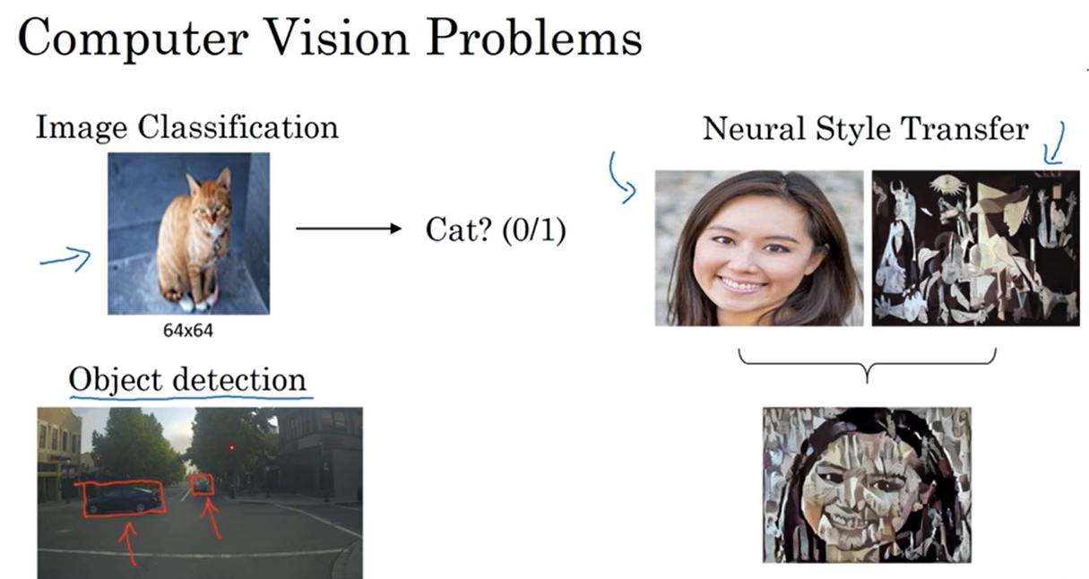

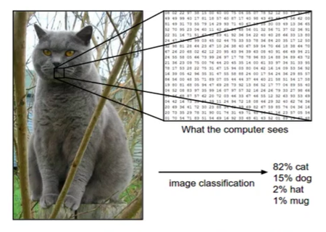

Everything we did in Artificial Neural Network (ANN) is included in CNN in its fully connected layer or dense layer. However, before going to the dense layer or the fully connected layer it has to come through many convolutional cycles or convolutional layers. The output of these convolutional layers is flattened (converted to 1D array) and are passed to the dense layer and then the remaining process is same as of Artificial Neural Network (ANN).



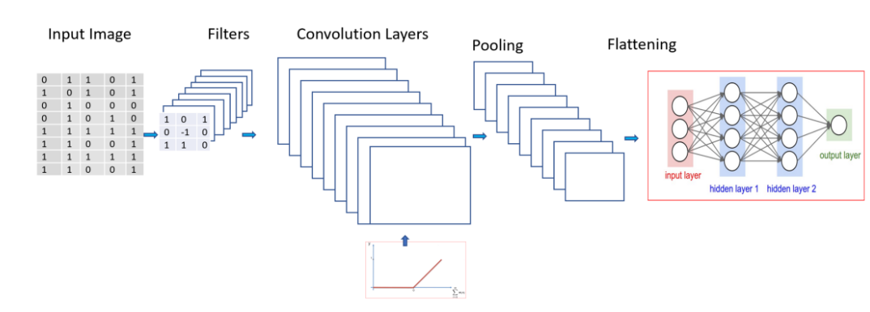

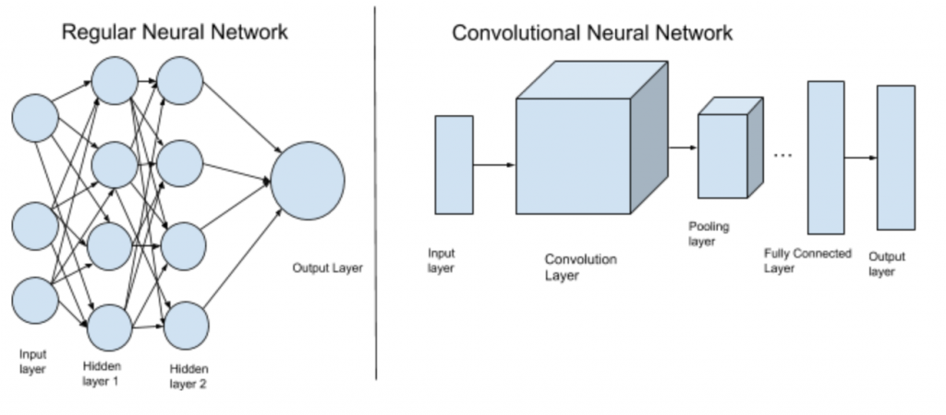

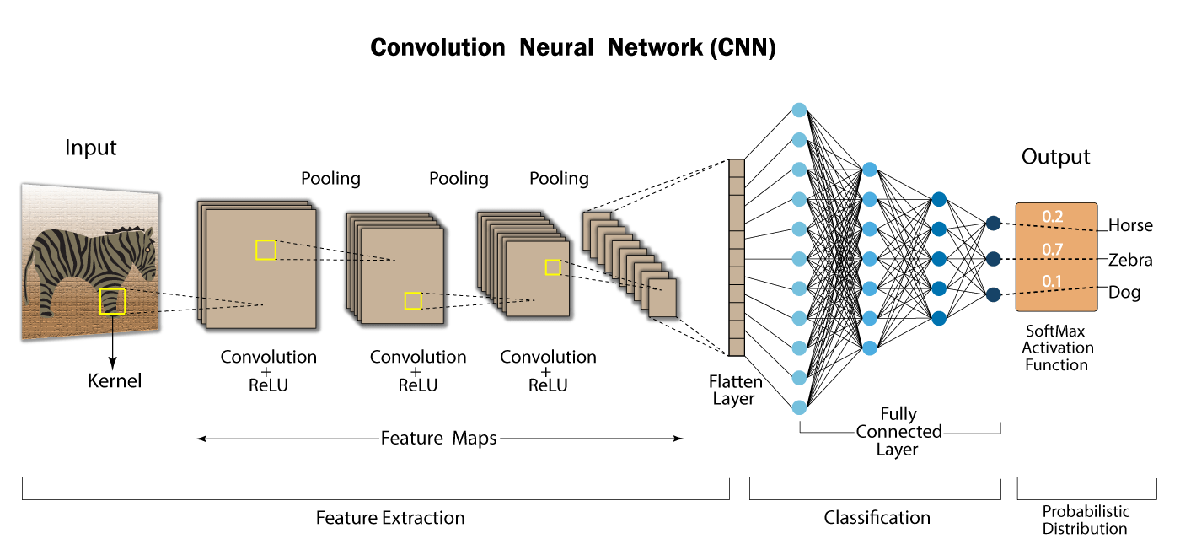

Feature Extraction is done by the convolution layers and after that the classification is done by the dense layer or the fully connected layer.



Convolution Layer (Feature Extraction Layer)

Each convolution layer in a CNN is used to extract a feature or is used to work on a feature. Suppose the first convolution layer finds the vertical edges, the second one finds the horizontal edges of object in the input image, the third one works on eyes, fourth on nose, fifth on hair and so on and after working on these features one convolutional layer merges all these features to construct the object and may pass the constructed object to the dense layer or the fully connected layer in the form of a 1D array (flattened array) and then that dense layer will classify that object.

A convolution layer includes following sub layers in it,

**Image (Input Layer) 🡪 Feature Extractor/Filter/Kernel 🡪 Feature Map 🡪 Bias 🡪 Activation function (Relu or Leaky Relu) 🡪 Convolutional Logic 🡪 Avg/Max Pooling(optional) 🡪 Back to feature extractor/filter/kernel.**

Again, the filter is applied to the resultant feature map of first output.

This cycle from Pooling **🡪**Feature Extractor/Filter/Kernel is continued and backpropagation is done until we find appropriate weights for our feature the machine will keep learning or back propagating until it finds relevant weights for the feature on which it was working.

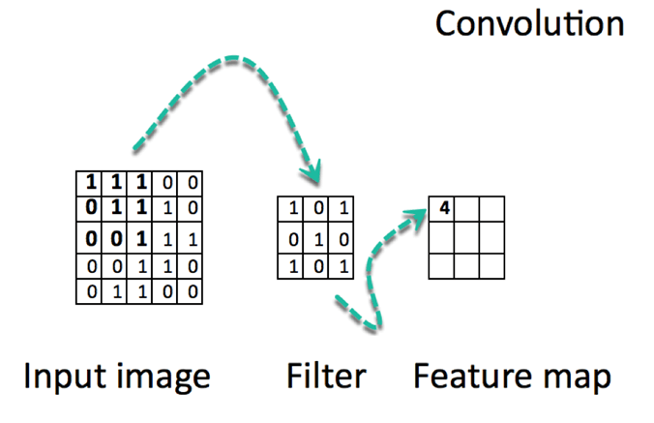

The dimensions of feature map can be calculated from the following formula,

Dimensions = [(image size - filter size + 2*padding) / total strides (filtering steps)] + 1.

**Strides**

Strides is the total gap or the skipped rows and columns during the movement of filter inside the image. In the image below, the value of stride is 1 because 1 row and 1 column are skipped during movement of the filter.



A CNN can have either a gray scale image of 1 channel or an RGB image having 3 channels in it (dimensions R, G, and B each of these 3 dimensions are equivalent to 1 gray scale image channel).

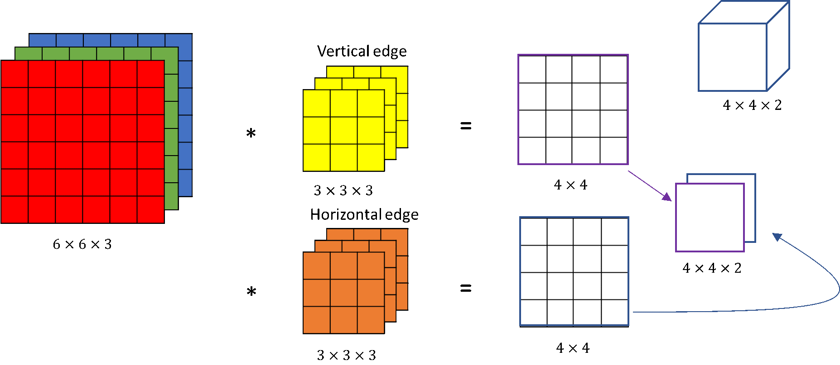

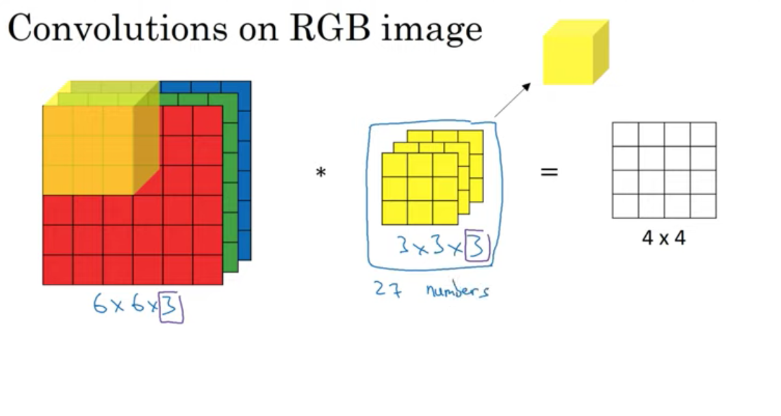



Feature map elements are the sum of the direct multiplication of image elements with the filter elements.

Example,

In the above image, the value 4 comes by multiplying and adding following,

1*1 + 1*0 + 1*1

0*0 + 1*1 + 1*0

0*1 + 0*0 + 1*1

=

1+1+1+1 = 4

This calculation of feature map can also be seen from the following image,







Once the feature map is calculated, a bias is added and activation function like Relu, leaky relu is applied in convolutional layers. We do not use sigmoid and softmax activation functions in convolutional neural network layers because they lead to vanishing gradient problem and exploding gradient problem. After applying activation function, we define a convolutional logic and then do pooling and then repeats the cycle from the filter and now our input for next iteration is our previous feature map.

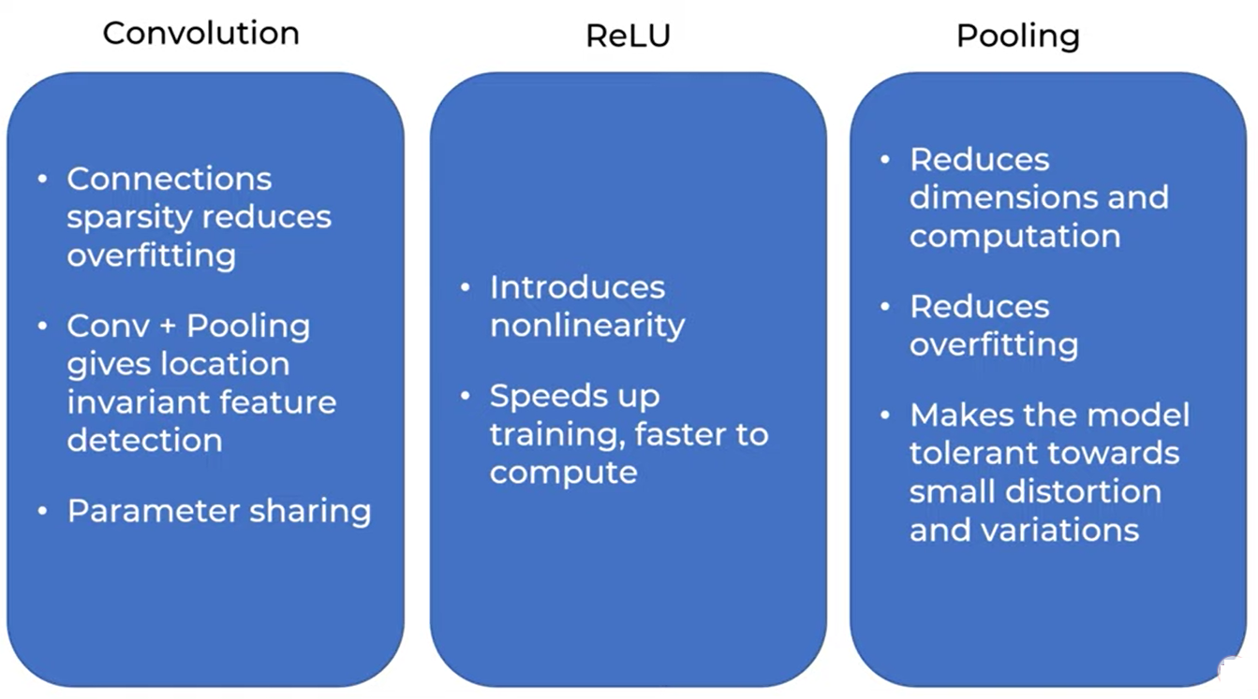

Padding

Padding is also added in original image in order to get feature map of size similar to the input image.

 

There are various types of padding but mostly we use 0 padding in which we initialize the rows and columns as 0. In other padding types we use neighbor values also.

Pooling

Pooling is a process through which we reduce the computation as well as the dimensions of the existing image and works only on important weights. The dimensions of the pooling matrix can be calculated using following formula,

Dimensions = [(image size - filter size + 2*padding) / total strides (filtering steps)] + 1.

There are basically 2 types of pooling.

1. Max pooling (max value is selected)
2. Mean pooling (Average of values is selected)

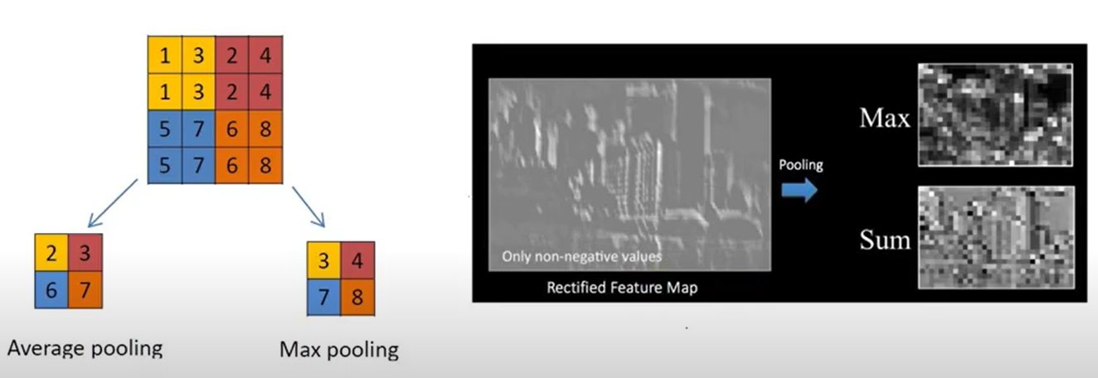





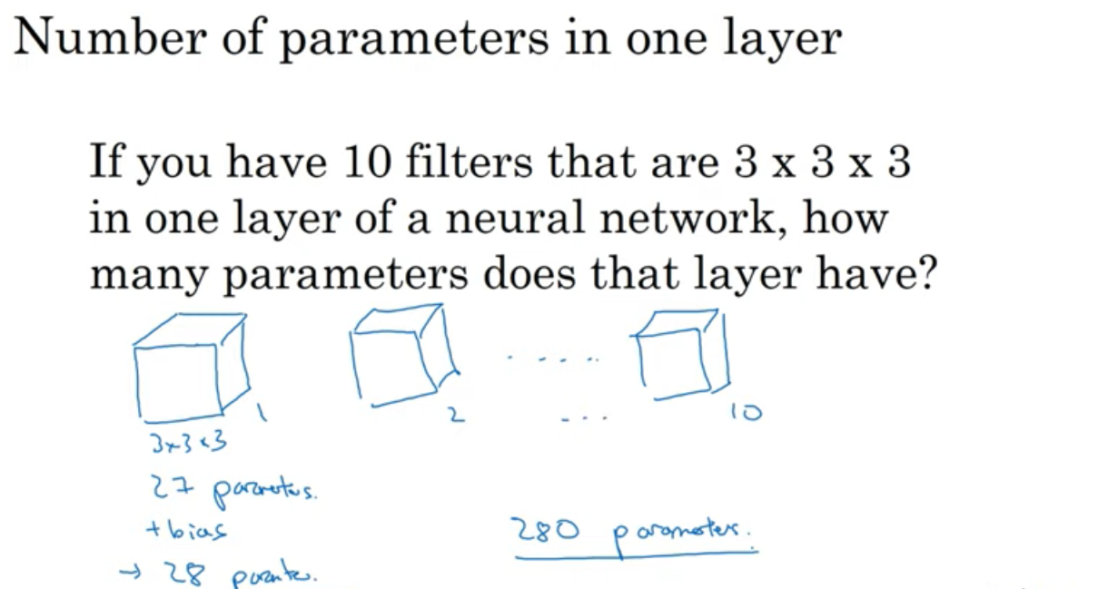

The Vanishing Gradient Problem

The Exploding Gradient Problem

Data Augmentation

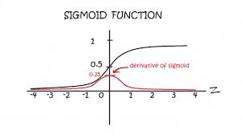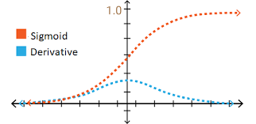

**YOLO Algorithm For Object Detection**

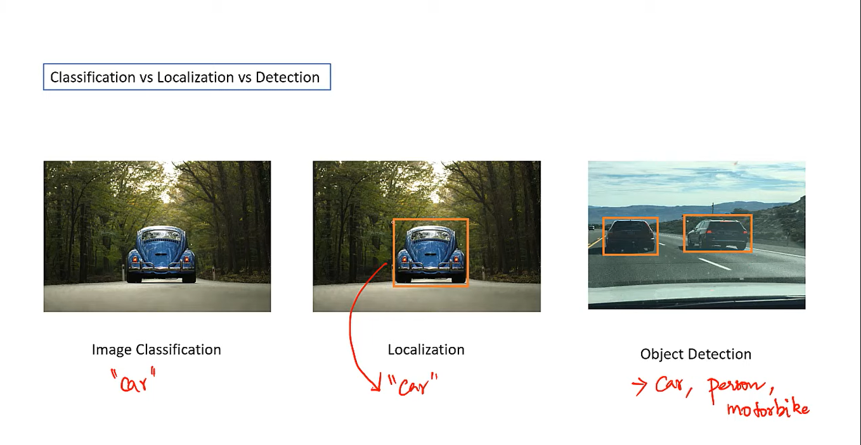

**Image Classification**

Labelling of an image on the basis of the object is called image classification. It is only for a single object.

**Localization**

It is similar to image classification but we draw a bounding box in the input image and label only that portion. It is also only for a single object.

**Object Detection**

Objection detection is similar to localization but it is for more than one object of different types.

**Bounding Boxes**

Bounding boxes are boxes that are predicted by the network. These predicted boxes are overwritten on the input image so that you can visually understand what the position or shape of rectangle are detected by the prediction. That is, they are rectangles you see in images or videos.

It has following parameters,

Bx 🡪 X co-ordinate of center of box

By 🡪 Y co-ordinate of center of box

Bh 🡪 height

Bw 🡪 width

**Anchor Boxes**

We can put some assumption on the shapes of bounding boxes. For example, if we want to detect humans, we should search humans with some vertical rectangular boxes. They are anchor boxes. The anchor boxes are fed to the network, before training and prediction, as a list of some numbers, which is a series of pairs of width and height:

anchors = [1.08, 1.19, 3.42, 4.41, 6.63, 11.38, 9.42, 5.11, 16.62, 10.52]

This list above defines 5 anchor boxes with 5 pairs of (height, width).

Total Objects/Classes = Total Anchor Boxes

For example,

A separate anchor box for human, car, bike, sofa etc.

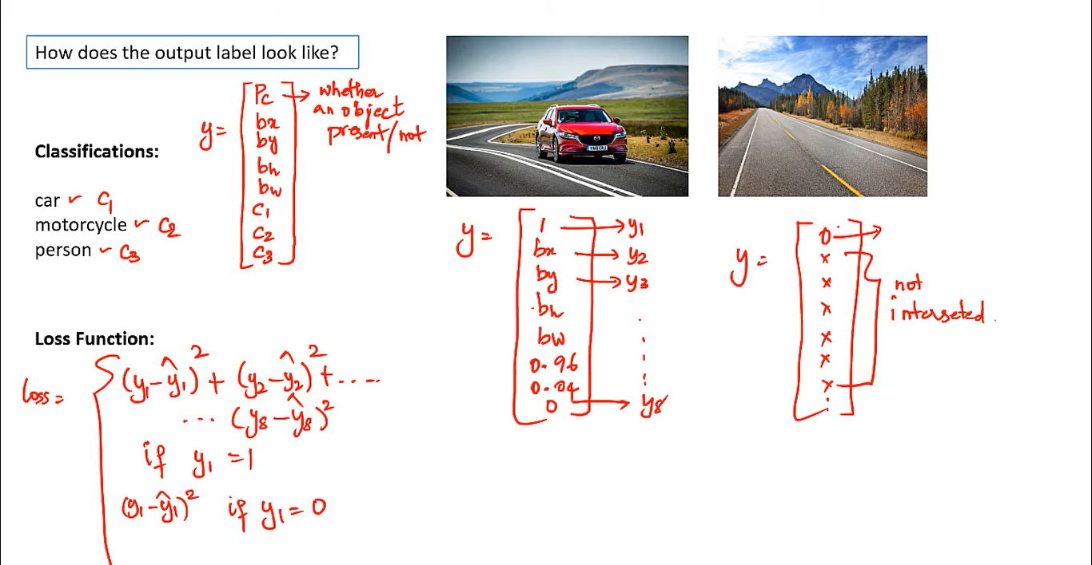

This output label Y contains following parameters,  
Probability count (Pc) 🡪 Probability of object detected from defined anchor box for an object.  
Bx, By, Bh, and Bw 🡪 They are parameters of bounding boxes that are also included in output Y.  
C1, C2, …, CN 🡪 Total classes/objects to be detected and only one class is true at a time in output label Y because output label Y represents a detected object of a specific class only.  
The loss is calculated by calculating the difference of each of these 8 (Pc, Bx, By, Bh, Bw, C1, C2, Cn) parameters that are described above with the same parameters of actual Y vector. The actual Y vector also contains all these parameters. But, if Pc OR the Y1(the first parameter is 0 or near to 0 or lesser than the threshold) then we say that there is no object and since when there is no object, we don’t need to calculate loss for other remaining parameters so we simple calculate the loss of probability count only.

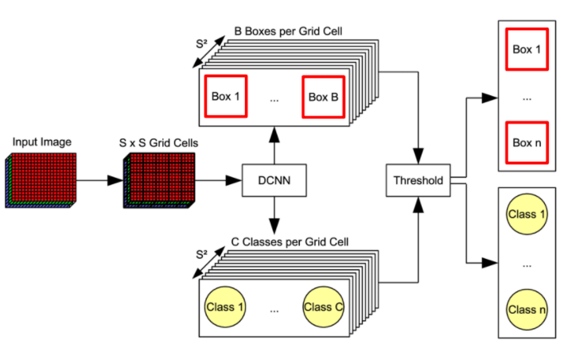

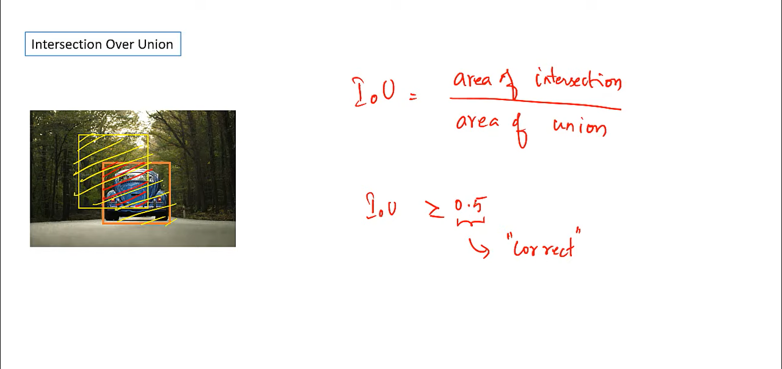

The intersection over union (IOU) helps us in determining which bounding box is more accurate because our model may predict multiple bounding boxes who has detected an object so in order to determine the accurate bounding box, we take intersection over union from the bounding box having maximum probability with the rest of the predicted bounding boxes and pick the one with highest IOU ratio. 0.5 is a threshold value, if IOU is >= 0.5 then we say the prediction is more accurate and if it is < than 0.5 then we say the prediction is not that much accurate. It means that it has max area covered with the bounding box having higher probability which means that we will have to reject other bounding boxes having iou > 0.5 because there already exist some bounding boxes covering the same area of current (accurate or the bounding box with max probability) this is done using **Non Max Suppression**.

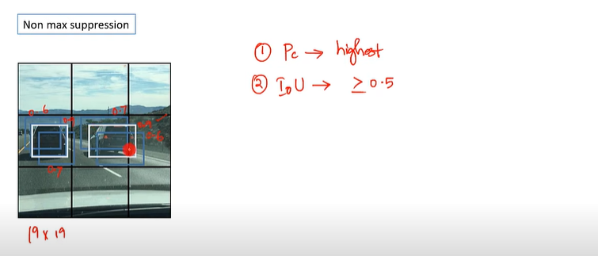

The following is the process of selecting the best bounding box using Non-Max Suppression.  
**Step 1:** Select the box with highest objectiveness score  
**Step 2:** Then, compare the overlap (intersection over union) of this box with other boxes  
**Step 3:** ‘**Remove**’ the bounding boxes with overlap (intersection over union) >50% or 0.5  
**Step 4:** Then, move to the next highest objectiveness score  
**Step 5:** Finally, repeat steps 2-4

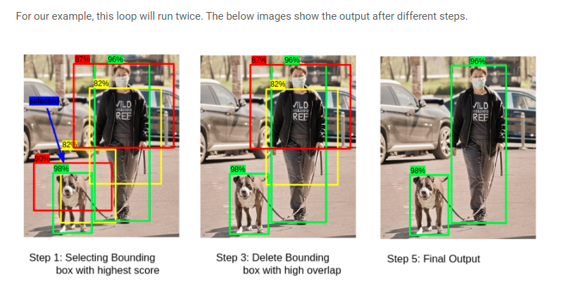

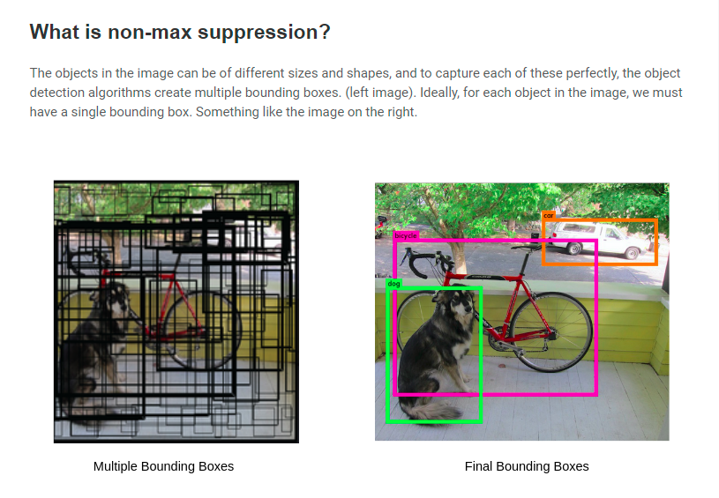

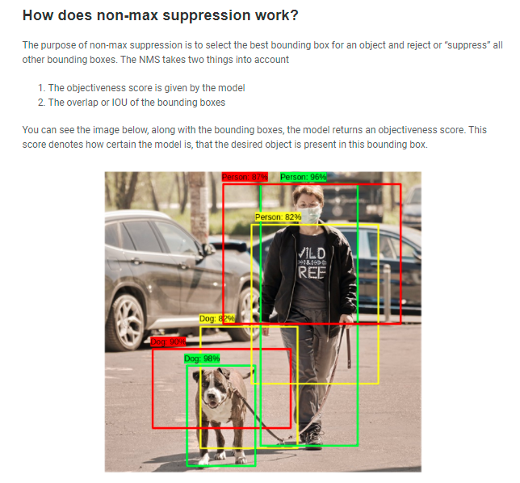

If two objects in an image have same center point then in order to detect such objects, we fed anchor boxes while training the model. Each object has its own anchor box now suppose if two objects have same center point in an image then we combine these anchor boxes together and merge them into one so our predicted Y vector or outcome label will look like,

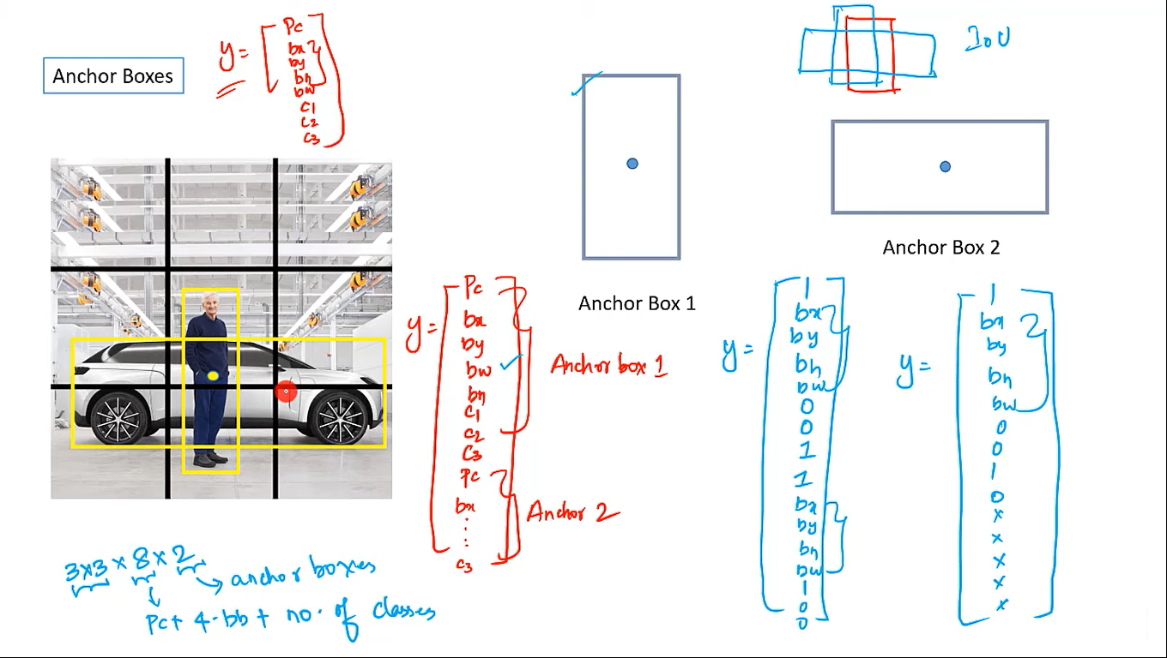

Once our Y or outcome label becomes like this, our model will then draw 2 bounding boxes covering both the detected objects.

**Limitations in YOLO**

cannot detect following:  
1. two anchor boxes and 3 objects with in a cell.  
2. two objects with same anchor box shape with in a cell.

These limitations can be addressed if we use a large grid size such as 19x19.

**How to select anchor boxes?**

1. Select by hand 8 to 10 most common shapes, which tend to cover most of  
the shapes  
2. Use unsupervised machine learning (such as K-means) to identify most  
common shapes within the dataset

How to select size What is the smallest size box I want to detect? If center of bounding box differs with center of anchor box, **we may miss the object detection**.

**How to detect objects using anchor boxes?**  
1. Create several (may be hundreds) of anchor boxes  
2. For each anchor box calculate which objects bounding box has highest overlap w.r.t IoU.  
3. If IoU >=50 percent detect the object with highest IoU  
4. else if IoU percent detection is ambiguous  
5. else if <40 percent ; no object

Region – CNN (R-CNN)

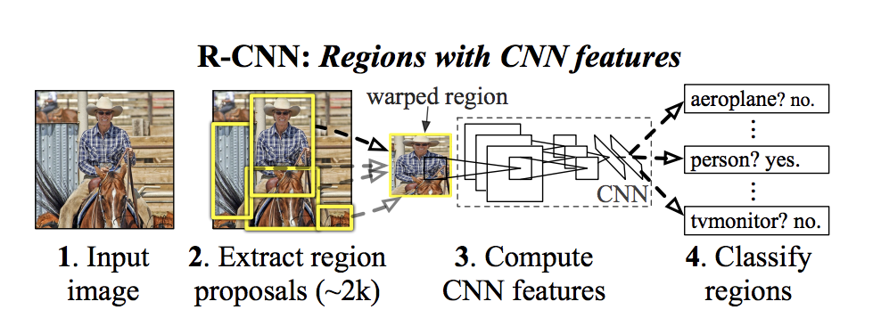

There are four attributes, which are used to form an object (scales, colors, textures, and enclosure).  
Regions are identified based on these attributes. Sub segments are generated to identify multiple regions. Similar regions are then combined to form large regions. Regions of Interest (RoI) are identified.

Recurrent Neural Network (RNN)

OR

Short Term Memory Neural Networks

Feedforward neural networks pass the data forward from input to output, while recurrent networks have a feedback loop where data can be fed back into the input at some point (self-loops in hidden layers, same hidden layer’s neurons can feed inputs/outputs to each other) before it is fed forward again for further processing and final output.

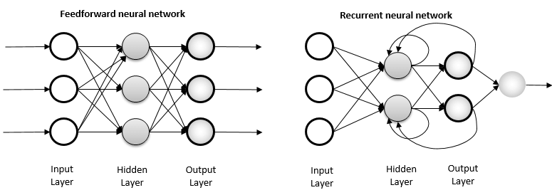  
  
  
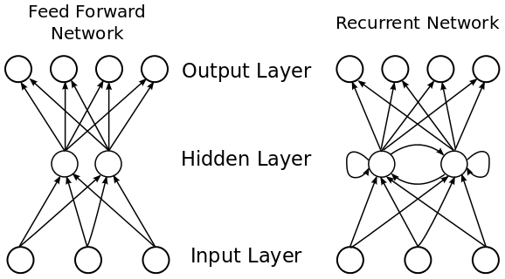

What makes Recurrent Networks so special?

A glaring limitation of Vanilla Neural Networks (and also Convolutional Networks) is that their API is too constrained: they **accept a fixed-sized vector as input** (e.g., an image) and produce a fixed-sized vector as output (e.g., probabilities of different classes). Not only that: These models perform this mapping using a fixed number of computational steps (e.g., the number of layers in the model). The core reason that recurrent nets are more exciting is that they allow us to **operate over sequences** of vectors: Sequences in the input, the output, or in the most general case both and it has a **short-term memory** that other neural networks like ANN and CNN does not have.

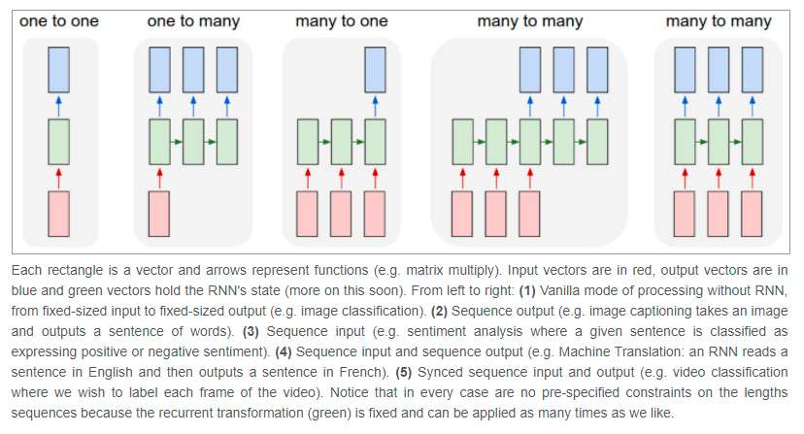

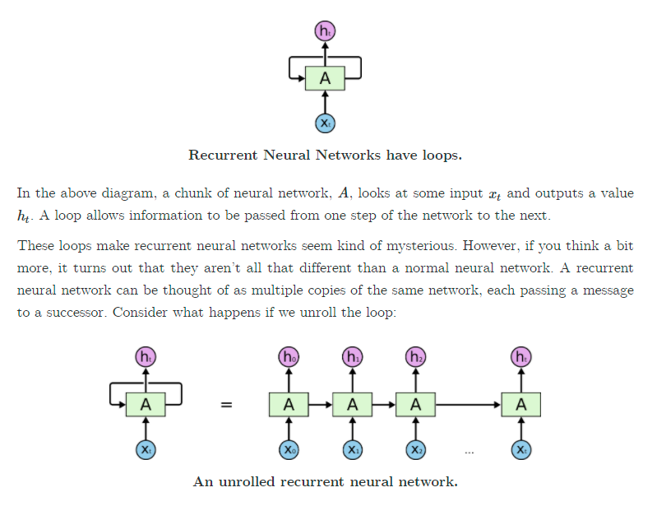

Here, the loop is also ht(output) which is an input for next layer at time t+1. Normally we represent the upper directed output with Y’ and loop output/input as ht which is same as Y’ for the first node only but when we go ahead in our deep neural network ht behaves as a short-term memory and it is no longer equivalent to output Y because it has previous layers output information also so ht=Y only at first node.

**Types Of RNN**

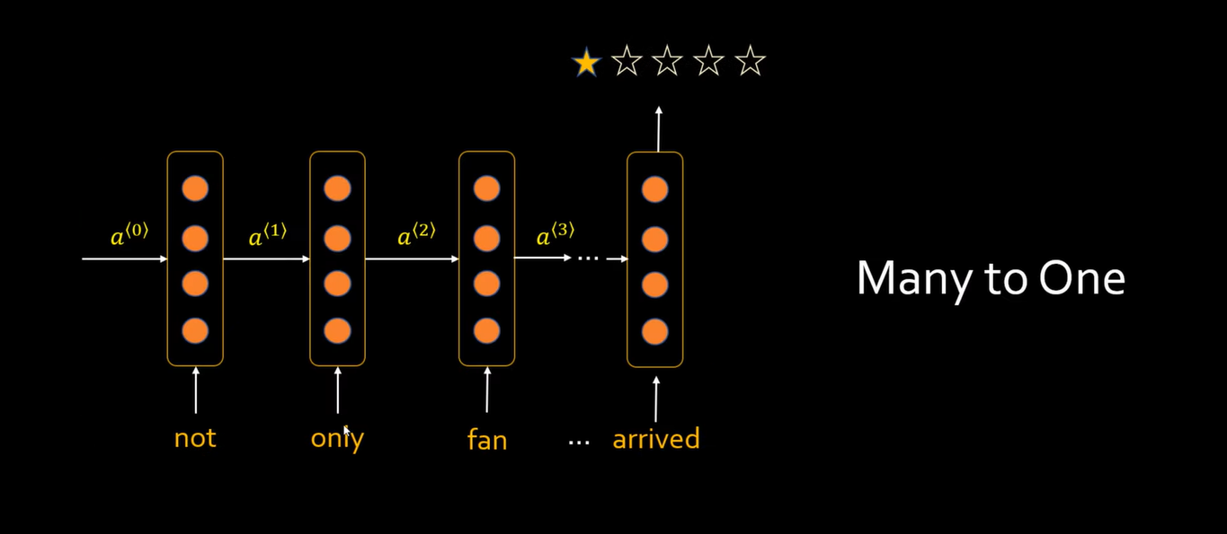

Here we have many inputs but only single output that is why we used Y’ at last node of RNN.

Similarly, in text classification problems (many-many) type of RNN when we have many inputs and many outputs, we will be using Y’ at each node of RNN,

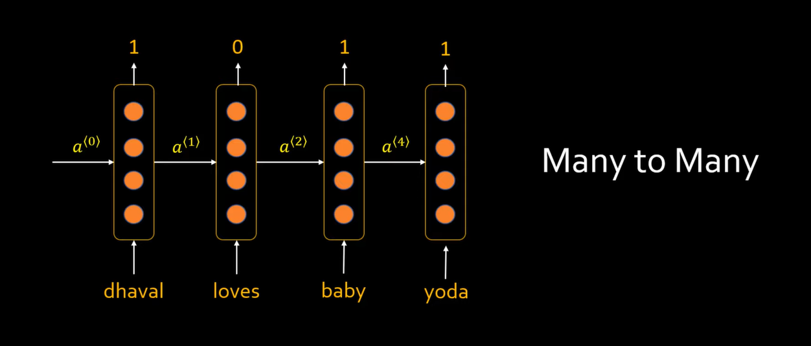

Here 1/0 represents the class of output. 1 represents class person for example Dhaval, baby and yoda and 0 represents non-person words like loves in the above example. For such neural networks, we use Y’ notation at each node of RNN.

Similarly, we have one more type of RNN which is one to many in which we have same input x for each node of RNN,

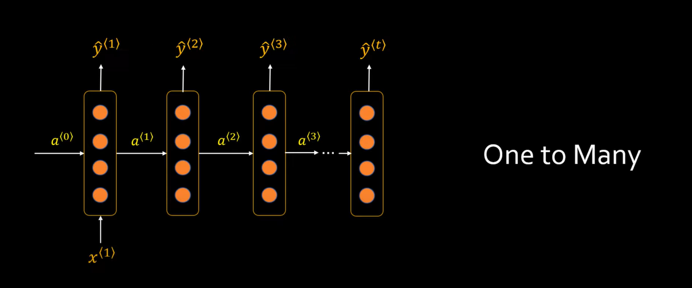

References

* <https://colah.github.io/posts/2015-08-Understanding-LSTMs/>
* Codebasics

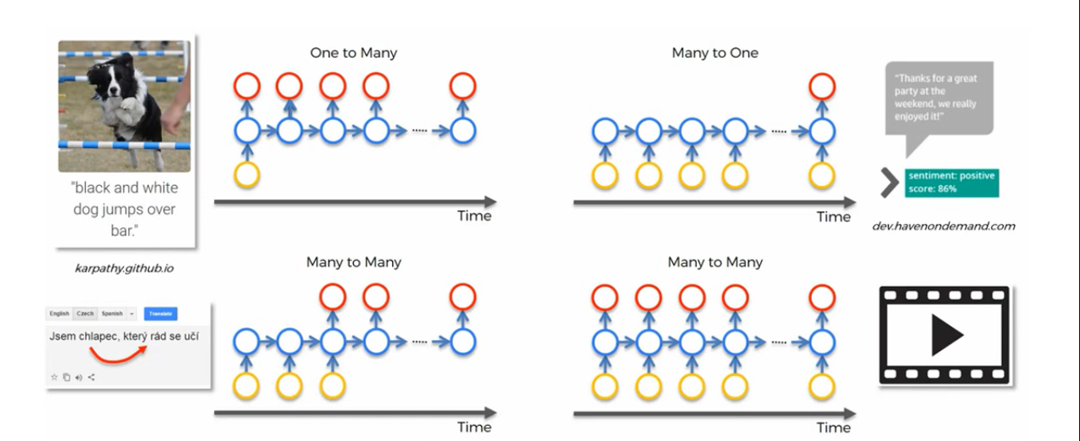

**Why RNN?**

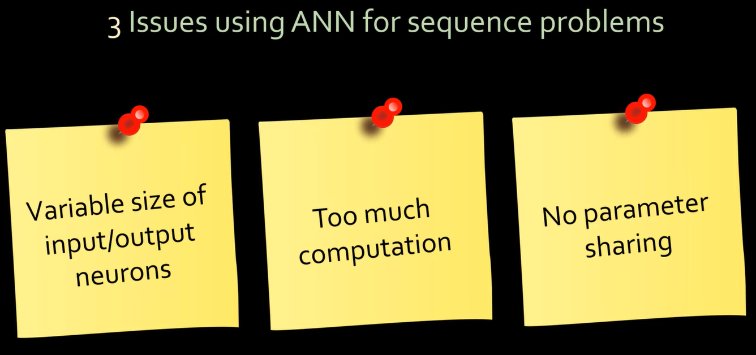

**Applications**

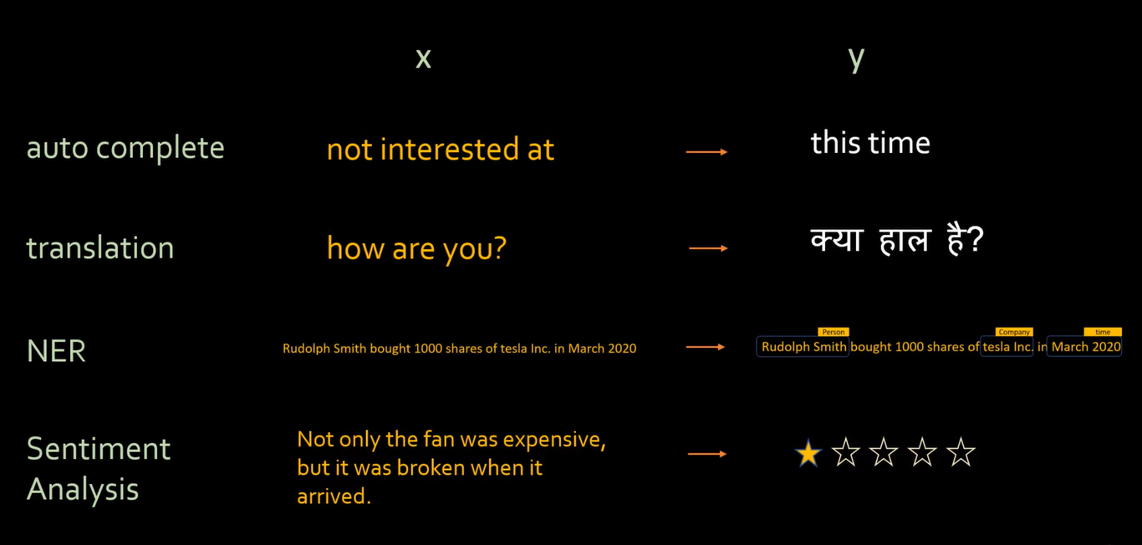

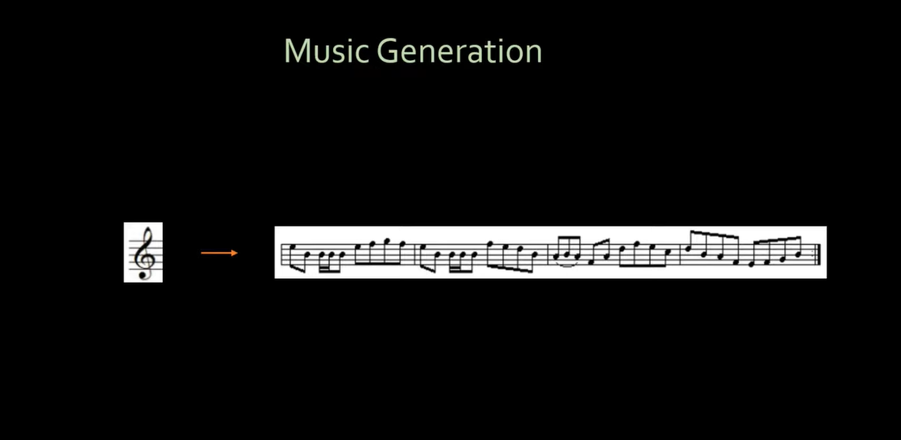

**Named Entity Recognition (NER)**

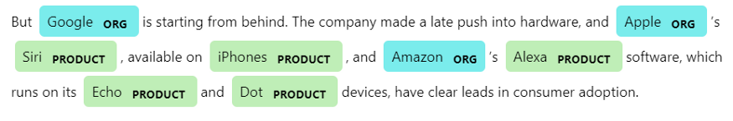

**Total Loss**

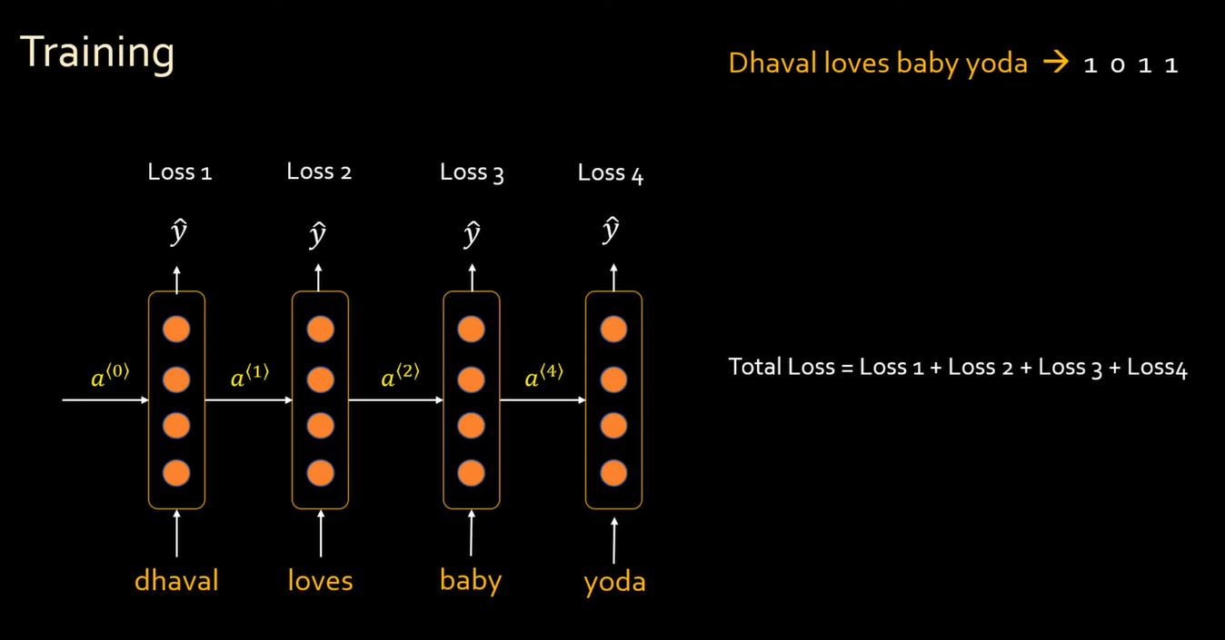

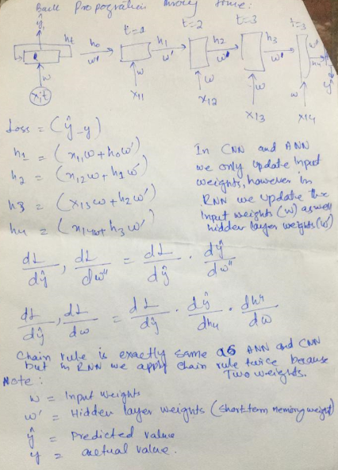

**Problems with Simple RNN**

The problem with simple RNN is that it has very short memory. For example, suppose if we have 10 words in a sentence and we want to predict the last word of the sentence then RNN will be having knowledge of just few words that it has read at end in the network let say last 3,4 words and not all 10 words because it has very short-term memory. However, it should have knowledge of all the 10 words to predict the last word because last word depends on the entire sentence and on the basis of just few words, we can’t predict the last word accurately. The is called **“long-term dependency”** problem. This problem occurs due to the **“vanishing gradient problem”** in simple RNN. The vanishing gradient problem occurs because while back propagating, the older inputs (words) have no more relation/link with current words in memory of hidden state (short-term memory) so the gradient on such non relatable words/inputs become non-changeable and therefore the vanishing gradient problem occurs.

Suppose if we have two sentences that are 99% similar and are little different and if we want to do prediction of words on such sentences then we need knowledge(context) of entire sentence to predict accurately otherwise we can’t predict accurately. The example below shows that when we have “Today” we predicted “need” but when we have “Last year,” we predicted “had”. Such predictions can’t be done using RNN because, it has short term memory and it can have knowledge of just few read words. The gradient at node of word “Today” and “Last year,” during the back propagation has **no impact** due to which we have vanishing gradient problem. We have two solutions available to solve this problem, LSTM and GRU.

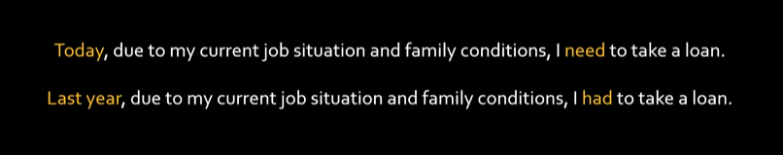

Simple RNN is like hero of film memento who has a very short-term memory due to which he forgets things too early.



As time passes, the impact of the words read earlier gets reduced,





In simple RNN, it is very hard to store the information of previous hidden layers. As the network grows (deep neural network with more hidden layers), the memory or information in previous layers is vanished.

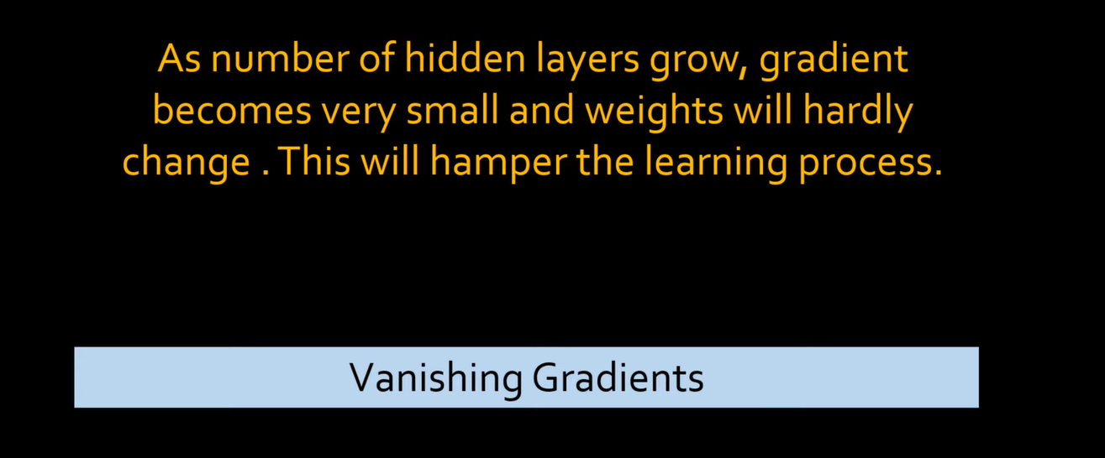

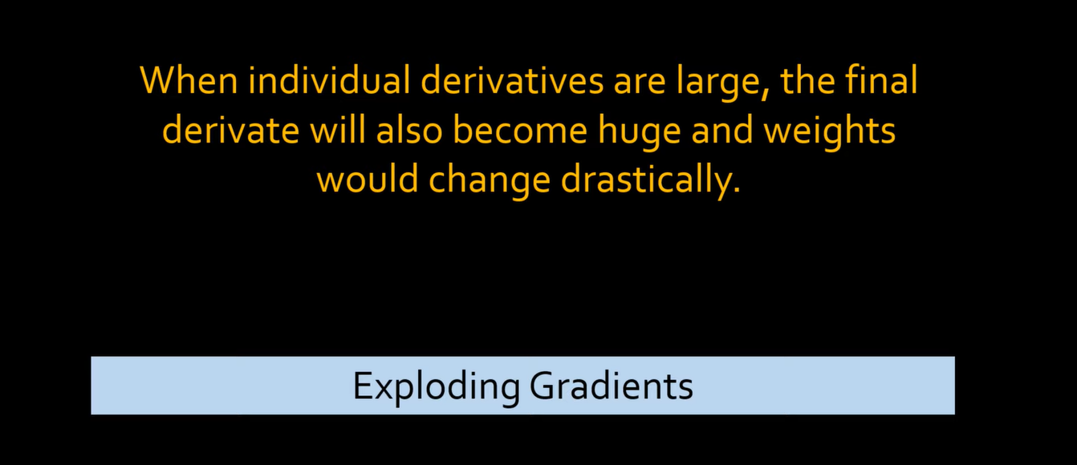

**Vanishing Gradient Example**  
wi = wi-1 + learning rate * some partial derivative value

w0 = 5  
w1 = 5 + (0.5) // here the second value ‘0.5’ is an assumption just to get the concept  
w2 = 5.5 + 0.25 // here the second value ‘0.25’ is an assumption just to get the concept  
w3 = 5.75 + 0.01 // here the second value ‘0.01’ is an assumption just to get the concept  
w4 = 5.76 + 0.000001 // **“vanishing gradient problem (weight stops changing)”**

**Exploding Gradient Example**  
wi = wi-1 + learning rate * some partial derivative value

w0 = 5  
w1 = 5 + (10) // here the second value ‘0.5’ is an assumption just to get the concept  
w2 = 15 + 100 // here the second value ‘0.25’ is an assumption just to get the concept  
w3 = 115 + 1000 // here the second value ‘0.01’ is an assumption just to get the concept  
w4 = 1115 + 10000 // **“Exploding gradient problem (The change in weights is too much)”**

**Simple RNN Structure**

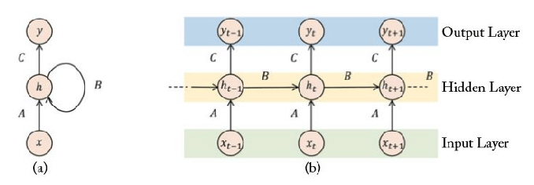

Ht = tanh((wx+b) + (w’ht-1 + b’))  
 **OR**  
ht = tanh (W (x, ht) +b) where W represent both weights 🡪 (w,w’)

Simple RNN (Short-Term memory) node memory using hidden layers,

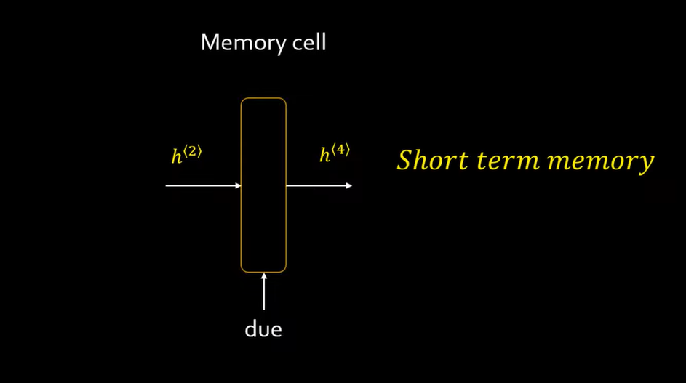

**Long Short-term Memory (LSTM) RNN**

LSTM (Long Short-Term Memory) RNN node,

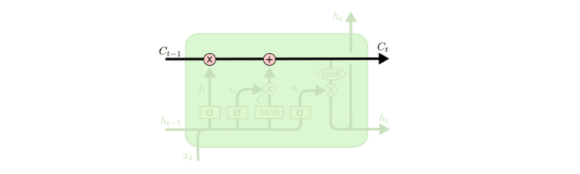

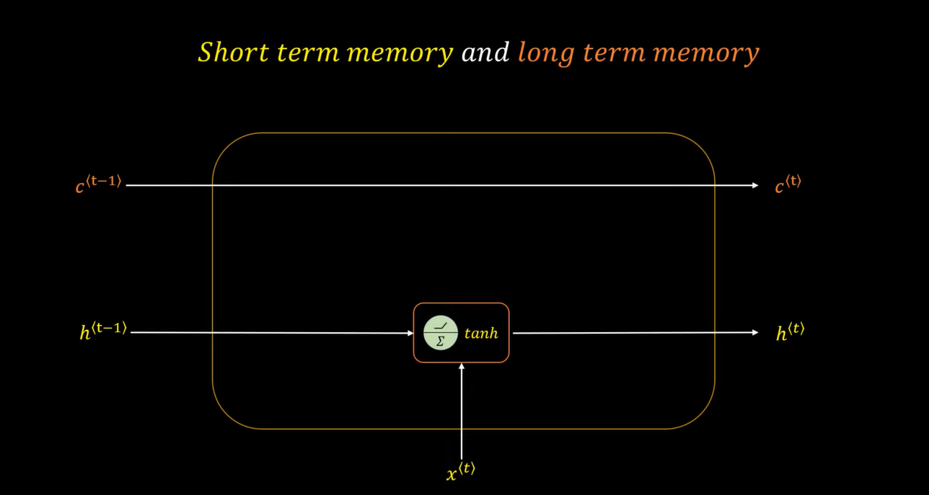

From the above images, we can see we now have an extra Long-Term memory (cell state) which we have named ‘C’ where t, t-1 represents the time intervals of memory at any node. C^t-1 represents the Long-Term memory at previous node/state whereas C^t represents Long-Term memory at current node/state.

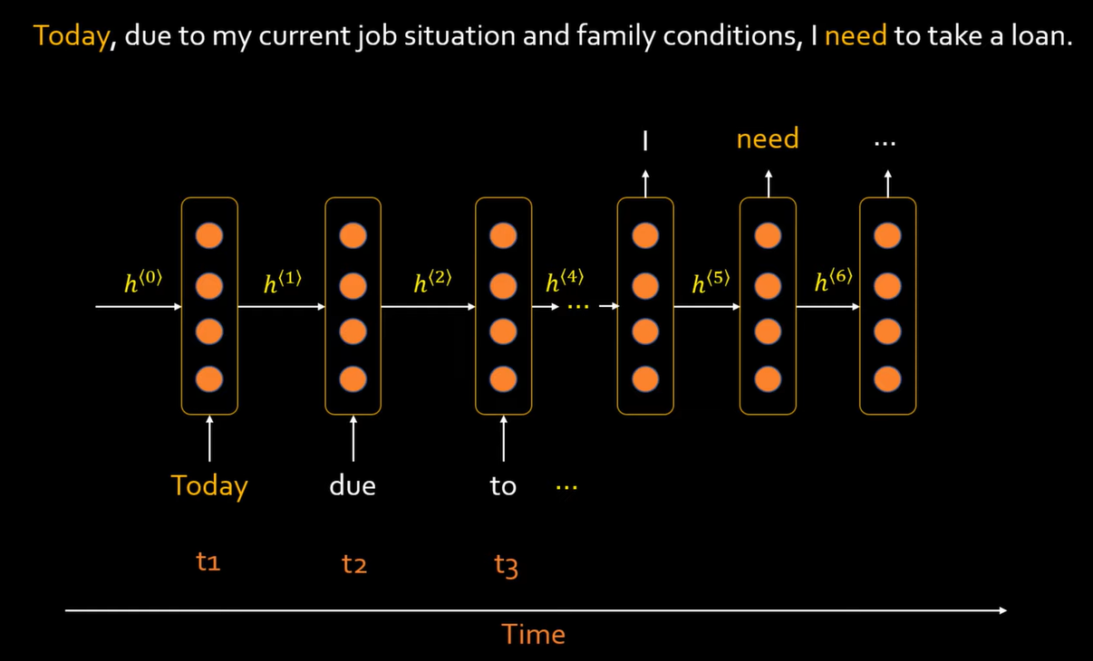

**Problem with simple RNN (short-term memory)**

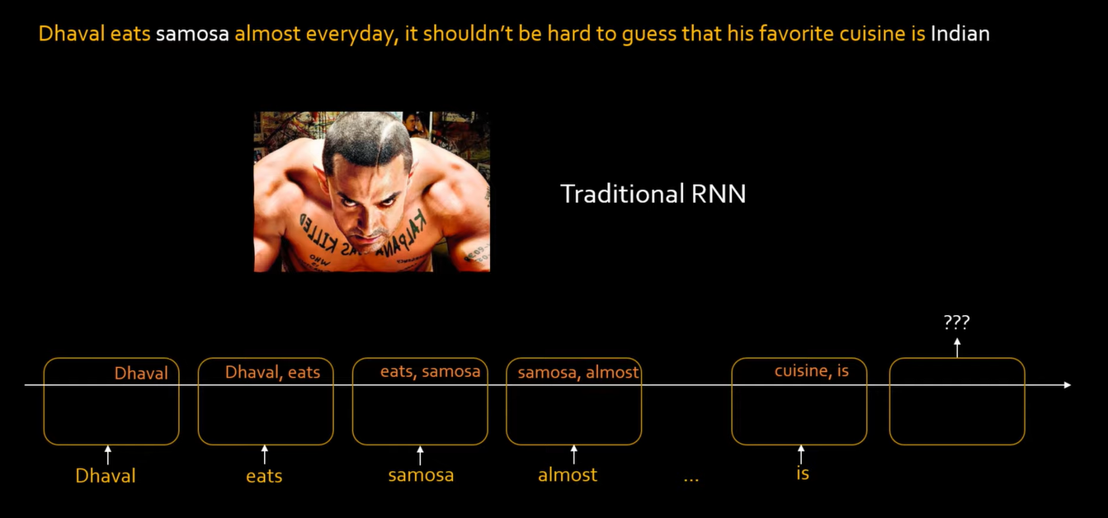

From the above image, we can see that simple RNN has very short memory for the purpose of understanding here let say, the simple RNN can only remember 2 important words at a time. Here we are determining the cuisine on the basis of previous inputs(food) like here we read samosa and based on this input out prediction should be Indian cuisine but since we are using simple RNN, we cannot have ‘samosa’ in our short-term memory for a **very long time** and hence this simple RNN can not predict the cuisine accurately. This problem arises because the sentence was long (long-term dependency).

Same sentence using LSTM,

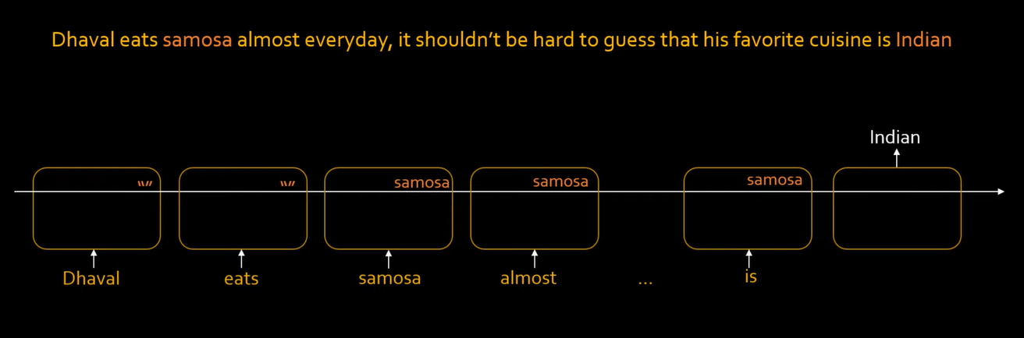

Here when we are using LSTM, we can see we have samosa (an important input) for a long time in the memory of RNN which helped in predicting the cuisine. The deep neural network will determine itself that what input(words) are important for prediction and what are not after the training with millions of inputs that is why we see that only samosa is placed inside the long-term memory of LSTM in the above example.

**Context Change In LSTM**

Similarly, if we take another long sentence to predict the cuisines, we see that for some time in the long-term memory we have samosa and we predicted Indian cuisine and even after prediction we still have samosa in our long-term memory but when the LSTM reads ‘Pasta’ it determines that the **Context** is now changed because during training phase, thousands of examples are given to the model and it can know which information to keep and which to forget or when the context is changing and when the context is not changing. The LSTM RNN will learn that samosa has no relation with pasta so it will change the context and it will remove samosa from the long term memory and add pasta in its place and that is the reason we predicted ‘Italian cuisine’ accurately for Dhaval’s brother otherwise if we had samosa in our long term memory instead so we would have predicted Indian cuisine which is wrong so the LSTM also knows when to remove inputs from the memory that is when to change the context and when to not change the context.

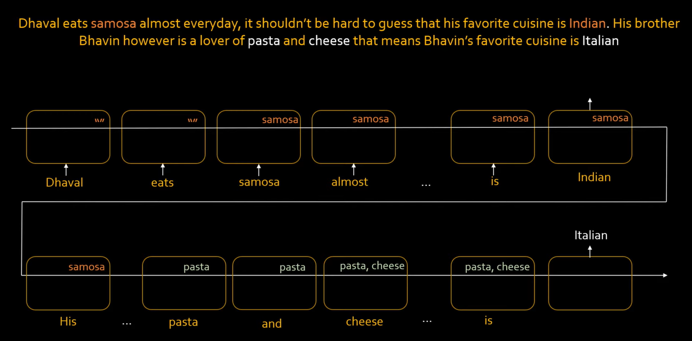

**LSTM Structure**

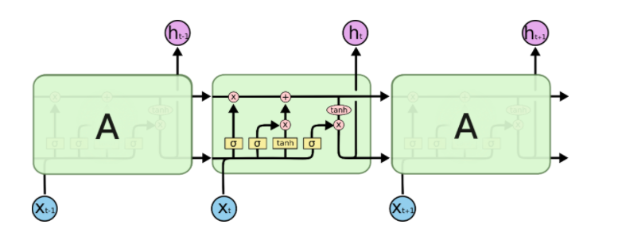

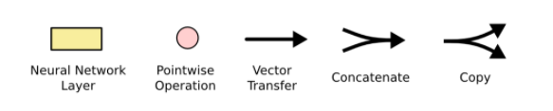

Here, the multiplication is not simple matrix multiplication but it is a pointwise/piecewise multiplication or the Hadamard multiplication. The example of Hadamard or pointwise/piecewise multiplication can be seen as,

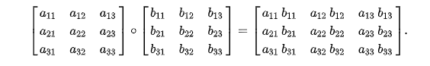

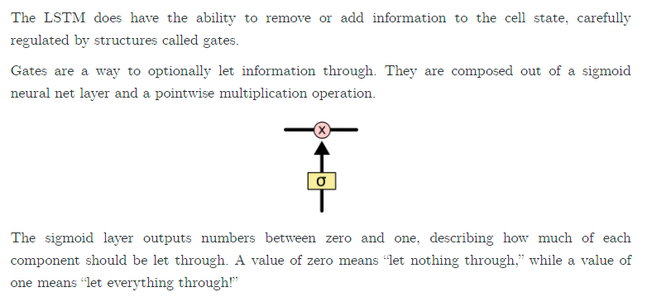

In LSTM, we have 3 types of gates,

1. The forget gate.
2. The Input gate.
3. The output gate.

**The Forget Gate**

The forget gate helps us in determining which information from the previous output(ht) should be kept with current context input(x). Remember the example of samosa and pasta that we discussed earlier where we forgot samosa when we read pasta to predict the Italian cuisine. This forget of samosa was done using this forget gate in LSTM. Similarly, let say we are predicting him/her on the basis of he/she, we sometimes have to forget he when she comes as new input and similarly, we will have to forget she when he comes as new input in order to predict him/her in current context.

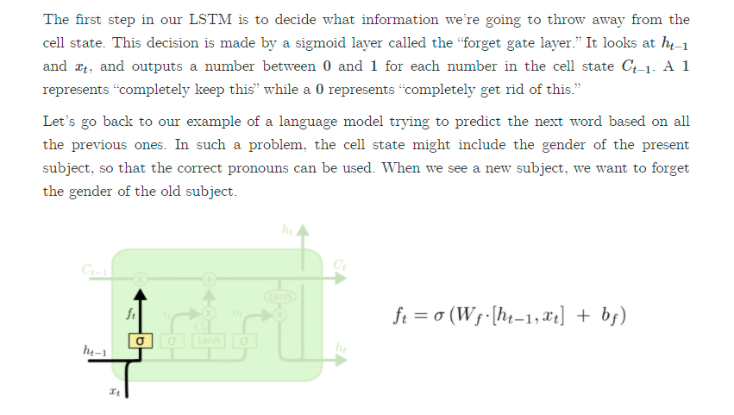

We have used sigmoid here because it gives values between 0 and 1 but after setting the threshold it helps us in getting only two values either 0 or 1. The 0 represents data is forgotten and 1 represents data to keep in cell memory ‘C’.

Here ‘Wf’ is basically a combination of two weights ‘Wf’ 🡪 (wi, wj). Let say the first weight ‘wi’ will be multiplied with the previous layer output ‘ht’ and ‘wj’ will be multiplied with current input ‘xt’ and then these matrices are concatenated together and a bias is then added to it. A sigmoid function is applied to it to determine which words(values) to forget from the cell and which words(values) to keep in the cell memory. 0 🡪 forget and 1 🡪 keep. A pointwise or piecewise multiplication is done between ft and ct-1 to forget/keep things from the cell memory that are only related to current context only.

Sigmoid specifically, is used as the gating function for the three gates (in, out, and forget) in LSTM, since it outputs a value between 0 and 1, and it can either let no flow or complete flow of information throughout the gates.

Therefore, current memory cell equation becomes,

Ct = Ct-1 * ft

**The Input Gate**

**The purpose of input gate is to forget things that has no relation with current input**. The input gate is used to input only new ‘relevant’ information that is important for current context and should be kept in memory cell ‘C’. For example, in the example of cuisine we discussed earlier that when we read ‘pasta’, we forgot ‘samosa’ because these words have no relation in current context. This new information of current context is placed using the input gate. Similarly, when we were reading ‘Cheese’ after reading pasta, we knew that these words are related to each other so we did not forget ‘pasta’ so all these things are done by the input gate.

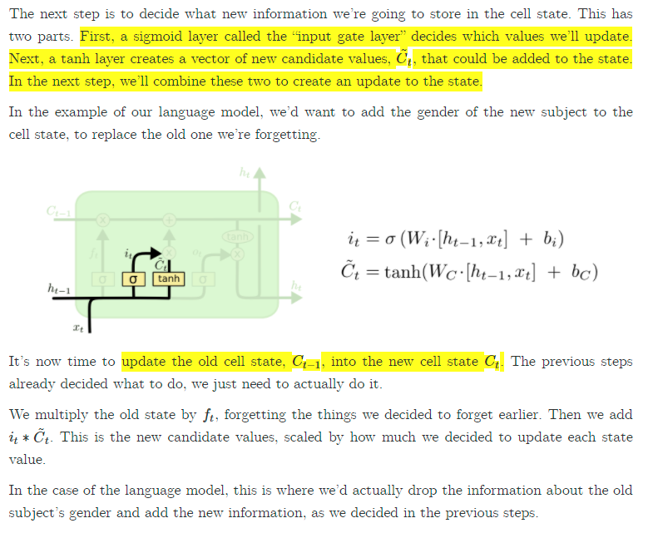

We multiply ‘it’ with new information to be kept ‘Ct’ and then add this information in the new cell memory state becomes,

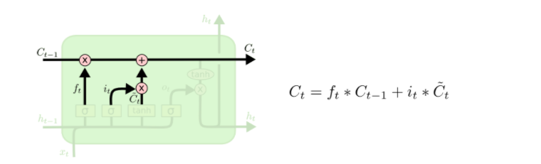

**The Output Gate**

The output gate is used to filter out the relevant information that is only needed for short-term memory (hidden layers). The LSTM will learn what is relevant for hidden state (what words are important for short term memory) and what is not relevant during the training phase so we do not need to worry about that. Suppose words like the, to etc. are not important so using output gate, we are able to filter only important keywords that are important for short term memory but comes too early in the network so due to long term dependency the impact/importance get reduced so in order to achieve that importance, we filter out the information using the output gate to keep only relevant information in our short-term memory.

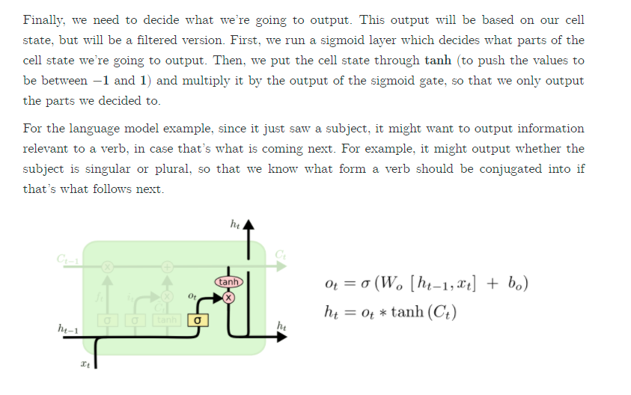

**Why Tanh function?**A **tanh** function ensures that the values stay between -1 and 1, thus regulating the output of the neural network. You can see how the same values from above remain between the boundaries allowed by the **tanh** function. So that's an **RNN**.

To overcome the vanishing gradient problem, we need a function whose second derivative can sustain for a long range before going to zero. Tanh is a good function with the above property. Tanh increases the derivative which helps in avoid the vanishing gradient problem because now derivative range is increased and is not from 0 🡪 0.25 like sigmoid.

A good neuron unit should be bounded, easily differentiable, monotonic (good for convex optimization) and easy to handle. If we consider these qualities, then we can also use RELU in place of the tanh function since they are very good alternatives of each other. But, before making a choice for activation functions, we must know what the advantages and disadvantages of our choice are.

**Summary**

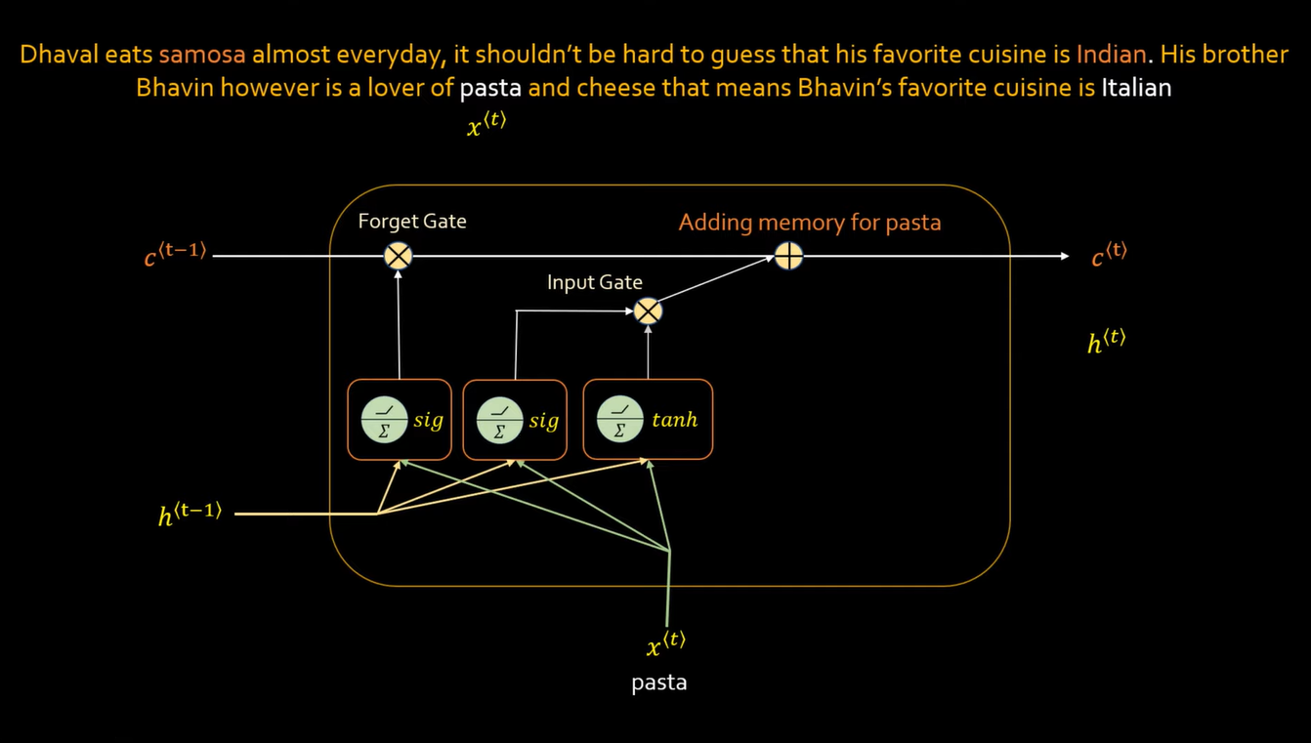

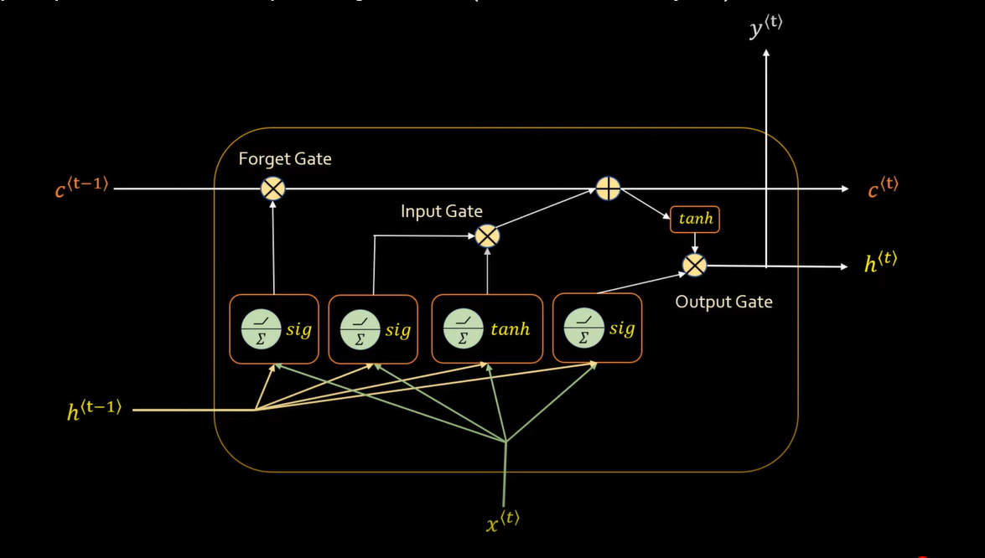



 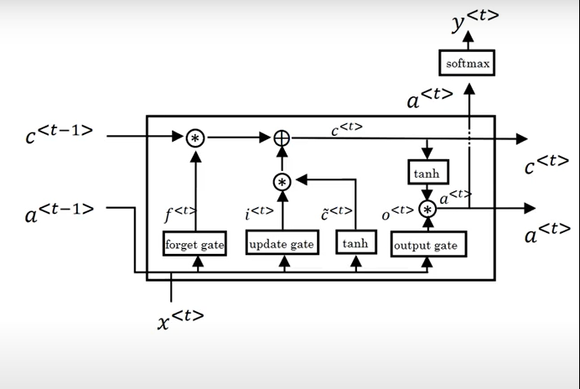

**Gated Recurrent Units (GRU)**

It is another variant of LSTM which solves the vanishing gradient problem and has a long-term memory like LSTM. It reduces the number of gates to 2 and it also do not have any cell memory like LSTM.

There are two gates in GRU,

1. The Reset Gate.
2. The Update Gate.

**The Reset Gate**

The Reset gate helps in forgetting the previous information whenever a context is changed and helps in putting the new information in hidden memory ‘ht’. It tells us when to forget the previous information and when to not on new inputs (if context is changing). The example below shows that when pasta was read (the context was changed) so samosa got forgotten and pasta was added as new information of new context. The equations of the reset and update gates are almost same and the only difference is of weights. In Reset gate, we have weights ‘Wr’ and ‘Ur’.

r^t 🡪 Represents Reset gate.

r^t = sigmoid ((new input at time t * its weights ‘Wr’) + (previous hidden layer output at time t-1 * its weight ‘Ur’))

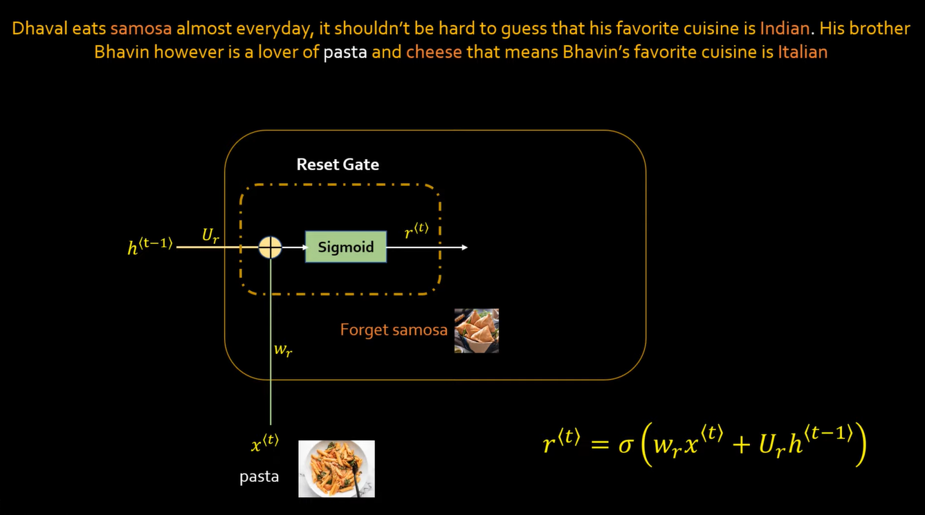

**The Update Gate**

The update gate helps us in telling what information to save/retain, if new words and the words in memory ht are of same context then retain/save it. The example below shows that when cheese was read (the context was not changed) so ‘pasta’ was retained in memory and cheese was added as new information of same context. The equations of the reset and update gates are almost same and the only difference is of weights. In Update gate, we have weights ‘Wz’ and ‘Uz’.  
z^t 🡪 Represents Reset gate.  
z^t = sigmoid ((new input at time t * its weights ‘Wz’) + (previous hidden layer output at time t-1 * its weight ‘Uz’))

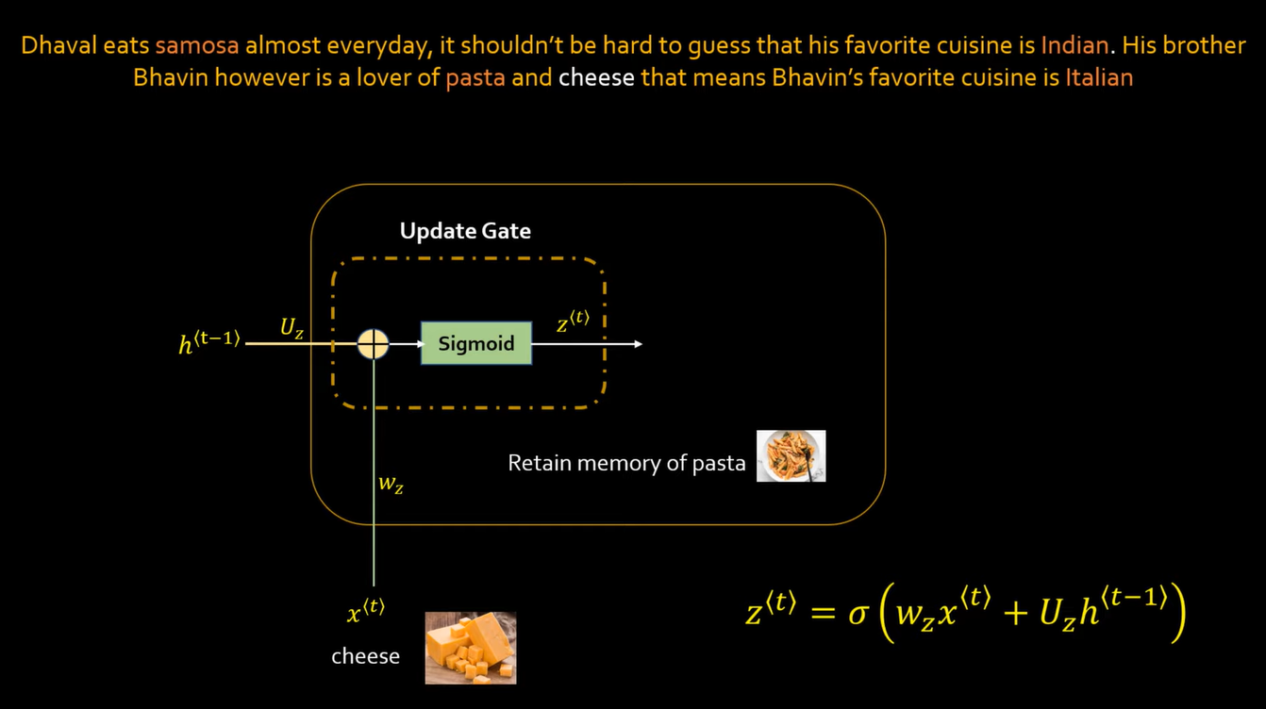

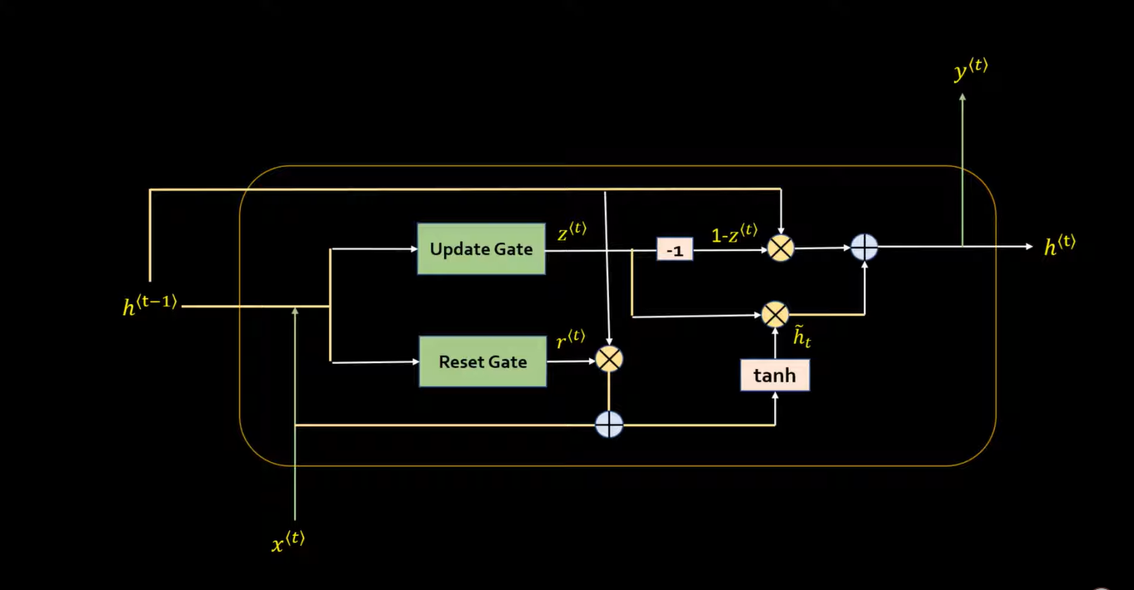

Working of reset 🡪 forget samosa and put pasta in short term memory.  
Working of update 🡪 do not forget pasta but update cheese with pasta

ht’ = tanh(( w * xt + b ) + (( w * ht-1 + b ) * rt ))) * zt  
ht’’ = (1-zt) * (ht-1)   
ht = ht’ + ht’’  
if zt = 1 then it means we are not performing update.

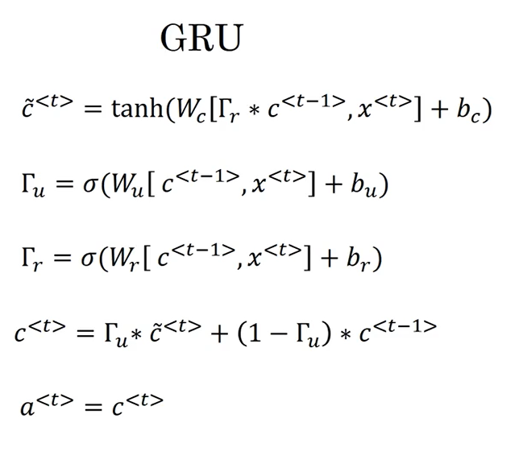

**Conclusion**

LSTM is more accurate but requires more computations as it has more gates than the GRU however, GRU is simpler, and requires less computations because it only has two gates.

**Bidirectional Recurrent Neural Network**

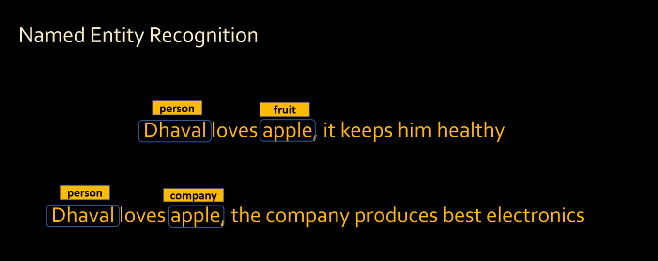

Suppose if we want to classify word (Named Entity Recognition) then for proper and accurate classification, we need information of future words/data in our sentence. The example given below shows that apple is a fruit as well as a company and its classification we need knowledge of the remaining sentence as well because we can not classify apply but just reading half context of the sentence as apple can be a fruit or it can also be a company.

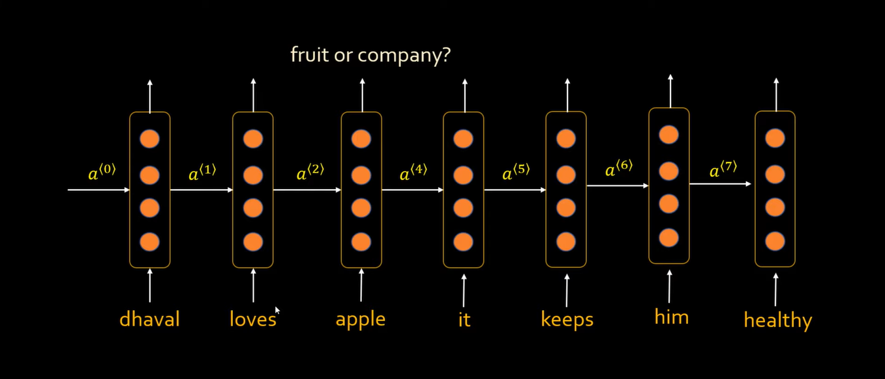

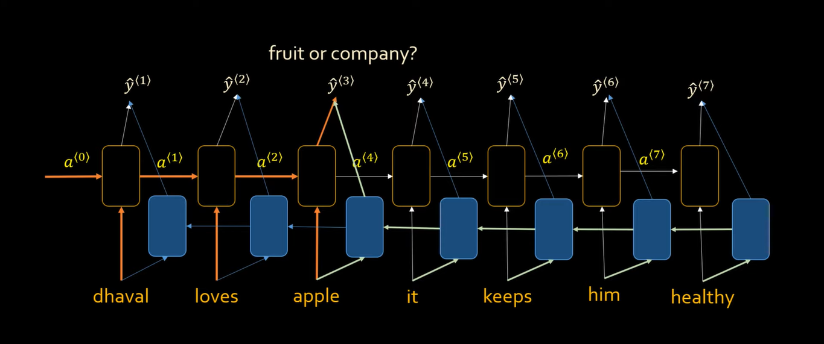

For such problems, we use bidirectional RNN and use the same recurrent neural network from opposite direction so that we can have knowledge of the future words in a sentence.

**Attention Models**

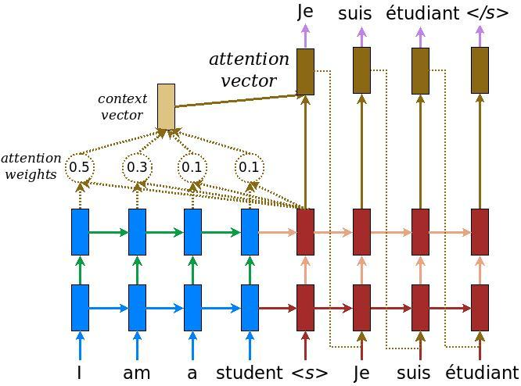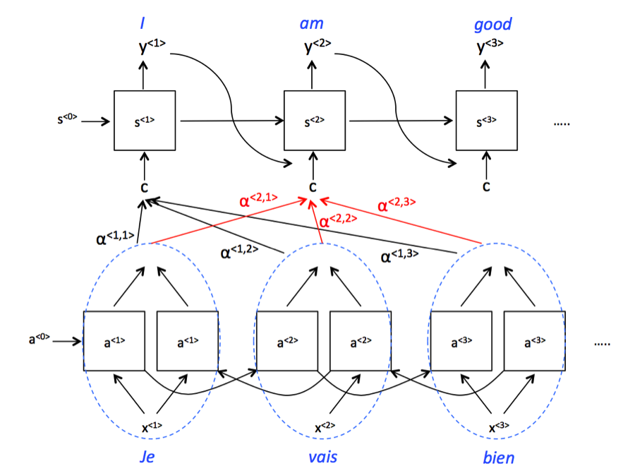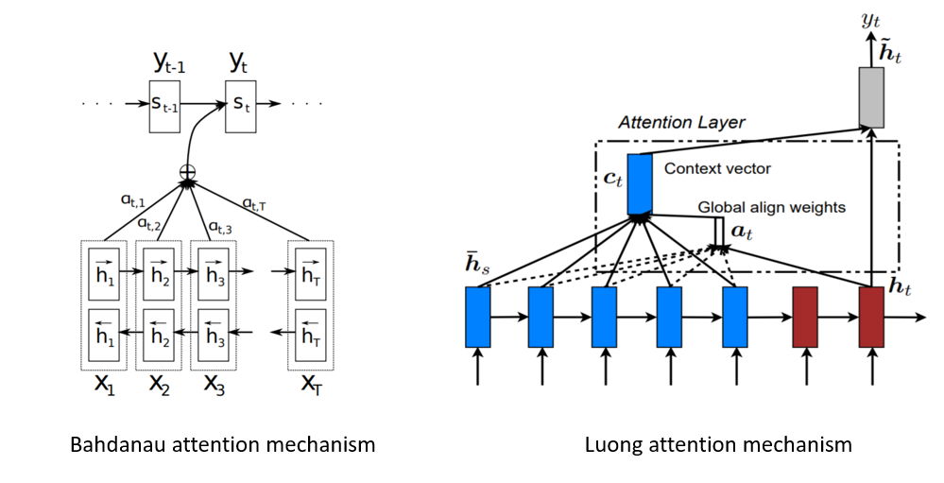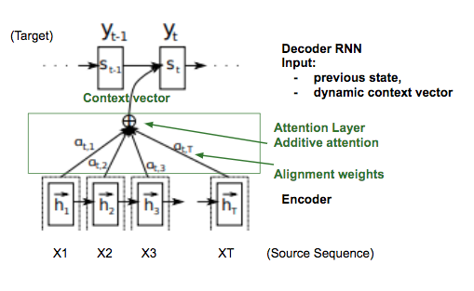

**Auto-Encoders and Decoders**

If you’re unfamiliar with encoder networks, but familiar with Convolutional Neural Networks (CNNs), chances are, you already know what an encoder does.  
  
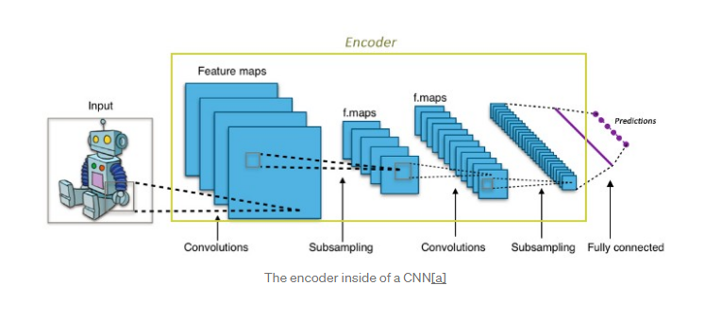

The encoder-decoder model is a way of using recurrent neural networks for sequence-to-sequence prediction problems.  
  
It was initially developed for machine translation problems, although it has proven successful at related sequence-to-sequence prediction problems such as text summarization and question  
answering.  
  
The approach involves two recurrent neural networks, one to encode the input sequence, called the encoder, and a second to decode the encoded input sequence into the target sequence called the decoder.  
  
Following is some of the application of sequence-to-sequence models

* Chatbots
* Machine Translation
* Text summary
* Image captioning

It consists of 3 parts: ***encoder, intermediate vector and decoder.***

***Encoder-***It accepts a single element of the input sequence at each time step, process it, collects information for that element and propagates it forward.

***Intermediate or latent vector***- This is the final internal state produced from the encoder part of the model. It contains information about the entire input sequence to help the decoder make accurate predictions.

***Decoder-*** given the entire sentence, it predicts an output at each time step.

Understanding the Encoder part of the model-

* The encoder is basically LSTM/GRU cell.
* An encoder takes the input sequence and encapsulates the information as the internal state vectors.
* Outputs of the encoder are rejected and only internal states are used.

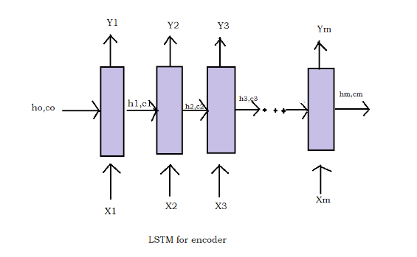

LSTM takes only one element at a time, so if the input sequence is of length m, then LSTM takes m time steps to read the entire sequence.

* Xt is the input at time step t.
* ht and ct are internal states at time step t of the LSTM and for GRU there is only one internal state ht.
* Yt is the output at time step t.

Let’s consider an example of English to Hindi translation-

***Inputs of Encoder Xt-***

Consider the English sentence- India is beautiful country. This sequence can be thought of as a sentence containing 4 words (India, is, beautiful, country). So here

X1 =’India’

X2=’is’

X3= ‘beautiful’

X4=’country’.

Therefore, LSTM will read this sequence word by word in 4-time step as follows-

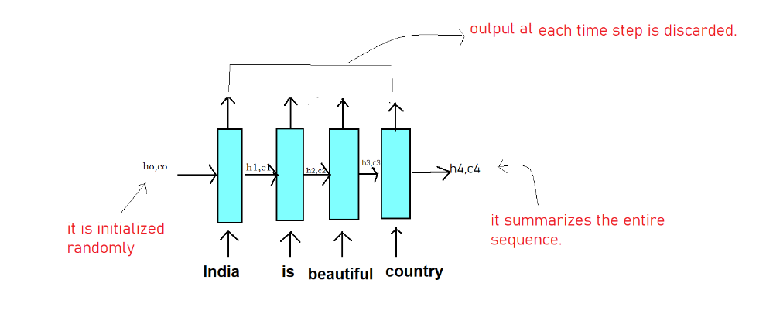

Here each Xt (each word) is represented as a vector using the word embedding, which converts each word into a vector of fixed length.

**Now coming to internal states (ht, ct) -**

* It learns what the LSTM has read until time step t. For e.g when t=2, it remembers that LSTM has read ‘India is ‘.
* The initial states ho, co (both are vectors) is initialized randomly or with zeroes.
* Remember the dimension of ho, co is same as the number of units in LSTM cell.
* The final state h4,c4 contains the crux of the entire input sequence India is beautiful country.

**The output of encoder Yt-**

Yt at each time steps is the predictions of the LSTM at each time step. In machine translation problems, we generate the outputs when we have read the entire input sequence. So Yt at each time step in the encoder is of no use so we discard it.

So summarizing the encoder part of the model-

The encoder will read the English sentence word by word and store the final internal states (known as an intermediate vector) of the LSTM generated after the last time step and since the output will be generated once the entire sequence is read, therefore outputs (Yt) of the Encoder at each time step are discarded.

# Understanding the Decoder part of the model in the Training Phase-

The working of the decoder is different during the training and testing phase unlike the encoder part of the model which works in the same fashion in training and test phase.

Let’s understand the working of the decoder part during training phase-

Taking the running example of translating **India is beautiful country** to its Hindi counterpart, just like encoder, the decoder also generates the output sentence word by word.

So we want to generate the output — **भारत खूबसूरत देश है**

For the decoder to recognize the starting and end of the sequence, we will add START_ at the beginning of the output sequence and _END at the end of the output sequence.

So our Output sentence will be **START_भारत खूबसूरत देश है _END**

Let’s understand the working visually-

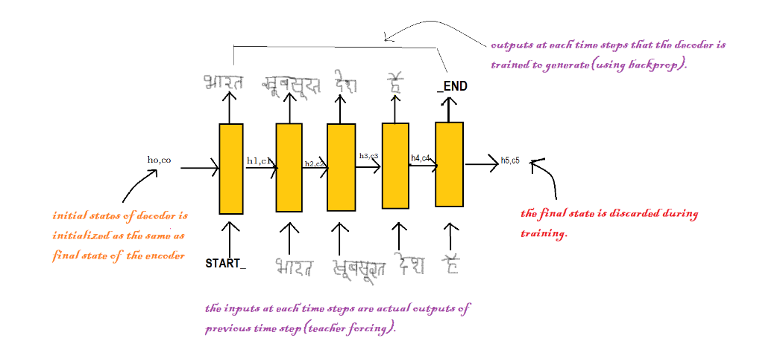

* The initial states (ho, co) of the decoder is set to the final states of the encoder. It can be thought of as that the decoder is trained to generate the output based on the information gathered by the encoder.
* Firstly, we input the START_ so that the decoder starts generating the next word. And after the last word in the Hindi sentence, we make the decoder learn to predict the _END.
* Here we use the teacher forcing technique where the input at each time step is actual output and not the predicted output from the last time step.
* At last, the loss is calculated on the predicted outputs from each time step and the errors are backpropagated through time to update the parameters of the model.
* The final states of the decoder are discarded as we got the output hence it is of no use.

Summarizing the encoder-decoder visually-

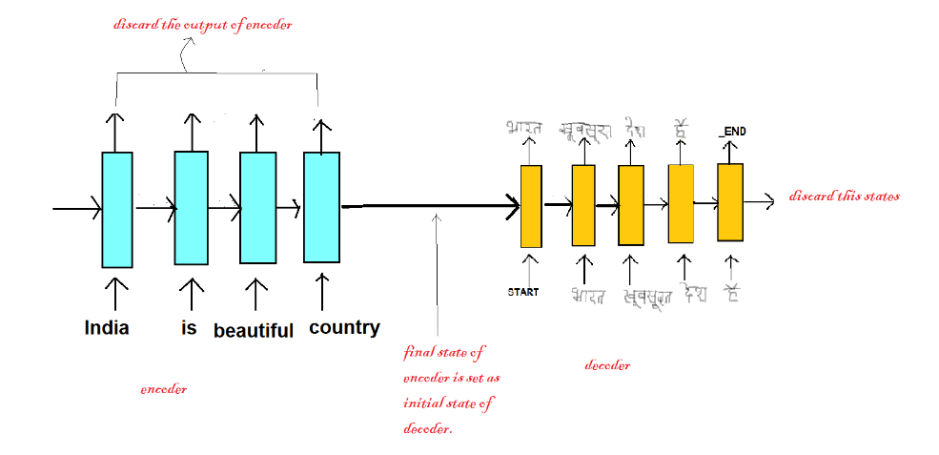

# Understanding the Decoder part of the model in Test Phase-

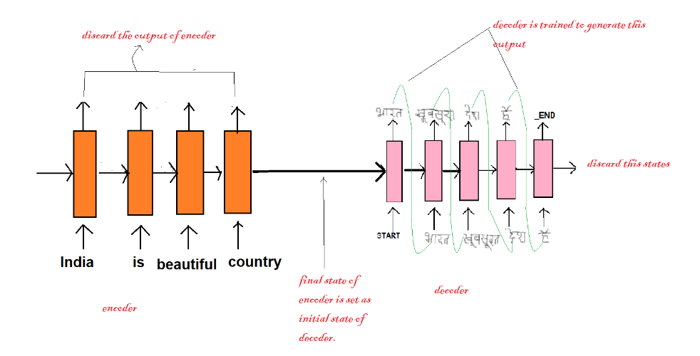

Process of the Decoder in the test period-

* The initial states of the decoder are set to the final states of the encoder.
* LSTM in the decoder process single word at every time step.
* Input to the decoder always starts with the START_.
* The internal states generated after every time step is fed as the initial states of the next time step. for e.g At t=1, the internal states produced after inputting START_ is fed as the initial states at t=2.
* The output produced at each time step is fed as input in the next time step.
* We get to know about the end of the sequence when the decoder predicts the END_.

**The problem of Language Modeling:**

Given the ‘**t — 1**’ words, we try to predict the**t’th** word for example: let’s say we are given the input as ‘**I am going to**’ now based on this input the model might predict the next word as the ‘**the**’ and then the input would be ‘**I am going to the**’ and this time the model might suggest the word as ‘**office**’.

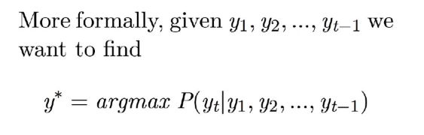

Given the input **y1, y2, ….., y(t-1)**; what is the most likely word at the **t’th** output/time step, we compute the probability(using Softmax) of all the possible words and the one with the maximum value of probability is returned, argmax means return that word which has the maximum probability.

So, lets model this using RNN.

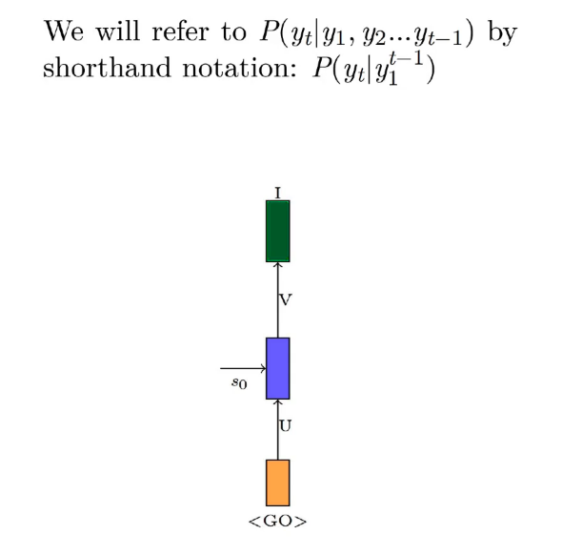

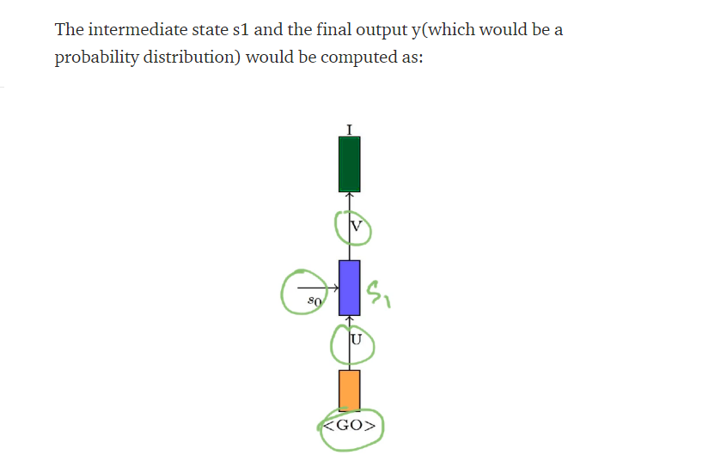

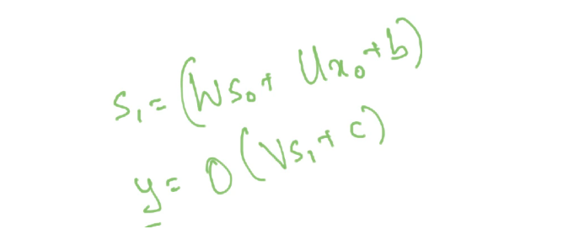

We already discussed in the article of RNNs about how we encode the input xo, as the input is going to be a sequence of words/characters, we encode the words/characters and then generate one hot vector all the words/characters in the input.

Let’s say the model gives the **output as ‘I’ for the first input**; now this word ‘**I**’ would act as the **input at the 2nd time step** and in a way the model’s output at any time step itself is serving as the input at the next time step so that’s the reason we use **y1, y2, ……, y(t-1)** in the equation of **y\***

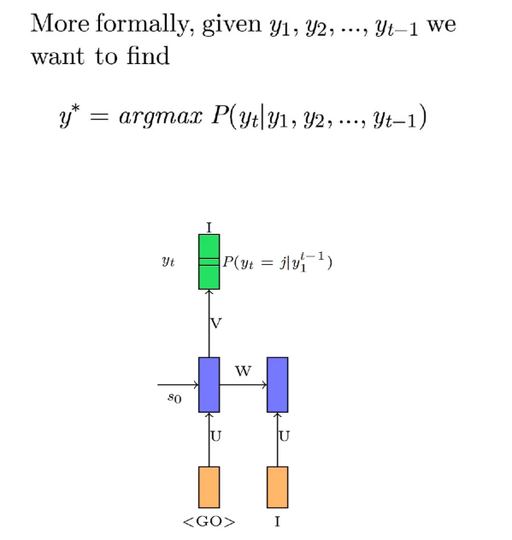

Output at the first time step is ‘**I**’ and is denoted by **y1**, now the input at the next time step is also ‘**I**’ but this time we denote it is as **x2**and the reason is that **x2**represents the output **y1**in one hot encoded form.

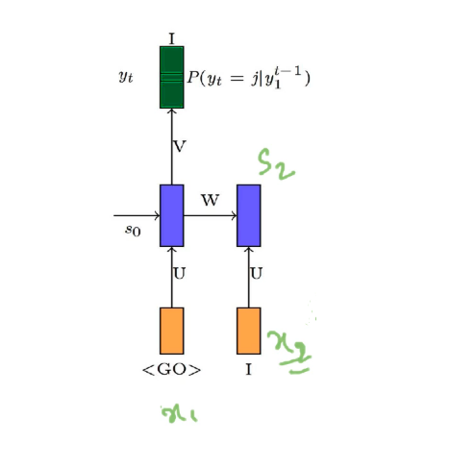

Now we compute the **s2**using the same formula as:

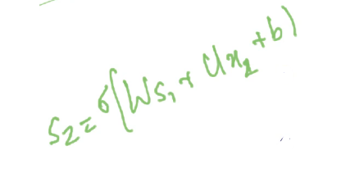

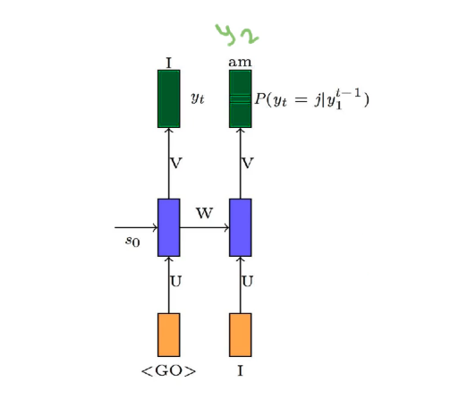

We compute y2 as:

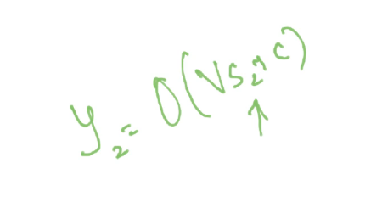

And this process continues like this

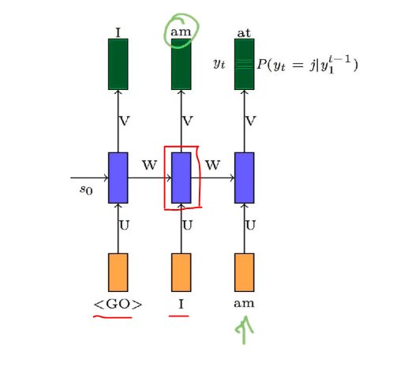

We pass on the **output at the 2nd time step** as the **input at 3rd time step** and the previous input(first two input) are captured in the hidden state **s2**(red box in the above image). And using this previous state as well as the current input, we compute the current state and from that, we compute the output. Hence, we can say that the output depends upon all the previous inputs(captured in the state vector) as well as the current input.

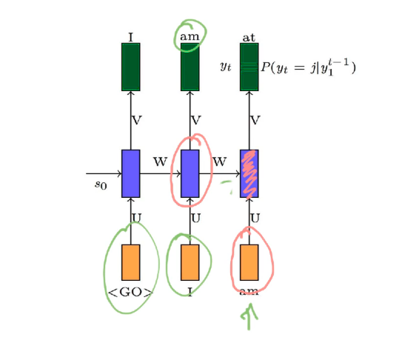

And this story continues all the way till the end

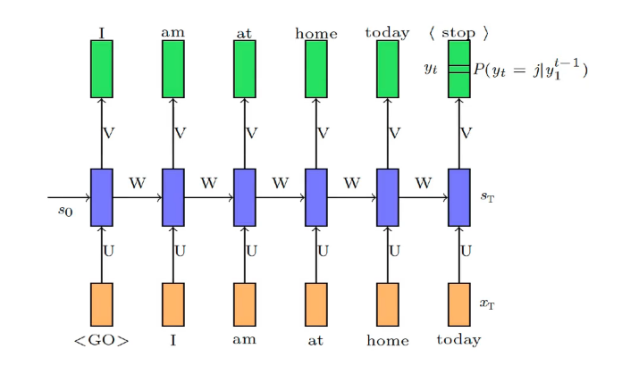

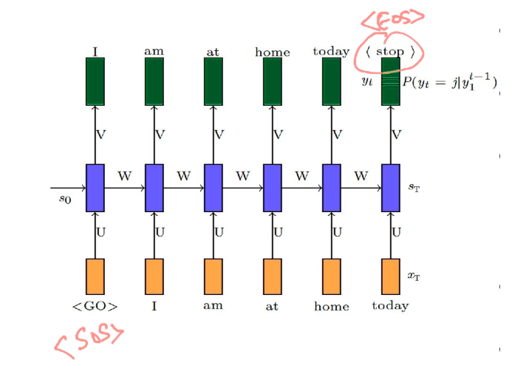

So, whenever it predicts <stop>(or <eos>), we know that now we don’t need to predict anything and give the entire sentence generated till now from y1 to yt(output at the final time step) as the final output.

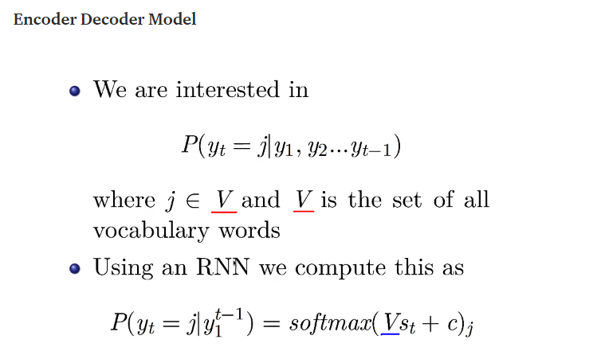

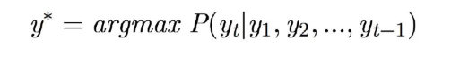

We want to compute the output as per the probability equation in the above image and as per that formula, we consider all the inputs from **y1, y2, …. all the way up to y(t-1)** but on the right-hand side of the same equation we are given this probability as dependent on **st**and some parameters. So, **st**has all the information of all the inputs till now i.e **y1, y2, ……, y(t-1)**. So, the model has encoded all this information into the hidden state vector **st**. So, RNN acts as the encoder here, it gives us the blue vector **st**which is an encoding of all the inputs seen so far including the current input. And now once everything has been encoded into this blue vector **st**, we give it to the output layer which tries to decode the answer (next word in this case) from the input/encoded value and it does so mathematically using the probability distribution.

So, our **RNN**is the **encoder**and the **simple feed-forward**(we pass **st**to sigmoid after multiplying it with the parameters **V**and adding bias **b**to it) **network is the decoder**.

Since **st**has encoded all the input information **y1, y2, ……., y(t-1)**, we can write

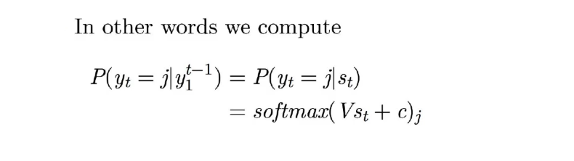

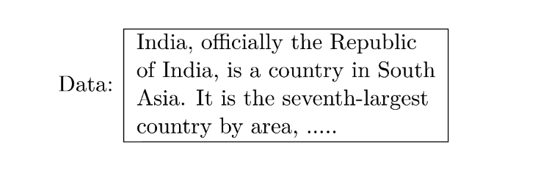

Let’s say we pass the **first word** ‘**India**’ to our model, the true distribution **y1**would have all the mass on the word ‘**officially’**and since this is the very first step so the parameters would not have the correct configuration so let’s assume that it gives us some distribution **y1_hat**.

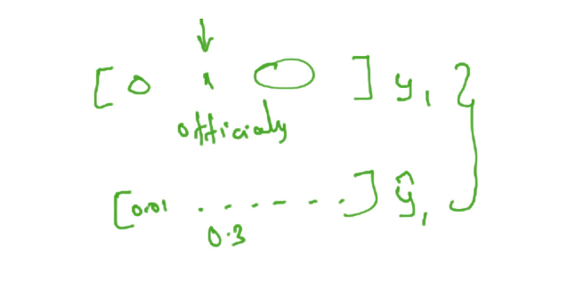

Now our job is to define a loss function between **y1**and **y1_hat**so that we can get a loss and the loss can be backpropagated and the parameters **W**, **U**, **V**get updated.

Now at the next time step, we feed in the input ‘**officially**’, the true distribution would have the entire probability mass (meaning value **1 for the true output** and 0 for all other words in the distribution) on the ‘**the**’ word and from our model, again we get a predicted distribution from our model as **y2_hat**, we compute the loss and backpropagate through the model.

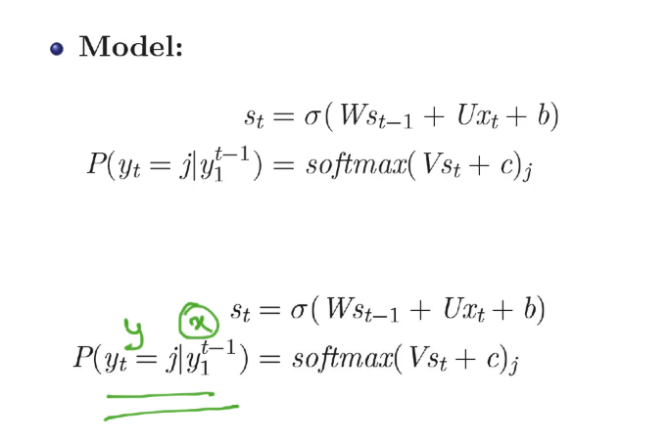

So, given some words we want to predict the next word so that’s the relation we are interested in, we want **y**as a function of **x**and instead of **x**which is from **y1, y2, … to y(t-1)**, we encode all of that information in **st**; **st** in turn depends on **xt**(first equation in the above image)hence we can have **st**as the substitute for all the previous inputs. So, we have only these 2 equations in the model, at every time step we compute the hidden state representation and from that, we compute the probability distribution **y** and then we compute the loss and the loss would be the sum of the cross-entropy loss at every time step.

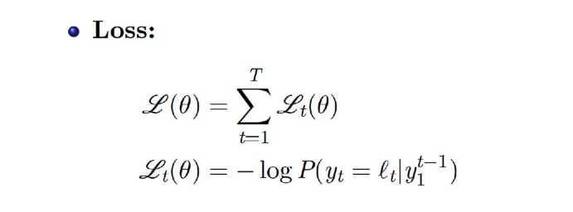

There would be say some ‘T’ time steps, at every time step we would have some loss value.

At the first time step, the model should predict **India**(first word in the training data taken in this case), so whatever is the loss at not predicting **India,**in a way we want to maximize the probability of the output as **‘India’(true class)**given the **<GO>(**represents start of sequence) because **y1, y2, ….., y(t-1)**is just **<GO>**in this case, through loss function. At the next time step, we want to maximize the probability of **y2**as the word ‘**officially**’ given the input as ‘**India**’ and we represent this input ‘**India**’ through encoded vector represented by the **state**. So, at every time step we have a classification problem and the loss function for a classification problem is the Cross-Entropy Loss(also called as Negative Log-Likelihood)(we take the log of the probability of the correct word at that time step as predicted by the model) and we sum this loss over all time steps and that becomes the overall loss function.

And once we have the Loss, we are going to use the Gradient Descent **Algorithm**with Backpropagation through time(as discussed in the case of RNN).

Applications:

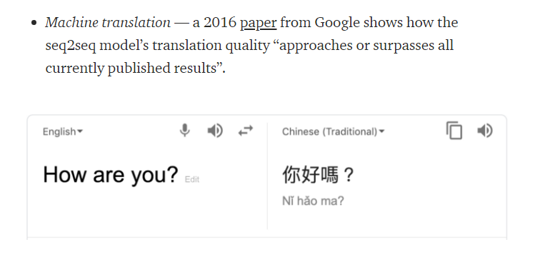

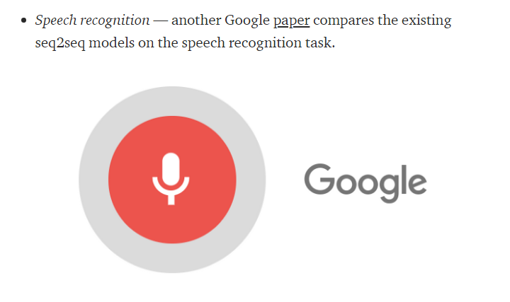

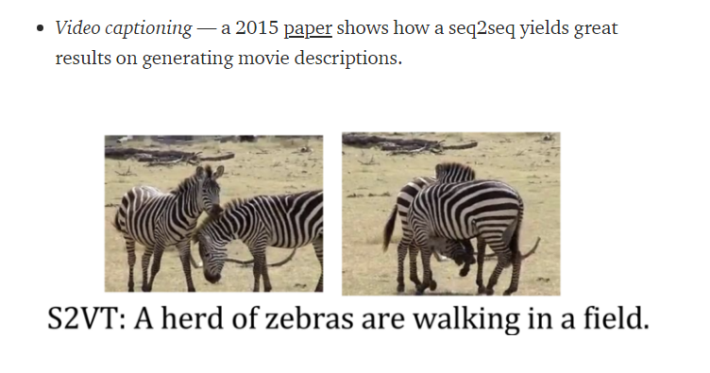

* Data compression

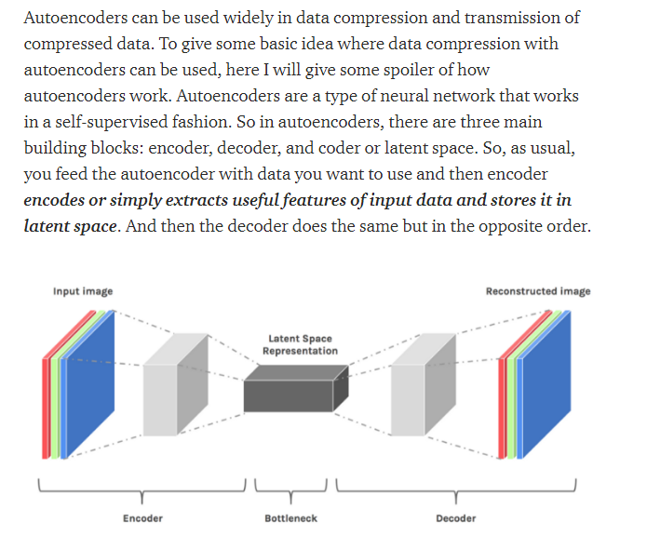

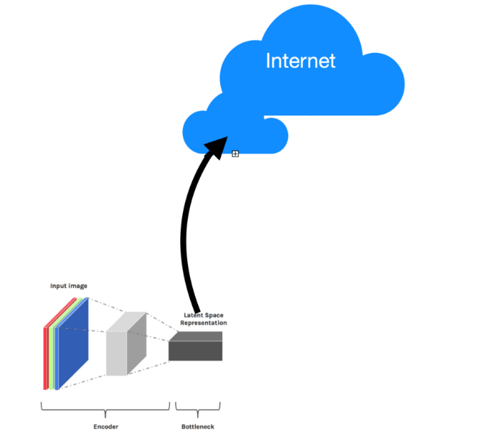

And then, in the same manner, you download the Latent Space Representation to your mobile device and then you decode your Latent Space Representation to get output result(for example image, video, audio files) even with better resolution/quality than it was in input:

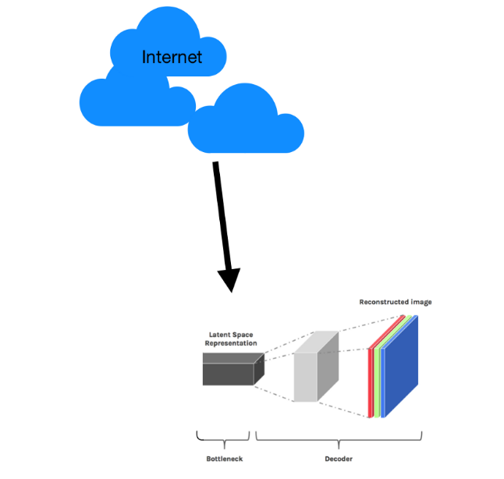

* Denoising Data

Quality loss of data (images/audio/video) is one main problem/issue in data transmission. Due to connection status or bandwidth, data such as image and audio can lose in quality, therefore the problem of denoising data arises. Denoising data is one of the cool advantages of autoencoders,

Ideally, we would like to have our autoencoder is sensitive to reconstruct our latent space representation and insensitive enough to generalize the encoding of input data. One of the ways of such a method is to corrupt the input data, adding random noise to input data and then encode that corrupted data.

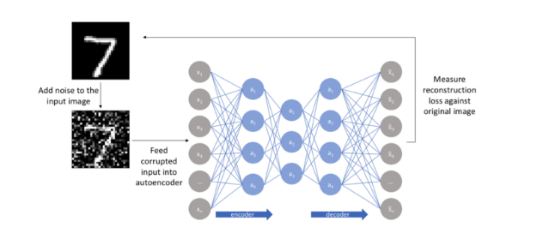

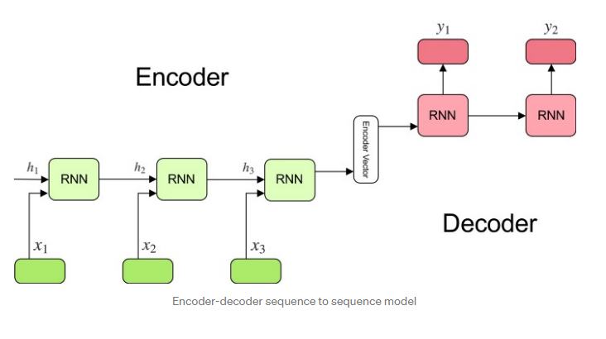

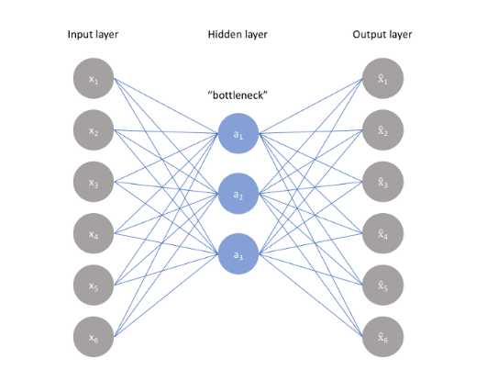

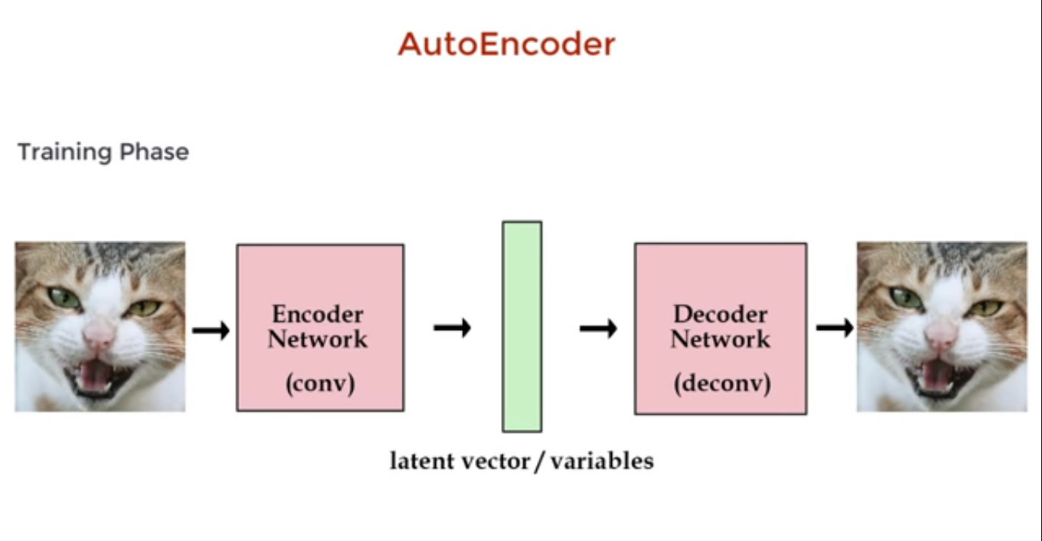  
  
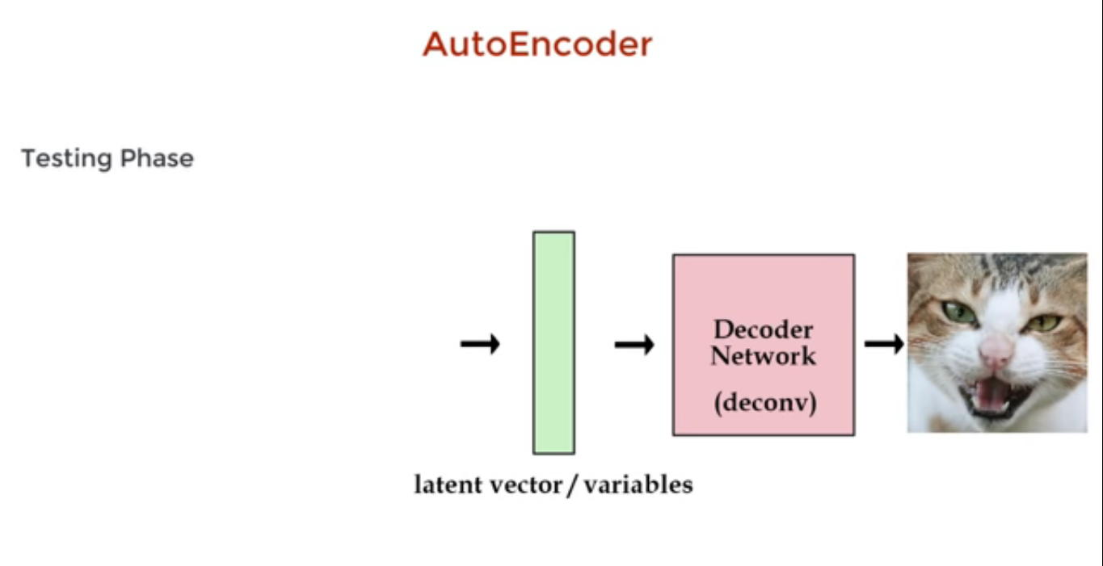  
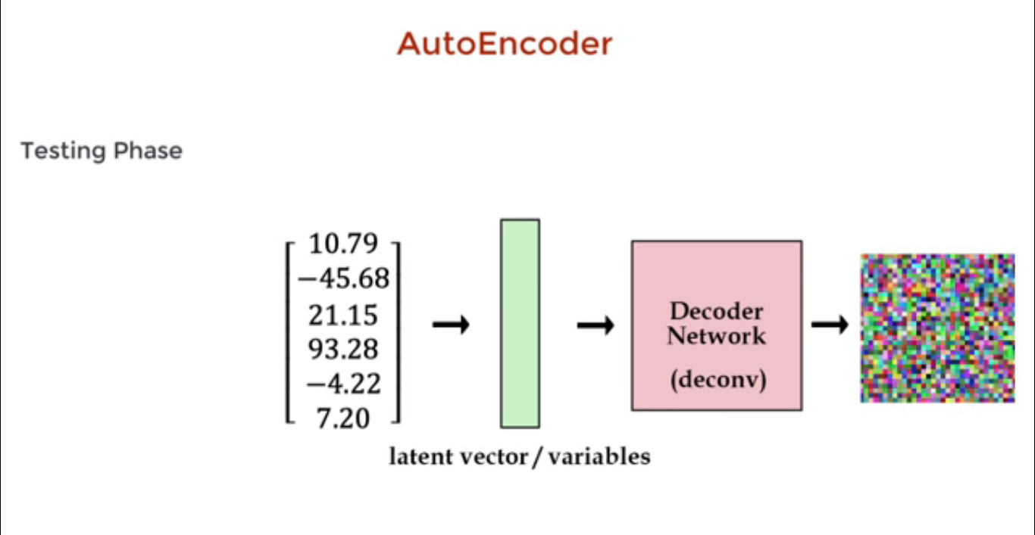  
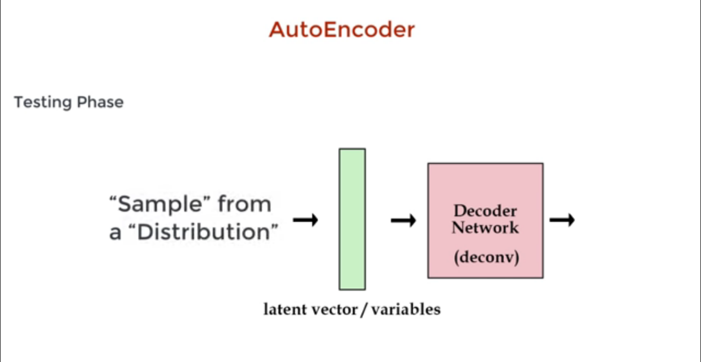

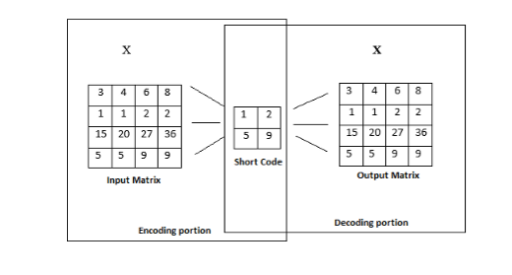

The simple vanilla autoencoder is used to generate the same input back. There are other types of autoencoders also that are used for different purposes for e.g., an autoencoder for denoising of data. Simple vanilla autoencoder can be seen from image below,  
  
 image below,  
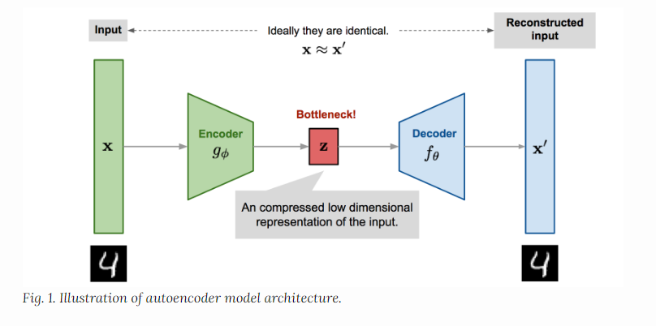

Types of Auto-encoders

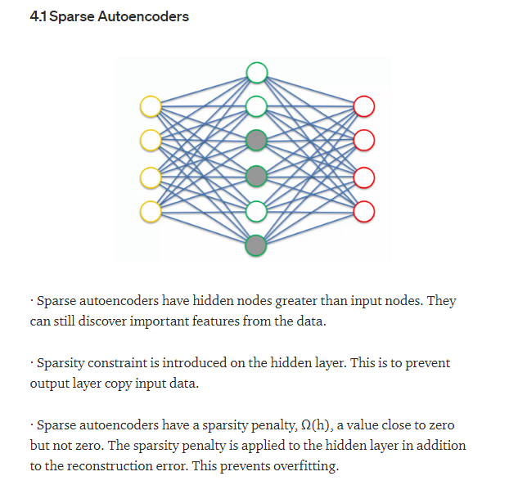  
  
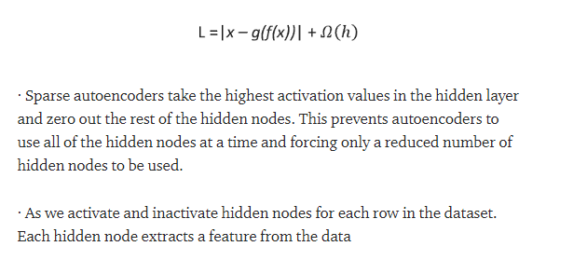  
  
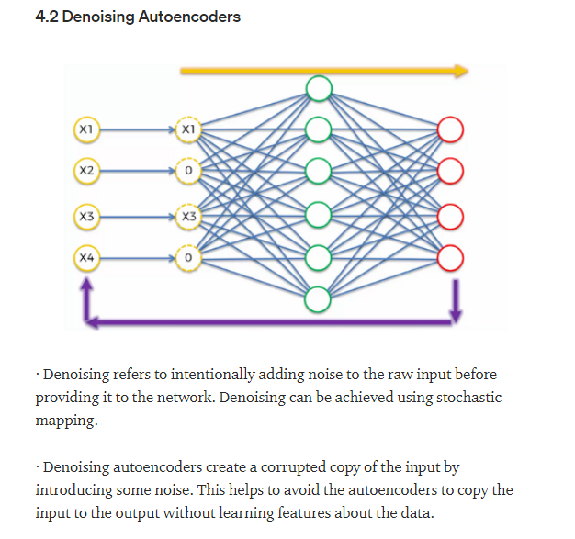  
  
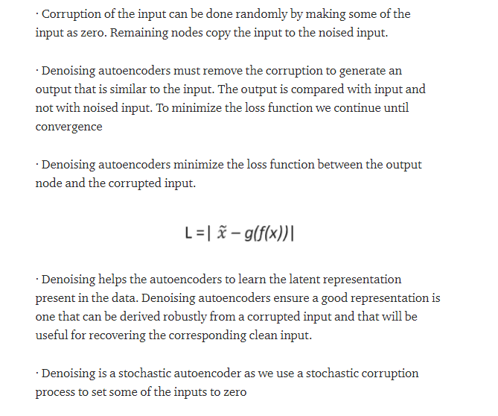  
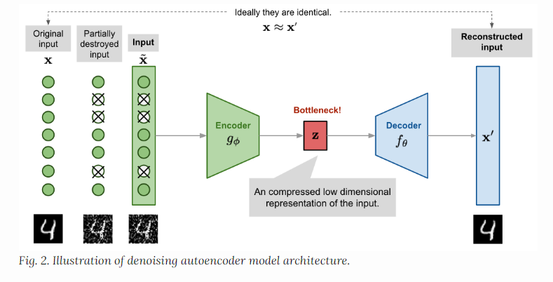  
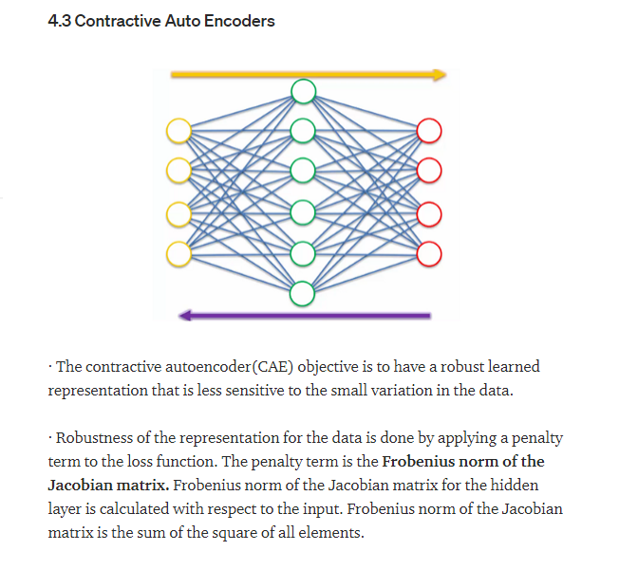  
  
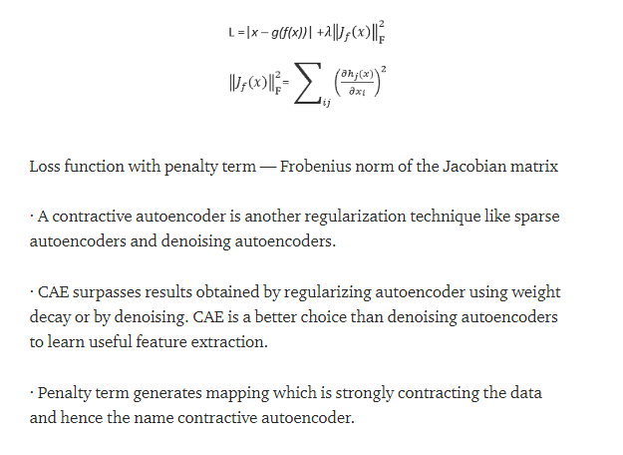  
  
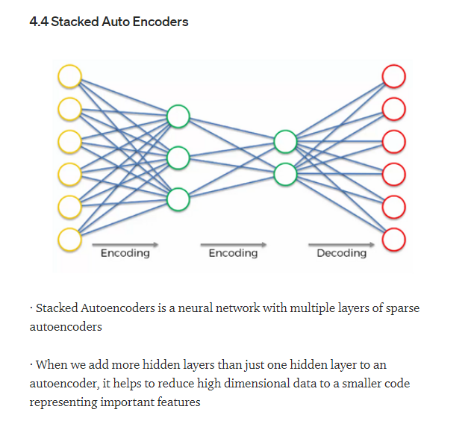  
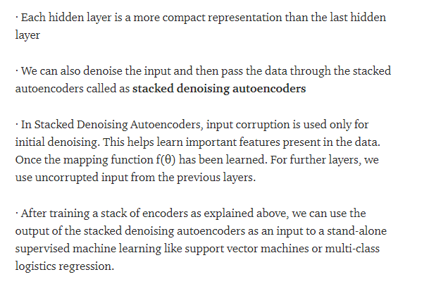  
  
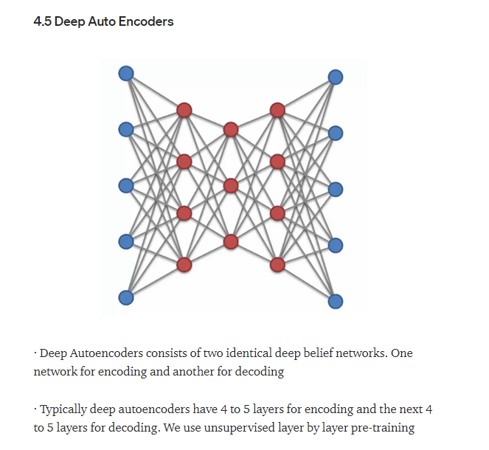  
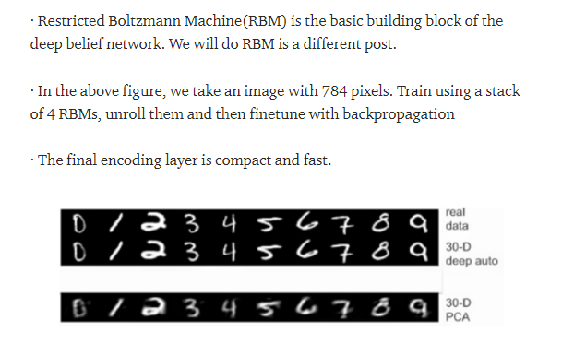  
  
Autoencoder types are discussed here,   
<https://lilianweng.github.io/lil-log/2018/08/12/from-autoencoder-to-beta-vae.html>

References:

<https://medium.com/analytics-vidhya/machine-translation-encoder-decoder-model-7e4867377161>  
<https://prvnk10.medium.com/encoder-decoder-models-fa0f155cf042>  
<https://towardsdatascience.com/understanding-encoder-decoder-sequence-to-sequence-model-679e04af4346>  
<https://medium.com/ai%C2%B3-theory-practice-business/understanding-autoencoders-part-i-116ed2272d35>  
<https://medium.com/machine-learning-researcher/auto-encoder-d942a29c9807>

Variational Autoencoder (VAE)  
  
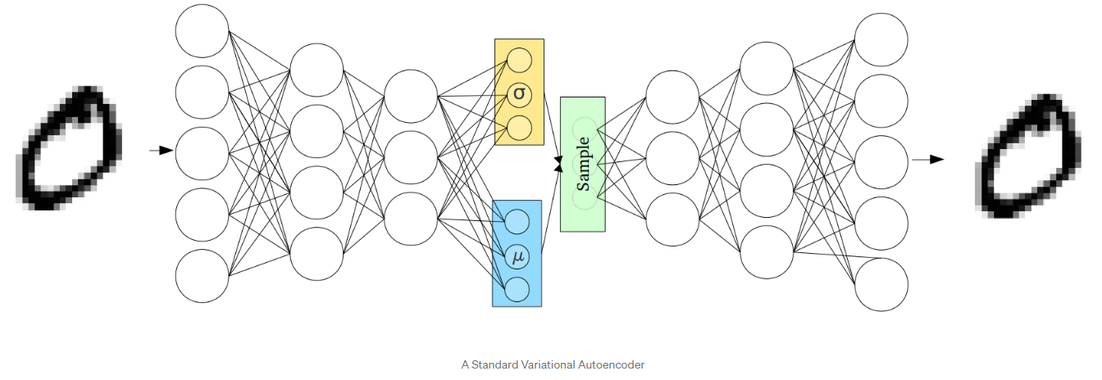

In contrast to the more standard uses of neural networks as regressors or classifiers, Variational Autoencoders (VAEs) are powerful **generative** models, now having applications as diverse as from generating fake human faces, to producing purely synthetic music.

When using generative models, you could simply want to generate a random, new output, that looks similar to the training data, and you can certainly do that too with VAEs. But more often, you’d like to alter, or explore variations on data you already have, and not just in a random way either, but in a desired, specific direction. This is where VAEs work better than any other method currently available.

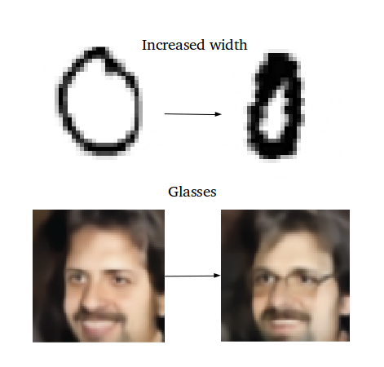

Problems with vanilla autoencoders  
  
Standard autoencoders learn to generate compact representations and reconstruct their inputs well, but asides from a few applications like denoising autoencoders, they are fairly limited.  
  
The fundamental problem with autoencoders, for generation, is that the latent space they convert their inputs to and where their encoded vectors lie, may not be continuous, or allow easy interpolation.  
  
For example, training an autoencoder on the MNIST dataset, and visualizing the encodings from a 2D latent space reveals the formation of distinct clusters. This makes sense, as distinct encodings for each image type makes it far easier for the decoder to decode them. This is fine if you’re just replicating the same images.  
  
But when you’re building a generative model, you **don’t** want to prepare to replicate the same image you put in. You want to randomly sample from the latent space, or generate variations on an input image, from a continuous latent space.  
  
If the space has discontinuities (e.g., gaps between clusters) and you sample/generate a variation from there, the decoder will simply generate an unrealistic output, because the decoder has no idea how to deal with that region of the latent space. During training, it never saw encoded vectors coming from that region of latent space.

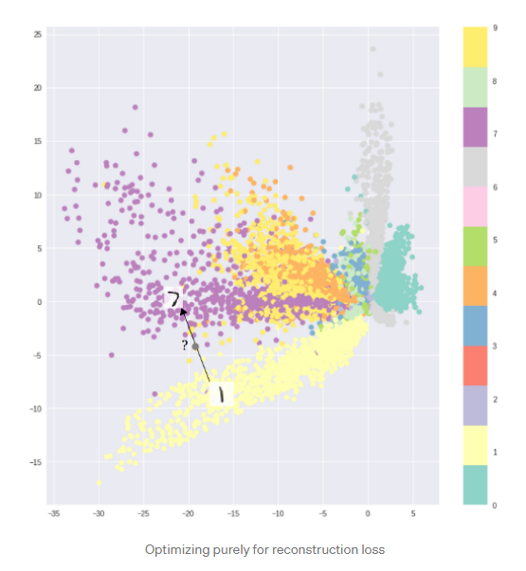

What are Variational Autoencoders (VAEs)?  
  
Variational Autoencoders (VAEs) have one fundamentally unique property that separates them from vanilla autoencoders, and it is this property that makes them so useful for generative modeling: their latent spaces are, by design, **continuous** (there is no gap in between clusters of different distributions), allowing easy random sampling and interpolation.  
  
It achieves this by doing something that seems rather surprising at first: making its encoder not output an **encoding vector** (a vector having important features fixed values of given input only and not a distribution of values. A distribution can be formed if we have means and standard deviations of all the features like smile, hair, eyes etc. Each value in mean and standard deviation vectors represent the mean of the distribution of each of these features) of size n, rather, outputting two vectors of size n: a vector of means**, μ**, and another vector of standard deviations, **σ**.  
  
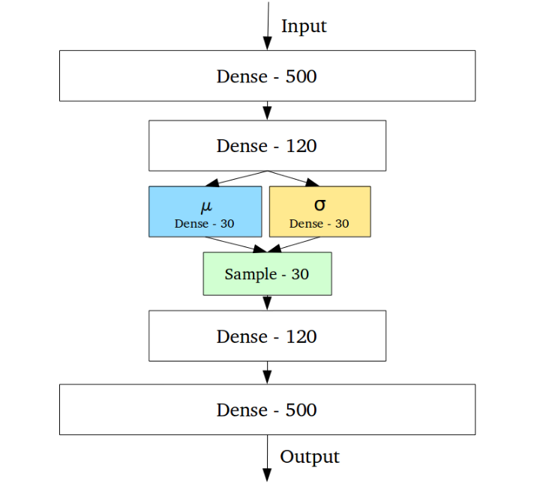  
Sampling data from latent space of Autoencoders (an encoding vector having discrete values of features in it) Verses sampling data from the latent space of the Variational Autoencoders (a probability distribution for each feature from the latent space). In vanilla autoencoders we only sample a fixed discrete value and not a distribution like we do in VAE that is why the encoders and decoders of VAE are called probabilistic encoders and decoders.  
  
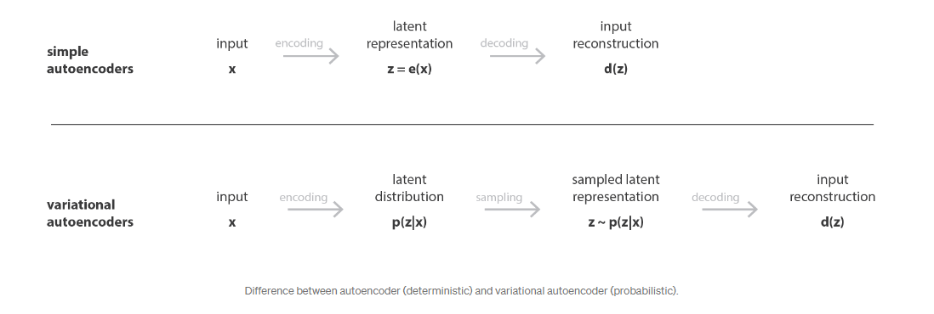  
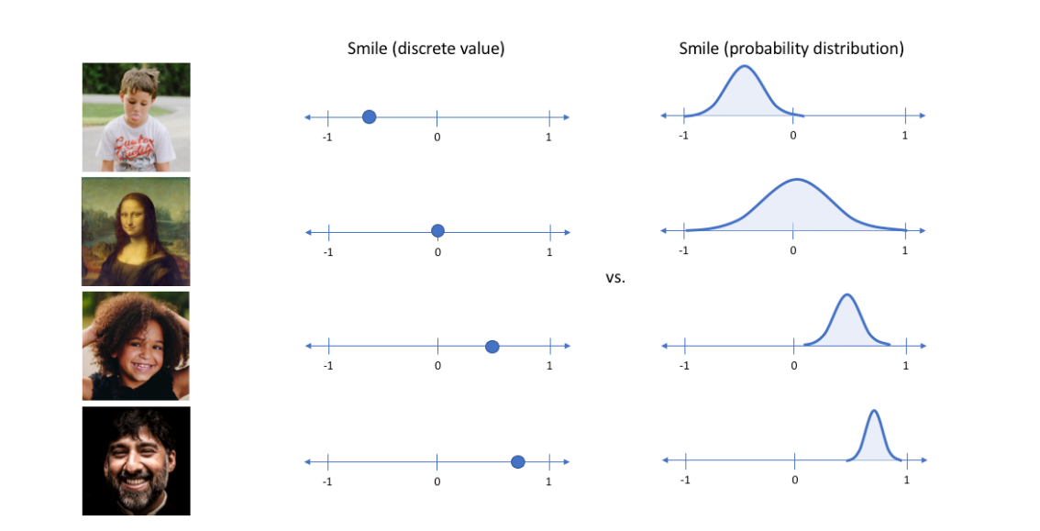  
  
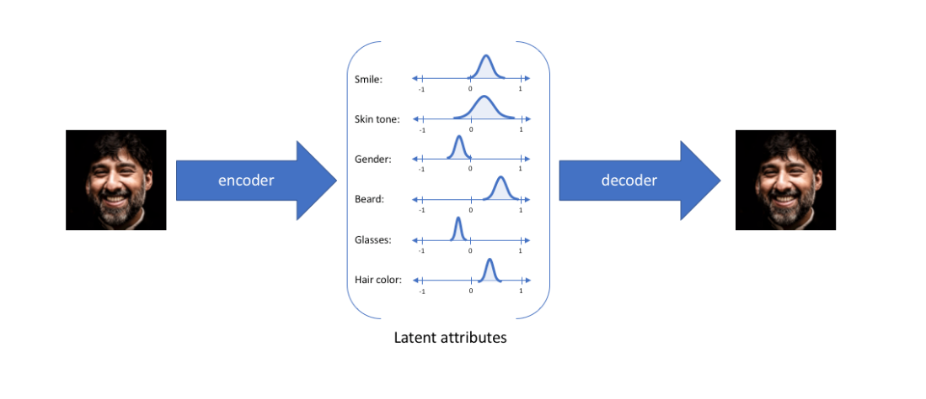  
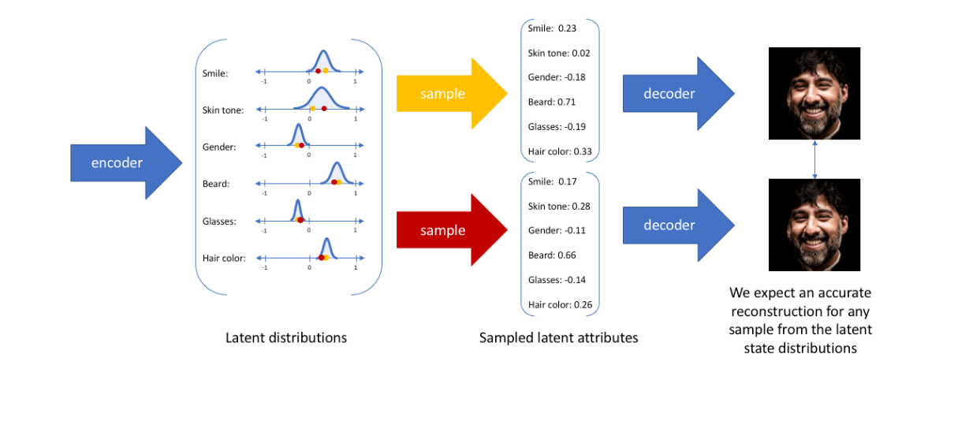  
Here we got an image that looks 99% same because the points from the distribution were very close to each other if we want to generate new data, we should pick points far from each other from the distribution.

To make a VAE a generative model, we do sampling (picking data randomly from the mean and standard deviation vectors and then forms or initializes a distribution)

They form the parameters of a vector of random variables of length n, with the i th element of **μ** and **σ**being the mean and standard deviation of the i th random variable, **X**i, from which we sample, to obtain the sampled encoding which we pass onward to the decoder:

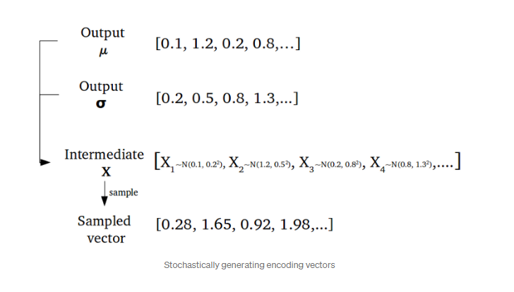

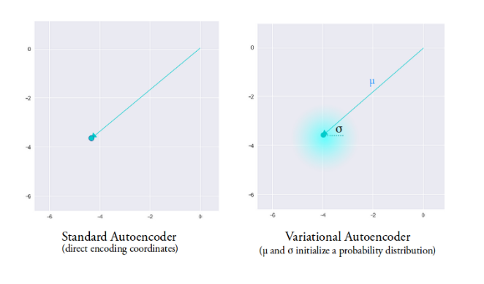  
Intuitively, the mean vector controls where the encoding of an input should be centered around, while the standard deviation controls the “area”, how much from the mean the encoding can vary. As encodings are generated at random from anywhere inside the “circle” (the distribution), the decoder learns that not only is a **single point in latent space referring to a sample of that class** (like we do in vanilla autoencoder), but all nearby points refer to the same as well. This allows the decoder to not just decode single, specific encodings in the latent space (leaving the decodable latent space discontinuous), but ones that slightly vary too, as the decoder is exposed to a range of variations of the encoding of the same input during training.  
  
  
  
The model is now exposed to a certain degree of local variation by varying the encoding of one sample, resulting in smooth latent spaces on a local scale, that is, for similar samples. Ideally, we want overlap between samples that are not very similar too, in order to interpolate between classes. However, since there are no limitson what valuesvectors **μ** and **σ** can take on, the encoder can learn to generate very different **μ** for different classes, clustering them apart, and minimize **σ**, making sure the encodings themselves don’t vary much for the same sample (that is, less uncertainty for the decoder). This allows the decoder to efficiently reconstruct the training data.

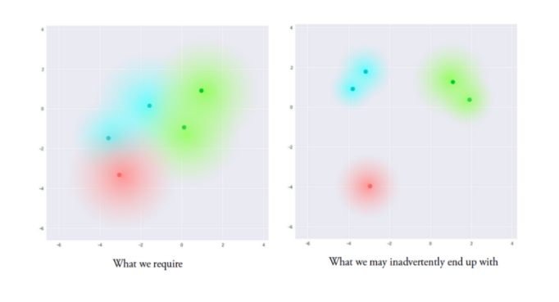  
  
What we ideally want are encodings, all of which are as **close as possible to each other** while still being distinct, allowing smooth interpolation, and enabling the construction of new samples.  
  
In order to force this, we introduce the Kullback–Leibler divergence (KL divergence) into the loss function. The KL divergence between two probability distributions simply measures how much they diverge *or far* from each other. Minimizing the KL divergence here means optimizing the probability distribution parameters **(μ** and **σ)**to **closely resemble** that of the target distribution.  
  
For VAEs, the KL loss is equivalent to the sum of all the KL divergences between the component Xi~N(μi, σi²) in **X**, and the standard normal. It’s minimized when μi = 0, σi = 1.  
  
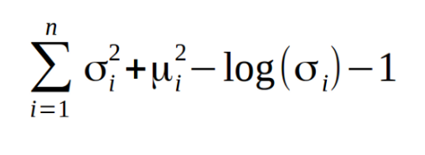  
  
Intuitively, this loss encourages the encoder to distribute all encodings (for all types of inputs, eg. all MNIST numbers), evenly around the center of the latent space. If it tries to “cheat” by clustering them apart into specific regions, away from the origin, it will be penalized.  
  
Now, using purely or only KL loss without reconstruction loss, it results a latent space having encodings densely placed randomly, near the center of the latent space, with little regard for similarity among nearby encodings. The decoder finds it impossible to decode anything meaningful from this space, simply because there really isn’t any meaning.

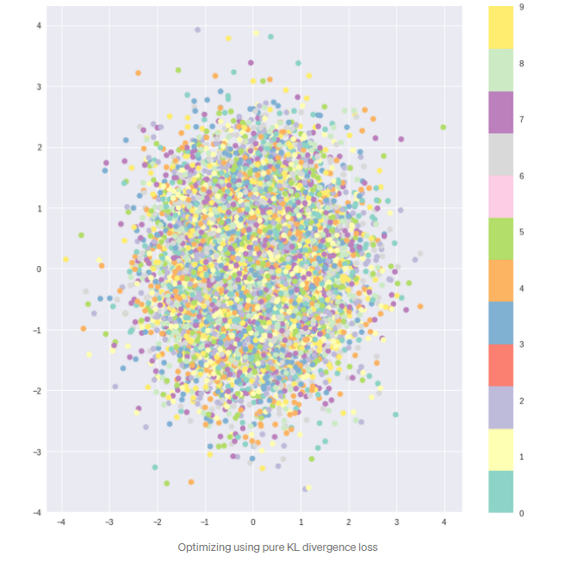  
  
  
  
  
  
  
  
  
Optimizing the two (reconstruction loss + Kl divergence loss) together, however, results in the generation of a latent space which maintains the similarity of nearby encodings on the local scale via clustering, yet globally, is very densely packed near the latent space origin (compare the axes with the original).  
  
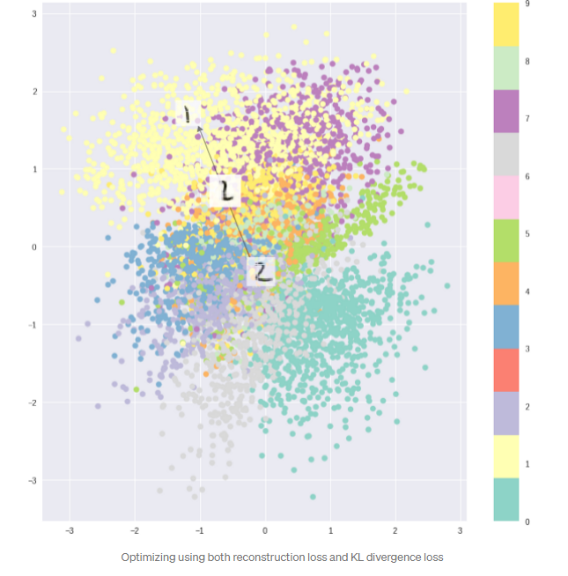  
Intuitively, this is the equilibrium reached by the cluster-forming nature of the reconstruction loss, and the dense packing nature of the KL loss, forming distinct clusters the decoder can decode. This is great, as it means when randomly generating, if you sample a vector from the same prior distribution of the encoded vectors, N(**0**, **I**), the decoder will successfully decode it. And if you’re interpolating, there are no sudden gaps between clusters, but a smooth mix of features a decoder can understand.  
  
  
  
  
  
Vectors Arithmetic  
  
So how do we actually produce these smooth interpolations we speak of? From here on out, it’s simple vector arithmetic in the latent space.  
  
For example, if you wish to generate a new sample halfway between two samples, just find the difference between their mean (**μ**) vectors, and add half the difference to the original, and then simply decode it.  
  
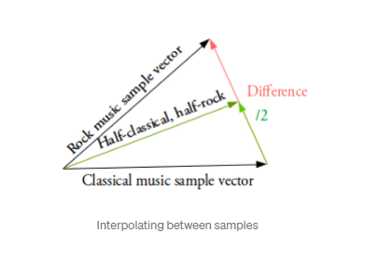  
  
What about generating specific features, such as generating glasses on a face? Find two samples, one with glasses, one without, obtain their encoded vectors from the encoder, and save the difference. Add this new “glasses” vector to any other face image, and decode it.  
  
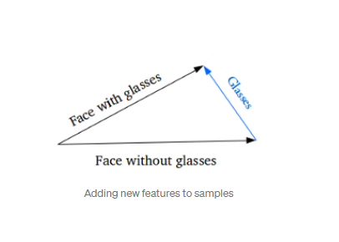  
  
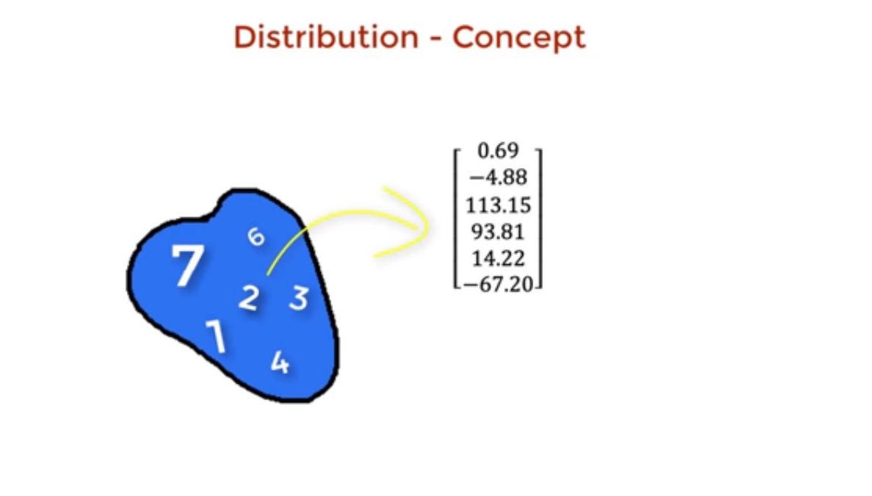  
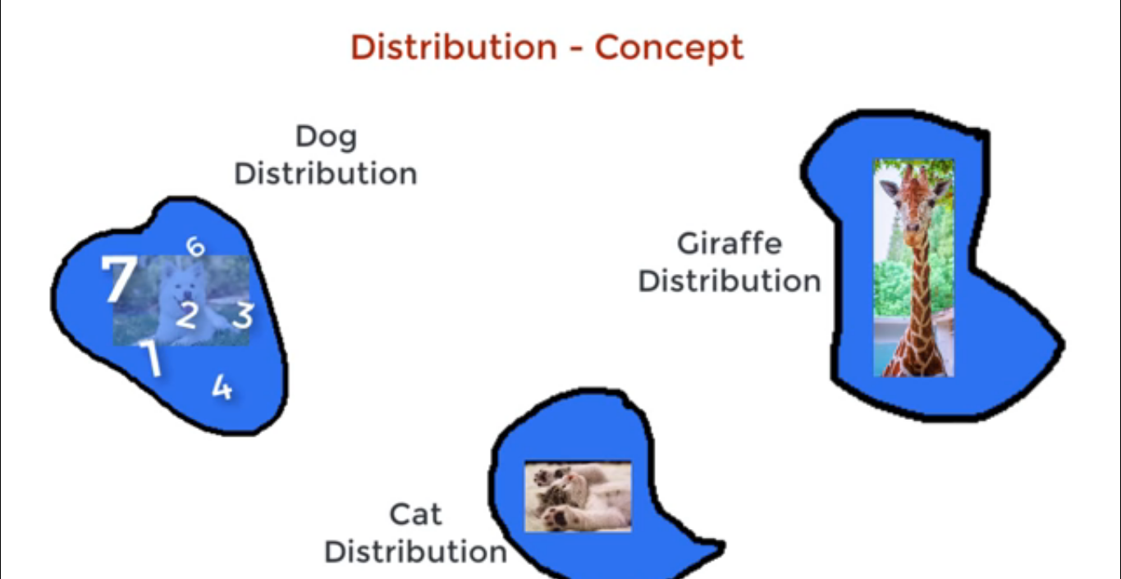  
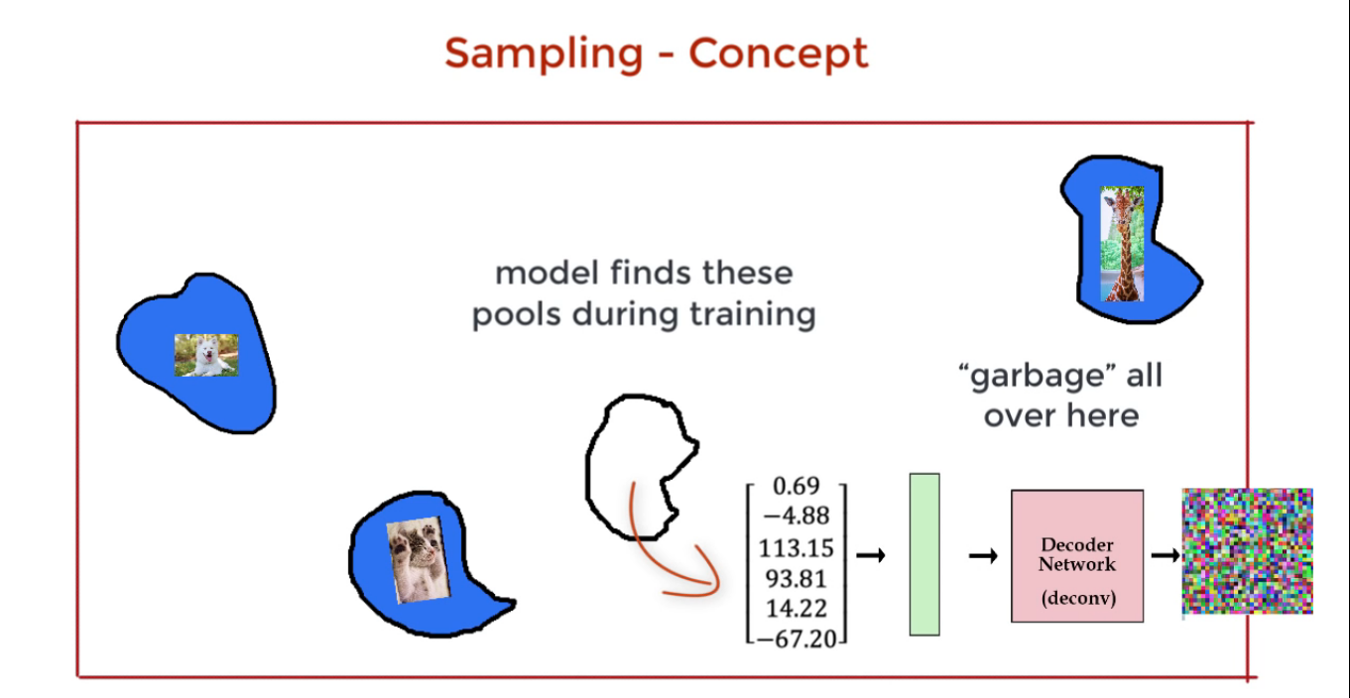  
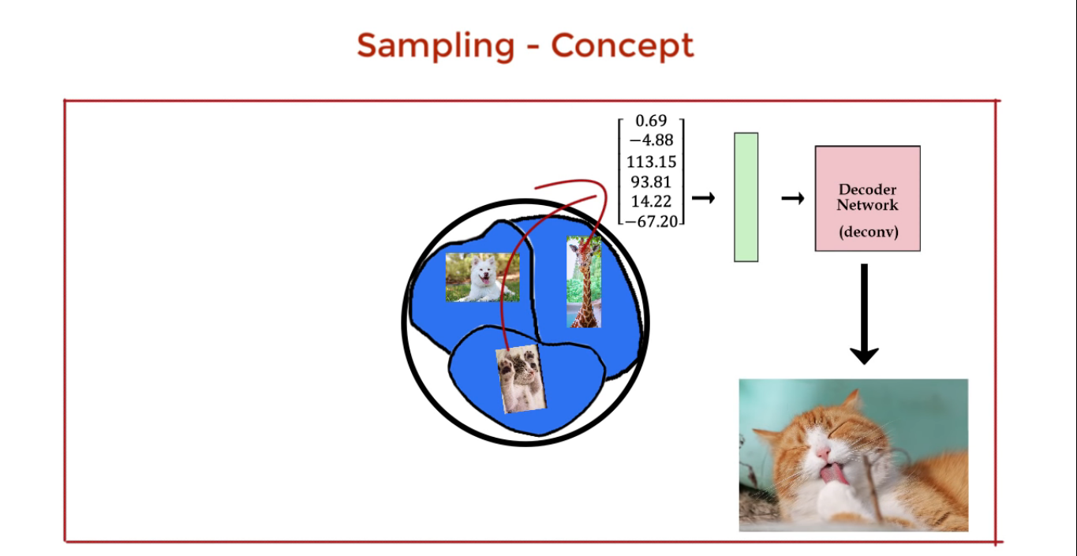  
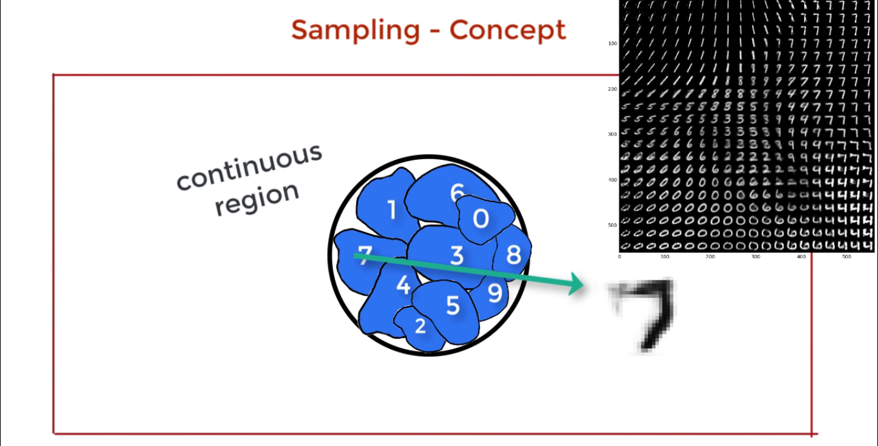  
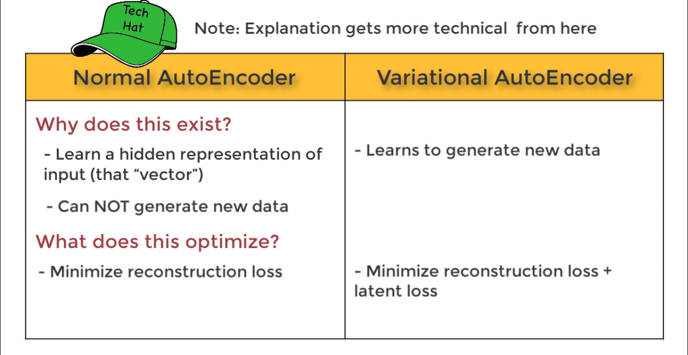  
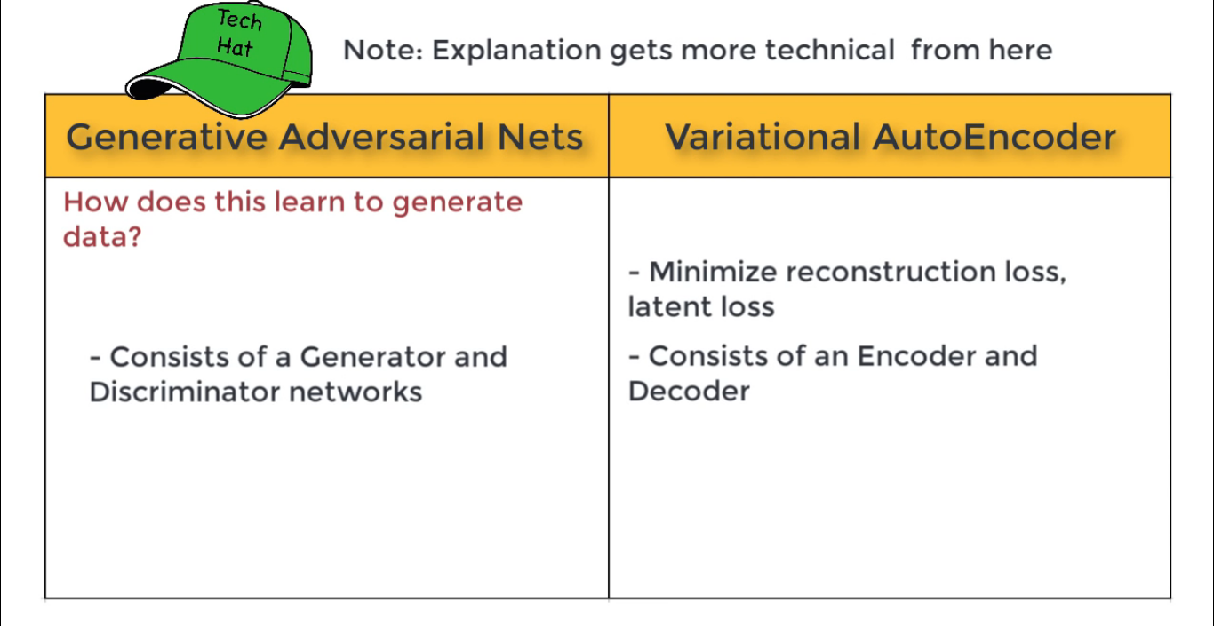

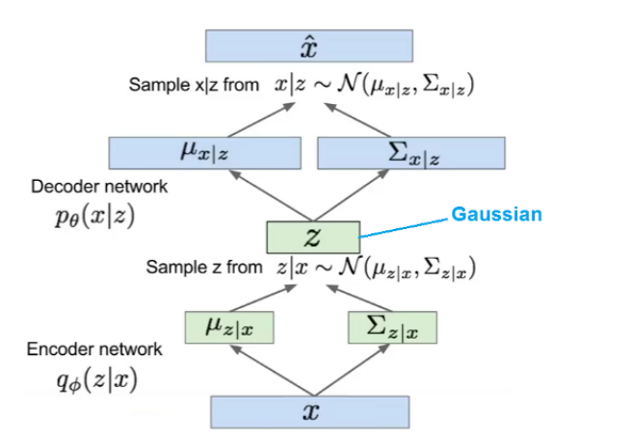

**Backpropagation and Reparameterization trick in VAE**This type sampling of z is random making z a stochastic node in neural network hence we cannot back propagate through that node because we randomly pick a sample of features from Z vector and we want to learn the MEAN and the SD and we cannot find the derivative of Z with any of these (Mean and SD) that is why we introduce another parameter epsilon because during the training process, we have to learn the Mean and the SD so we cannot differentiate Z w.r.t to the Mean and the SD. To overcome this, instead of randomly sampling Zᵢ from the N (𝝁ᵢ, 𝞂ᵢ²) VAE’s use a clever trick by introducing an **error term ϵ** where we randomly sample from N (0,1) that is **Normal distribution**, also known as the **Gaussian distribution**, is a probability **distribution** that is symmetric about the **mean**, showing that data near the **mean** are more frequent in occurrence than data far from the **mean**. In graph form, **normal distribution** will appear as a bell curve for each dimension or each feature present in Zi for e.g., eye, nose, hair etc. Now by multiplying this error term with the standard deviation, the standard deviation can be reduced and we can learn both the Mean and SD during the training and it also becomes differentiable by introducing epsilon a new parameter which makes Z Node deterministic. We now do sampling from epsilon 𝜖. Also, we make a Gaussian distribution or normal distribution of (0,1 or I) here which is a distribution between 0 to 1 or I which means that the mean of the distribution will be at x = 0 and y = 1 or I). We construct zᵢ as 𝝁ᵢ + 𝜖*𝞂ᵢ (* here mean element wise dot product). Now, the **error term ϵ** is now stochastic (differentiable) and z is deterministic and hence we can back-propagate through z. The sampling process and reparameterization trick is shown below. Now if we try the same input x twice, we should get two different values for z this is achieved by introducing the random layer 𝜖. This reparameterization trick allows us to take derivative of Z with respect to parameter theta *θ* using the chain rule.

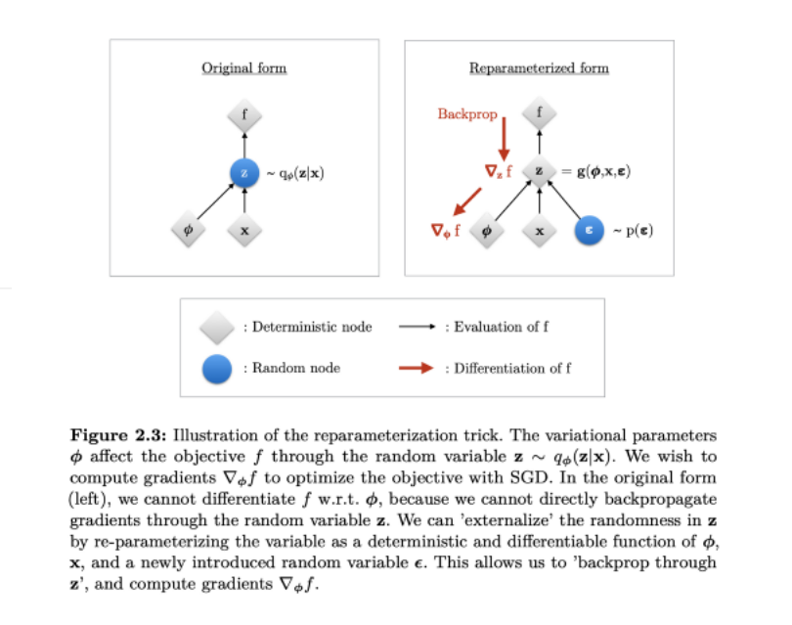  
  
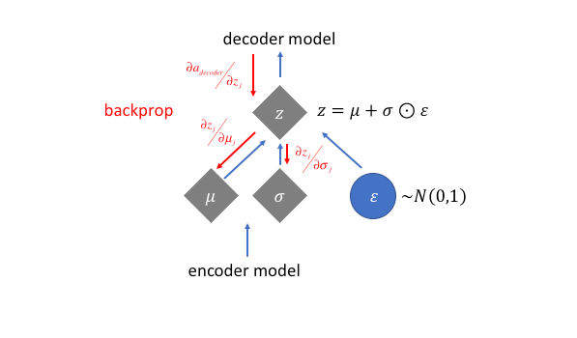

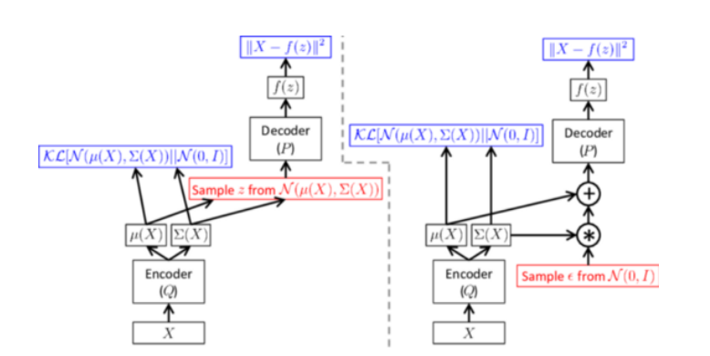

**VAE architecture without/with reparameterization**: left side shows sampling of data points from generated means and sigma’s this sampling is a stochastic process (we cannot backpropagate in this stochastic process because they are indeterministic due to random sampling for features from Z vector). The right side of the image shows sampling with reparameterization where we sample e from a standard normal.  
  
For every latent vector z which is generated we ask ourselves how good is this latent vector in reconstructing the original data X i.e., the likelihood of X represented p(x|z) using the decoder. The prior p(z) is chosen to be a standard multivariate Gaussian N (0,1). The posterior probability is the one approximated by the encoder for a given input and represented as q(z|x).

* The conditional probability p_θ(x|z) defines a generative model (probability of x given z), similar to the decoder f_θ(x|z) introduced above in the auto-encoder section. p_θ(x|z) is also known as a **probabilistic decoder**.
* The approximation function q_ϕ(z|x) is the **probabilistic encoder**, playing a similar role as g_ϕ(z|x).

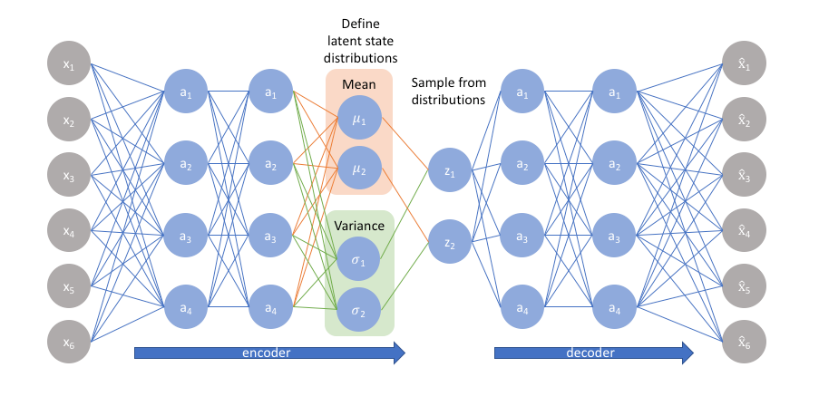  
  
We learn the Mean and SD from the input because it can help us in making a normal or gaussian distribution (a probability distribution having a bell curve). Standard deviation tells us how spread out the data is. It is an average measure of how far each observed value is from the mean.   
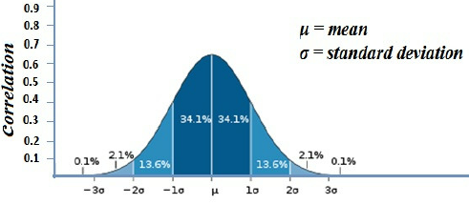  
  
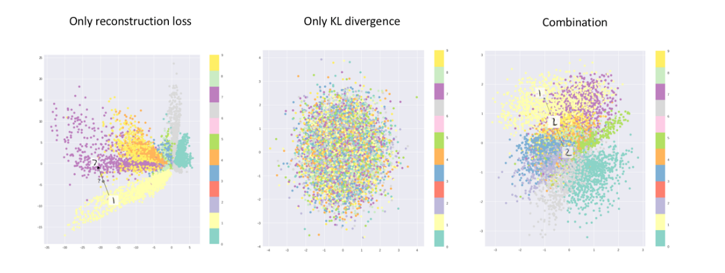  
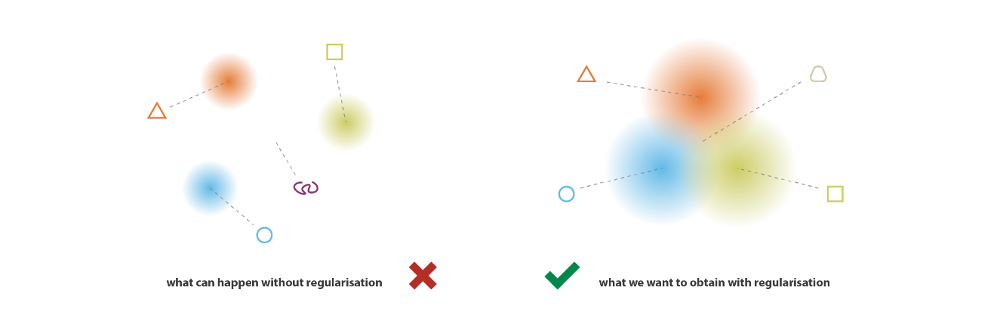  
  
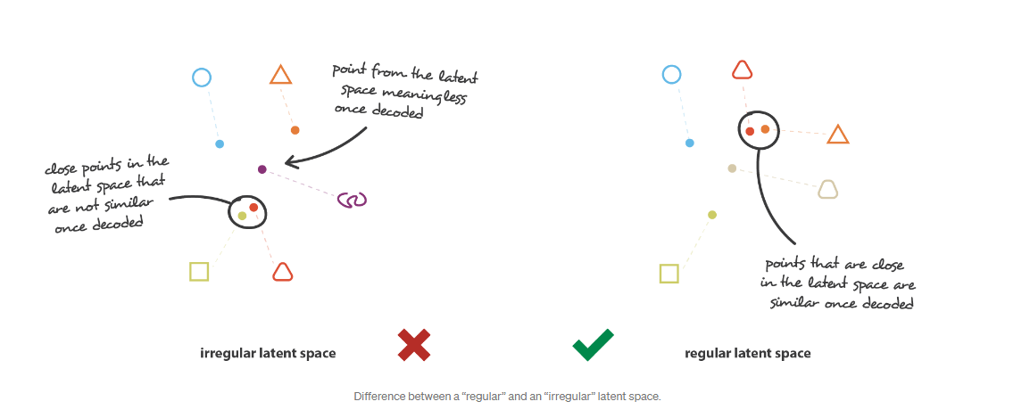  
  
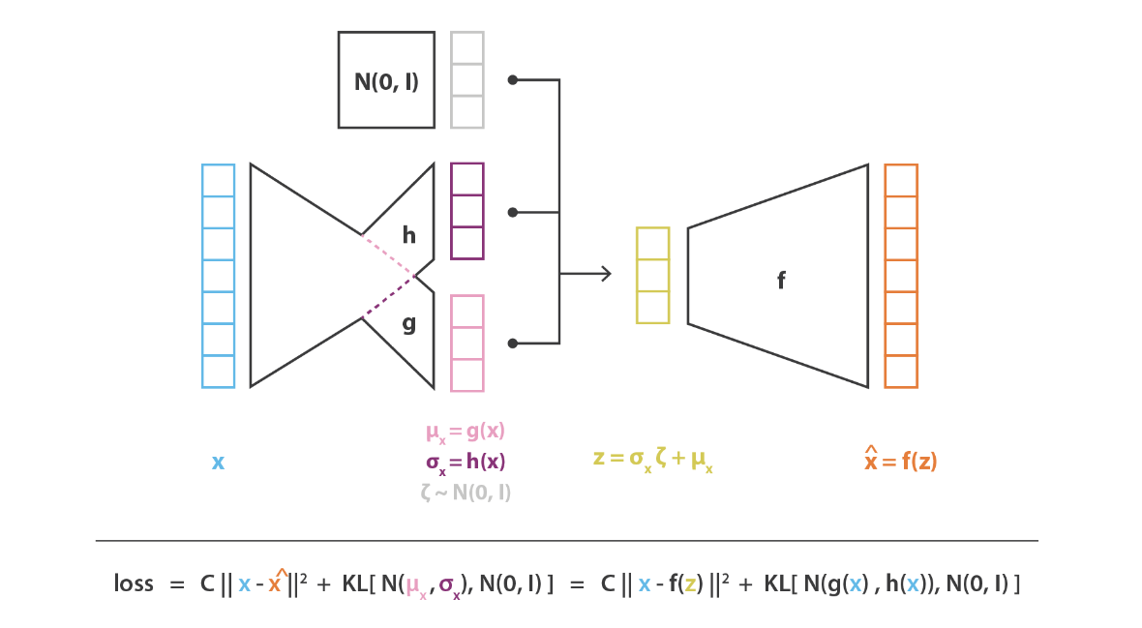  
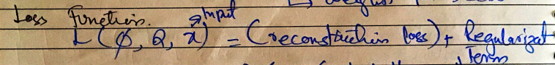  
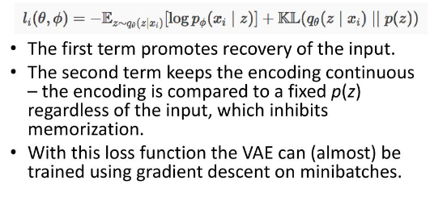  
  
Here, E is the expectation operator of probability. The first term represents the reconstruction loss and the second term with KL divergence is regularization term.  
  
For understanding the math behind KL divergence see following videos,  
  
<https://www.youtube.com/watch?v=w8F7_rQZxXk>  
<https://www.youtube.com/watch?v=wdKYveLIxgU>  
<https://www.youtube.com/watch?v=YHldNC1SZVk>  
<https://www.youtube.com/watch?v=Hlr3CYfRMf0>  
  
  
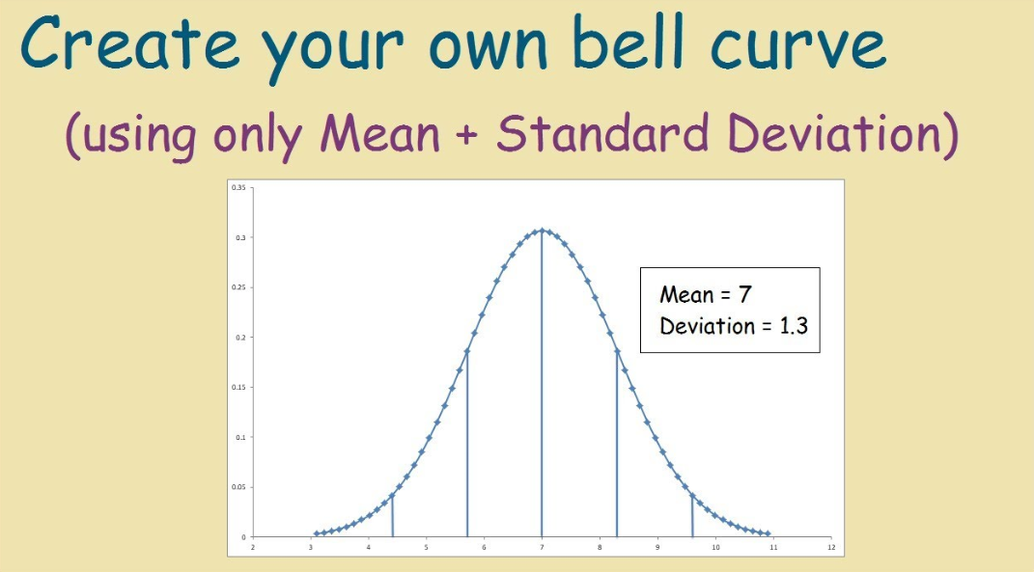  
  
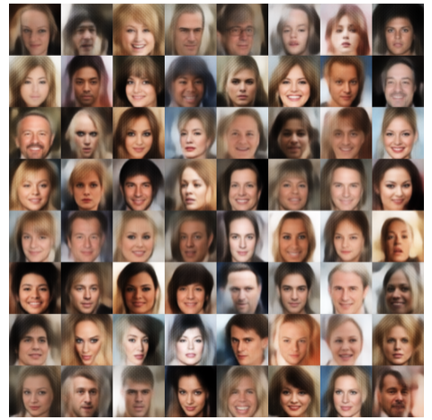  
  
  
References:  
<https://towardsdatascience.com/intuitively-understanding-variational-autoencoders-1bfe67eb5daf#:~:text=The%20loss%20function%20is%20usually,outputs%20different%20fom%20the%20input>  
<https://medium.com/vitrox-publication/generative-modeling-with-variational-auto-encoder-vae-fc449be9890e>  
<https://towardsdatascience.com/understanding-variational-autoencoders-vaes-f70510919f73>

# Expectation operator in probability (E)

# 

# Generative Adversarial Networks (GAN)

# The Generative Adversarial Network (GAN) comprises of two models: a generative model ****G**** and a discriminative model ****D****. The generative model can be considered as a counterfeiter who is trying to generate fake currency and use it without being caught, whereas the discriminative model is similar to police, trying to catch the fake currency. This competition goes on till the counterfeiter becomes smart enough to successfully fool the police.

**Discriminator**The role is to distinguish between actual and generated (fake) data.

1. **Generator:**The role is to create data in such a way that it can fool the discriminator.  
     
   **The discriminator maximizes the probability of assigning the correct label to both training examples and images generated by the generator.** I.e the policeman becomes better at differentiating between fakes and real paintings.
2. **The generator minimizes the probability that the discriminator can predict that what it generates is fake.** I.e the generator becomes better at creating fakes

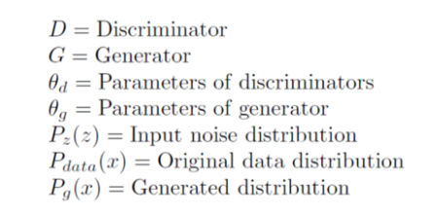  
  
Loss Function Derivation  
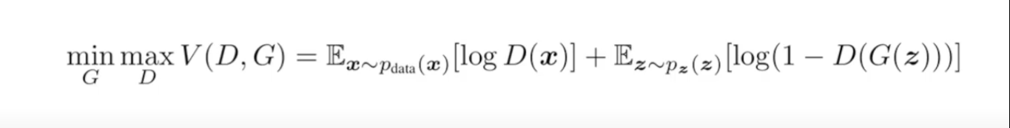  
See this video for complete explanation of loss function derivation by channel WelcomeAiLords,  
<https://www.youtube.com/watch?v=J1aG12dLo4I>  
  
The loss function can be derived from the cross-entropy loss.   
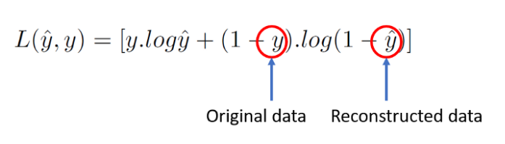

Discriminator Loss

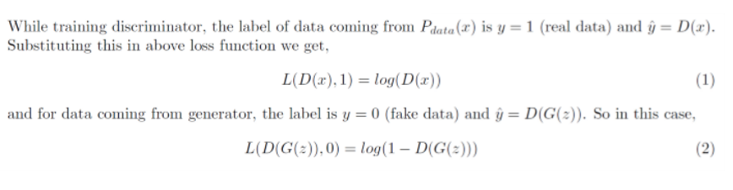  
  
Now, the objective of the discriminator is to correctly classify the fake and real dataset. For this, equations (1) and (2) should be maximized and final loss function for the discriminator can be given as,



Generator Loss  
  
Here, the generator is competing against discriminator. So, it will try to minimize the equation (3) and loss function is given as,

## Combined Loss Function after combining 3,4 we get,

Remember that the above loss function is valid only for a single data point, to consider entire dataset we need to take the expectation of the above equation as  
  
  
  
Algorithm  
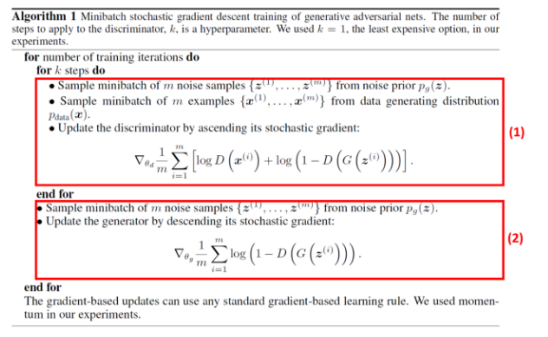  
It can be noticed from the above algorithm that the generator and discriminator are trained separately. In the first section, real data and fake data are inserted into the discriminator with correct labels and training takes place. Gradients are propagated keeping generator fixed. Also, we update the discriminator by ascending its stochastic gradient because for discriminator we want to maximize the loss function given in equation (6).

On the other hand, we update the generator by keeping discriminator fixed and passing fake data with fake labels in order to fool the discriminator. Here, we update the generator by descending its stochastic gradient because for the generator we want to minimize the loss function given in equation (6).

## The optimal discriminator **D** for any given generator **G** can be found by taking derivative of the loss function (equation (6)), The above equation is very important mathematically but in reality, you cannot calculate optimal **D**as**Pdata(x)** is not known. Now, the loss for **G** when we have optimal **D** can be obtained by substituting equation (7) into loss function as, Now, Kullback-Leibler(KL) and Jensen-Shannon(JS) divergences are given by, The loss function derived (equation (9)) has some limitations,

## 1. **Vanishing Gradient**

The aim of optimization for equation (9) is to move **Pg** towards **Pdata** or **Pr** for an optimal **D**. JS divergence remains constant if there is no overlap between **Pr** and **Pg** (figure 3). It can be observed that JS divergence is constant and its gradient is close to 0 when the distance is more than 5, which represents that the training process does not have any influence on **G**(figure 4). The gradient is non-zero only when **Pg** and**Pr** have a significant overlap that means when **D** is close to optimal, **G** will face vanishing gradient problem.

## 2. **Mode Collapse**

During training, the generator may get stuck into a setting where it always produces the same output. This is called mode collapse. This happens because the main aim of **G**was to fool **D**not to generate diverse output.

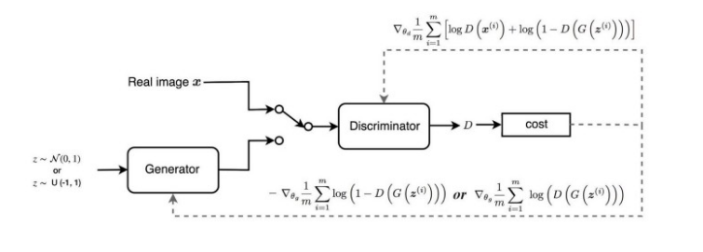  
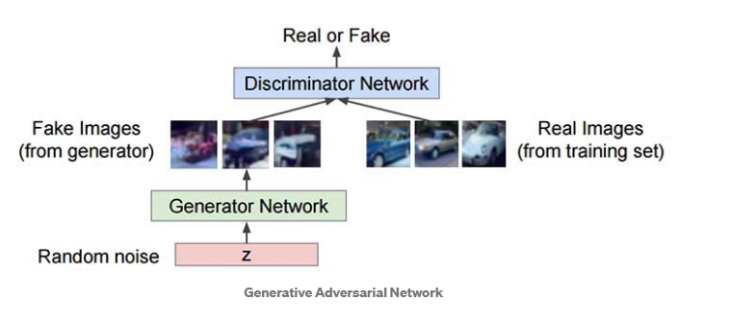  
  
Problems with GANs

* **Mode collapse**: the generator collapses which produces limited varieties of samples,
* **Diminished gradient**: the discriminator gets too successful that the generator gradient vanishes and learns nothing,
* Unbalance between the generator and discriminator causing overfitting, &
* **Highly sensitive** to the hyperparameter selections.
* N**on-convergence**: the model parameters oscillate, destabilize and never converge,

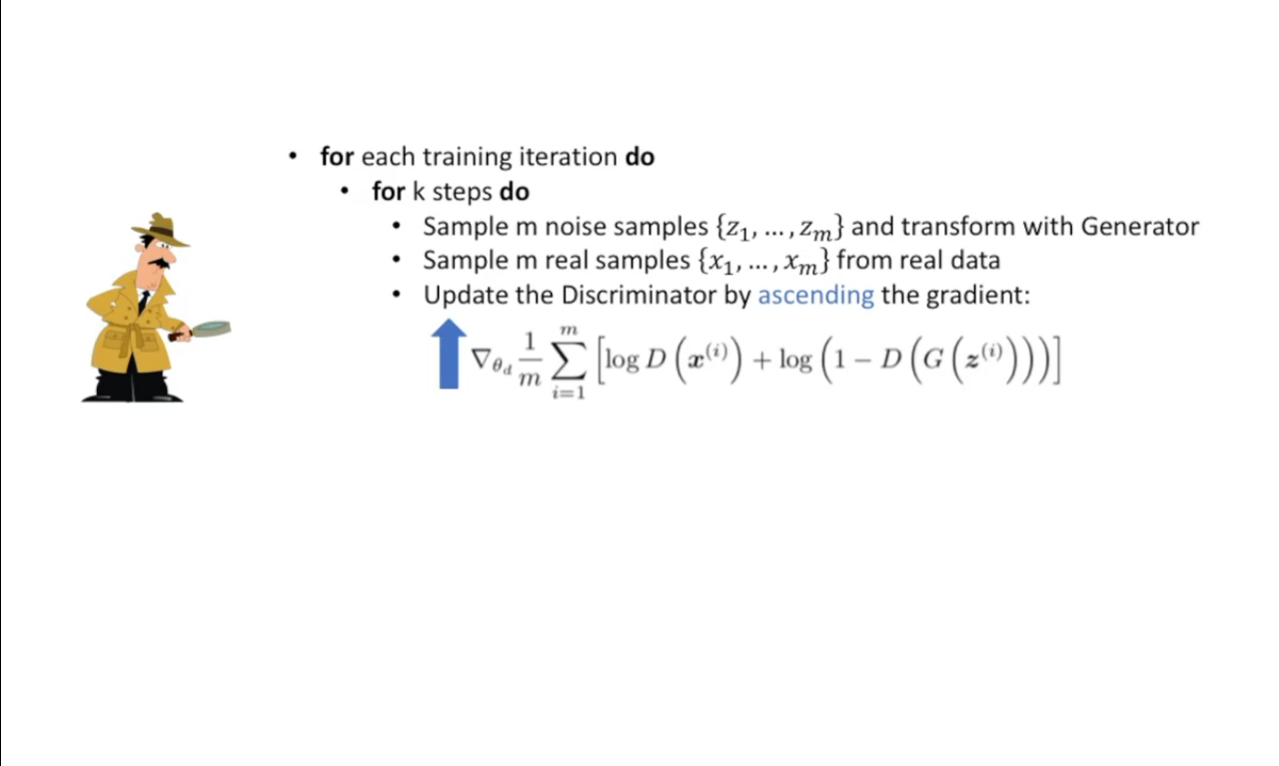

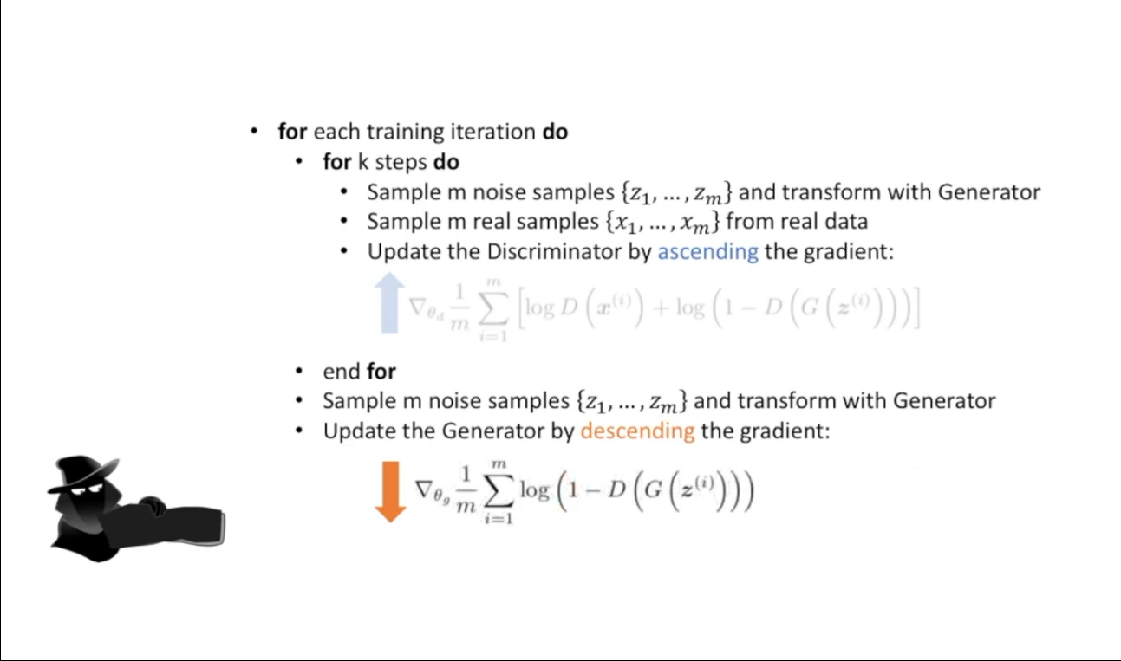  
  
  
Why Generator minimizes the loss function and discriminator maximizes it?  
The **generator** seeks to **minimize** the log of the inverse probability predicted by the discriminator for fake images. This has the effect of encouraging the **generator** to generate samples that have a low probability of being fake.  
  
The **discriminator** seeks to **maximize** the probability assigned to real and fake images. **We** train D to **maximize** the probability of assigning the correct label to both training examples and samples from G.

Learning Classes

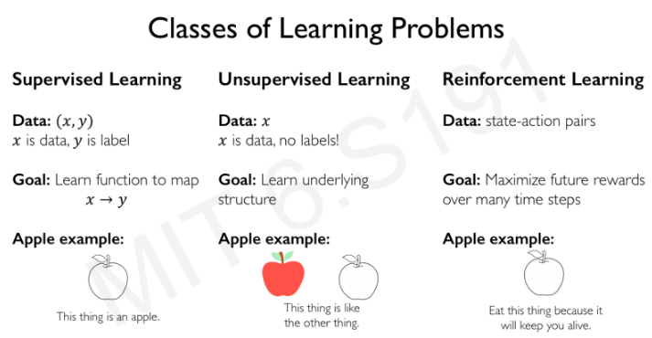

Reinforcement Learning

Reinforcement learning is an area of machine learning concerned with how intelligent agents ought to take actions in an environment in order to maximize the notion of cumulative reward. Reinforcement learning is one of three basic machine learning paradigms, alongside supervised learning and unsupervised learning.

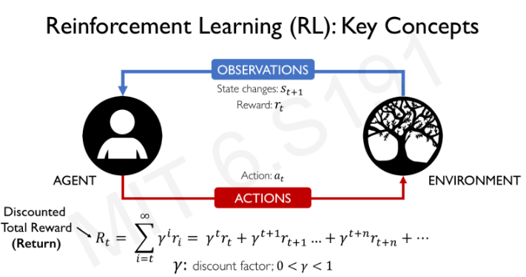

Here, the gamma is a discount factor which basically allows us to take and prioritize current rewards rather than the future rewards.   
For e.g., Taking 500$ at the moment is more beneficial than taking 1000$ after 2 years that is why the power of gamma increase as we proceed in time ‘t’ when calculating the reward using total reward formula. Its value is between 0-1 so when we increase gamma powers, we are basically making the future rewards less important and giving the current rewards the higher priority.  
  
The Quality Function  
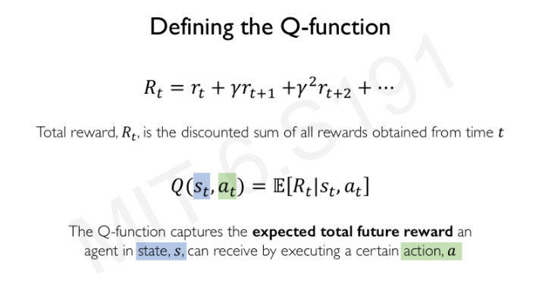

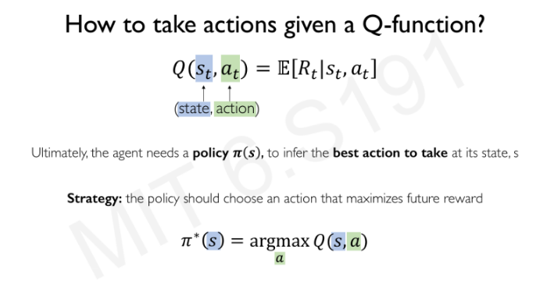  
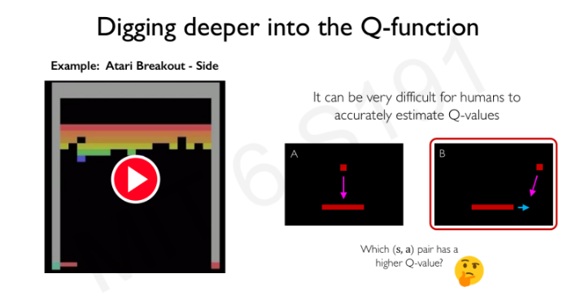  
  
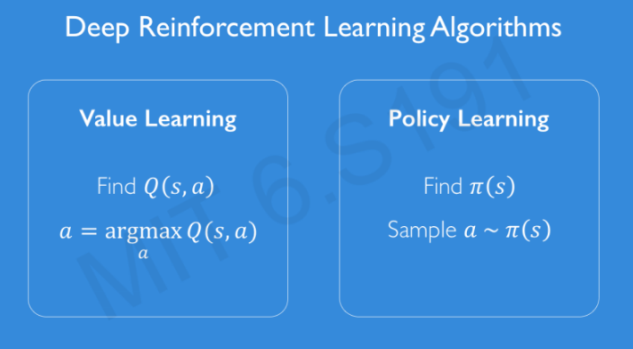

- Value Learning  
   
 In value learning we first find all the values of Q functions for each possible action and then we pick the action that has maximum Q function value.

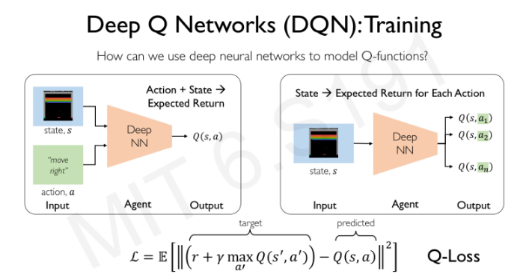  
  
The Deep Neural Network architect or the approach in the left is inefficient because we will have to run the deep neural network N times (Total action times) to determine the Q function for each of the given action. For e.g., action -> move right in the given example.  
However, if we use the DNN architecture defined in the right-hand side, we can get all the rewards from Q functions for each action and then we can select the one with maximum reward.  
  
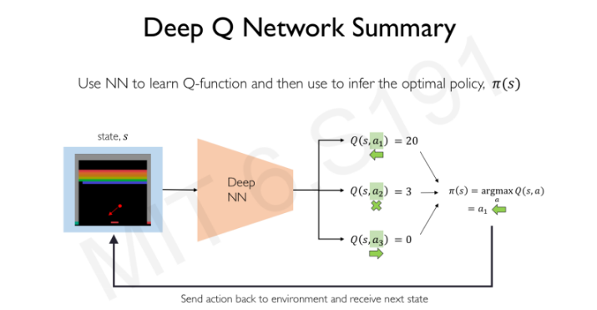  
  
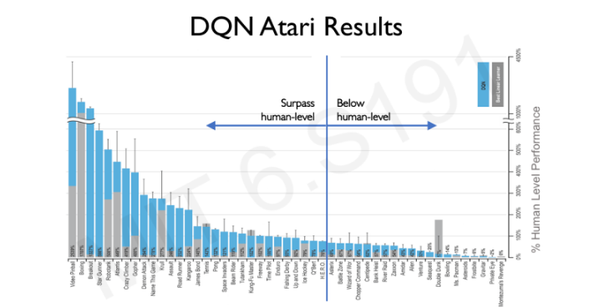  
  
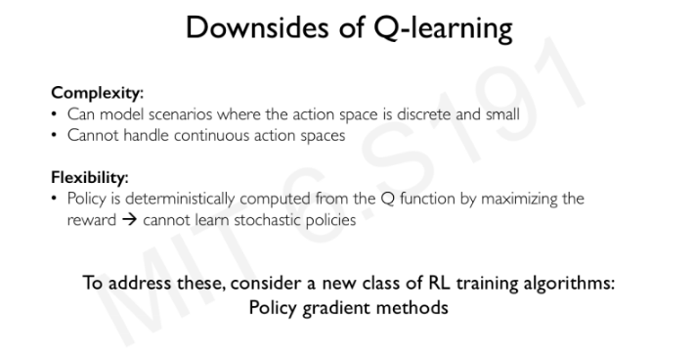

* Policy Learning

In policy learning, instead of picking the maximum reward out of all the possible rewards returned by Q functions for each action, we learn a policy by making a probabilistic distribution and also **optimize** it.

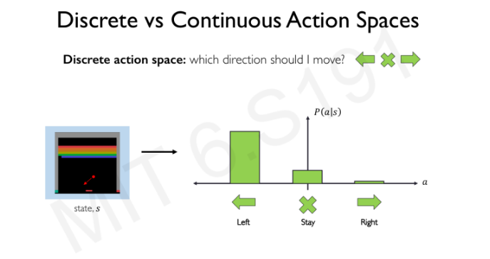

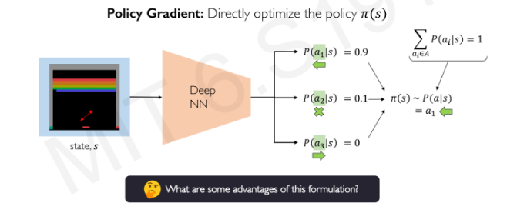  
  
By doing this, we don’t only pick the best actions from the learned policy but also, we get some more new information like in this game, with how much speed we should move?

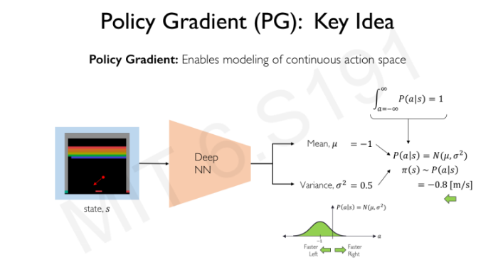

Learning the policy for the first time until termination, after termination of first time, we will now decrease the probability of the actions on state ‘s’ that resulted low rewards as defined in point 3 and 4.   
  
Now again we will do the same procedure and wait for the termination and will decrease the probability of the actions on state ‘s’ that gives low rewards.  
  
We will do this multiple times and at some time the model will learn everything and it will avoid terminating anymore.  
  
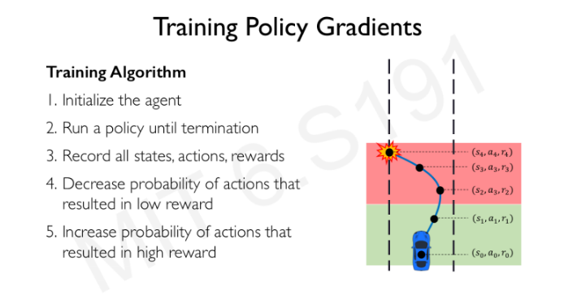

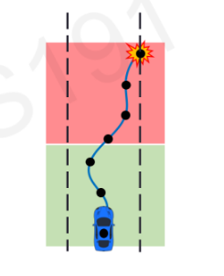 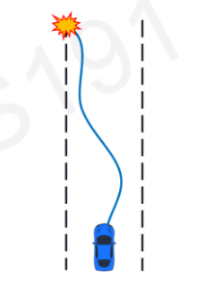 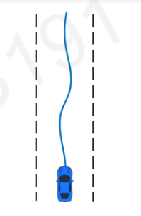  
  
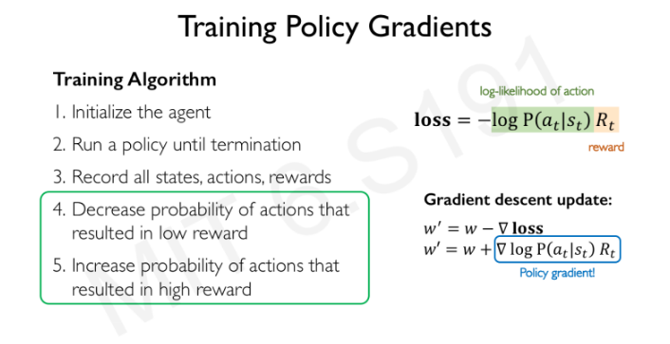  
Log of likelihood will allow us to do the working of point 3 and 4.